Aldelo®
Express App
User Guide

PUBLISHED BY
Aldelo, LP
6800 Koll Center Parkway, Suite 310
Pleasanton, CA 94566

Copyright © 1997-2017 by Aldelo, LP

All rights reserved. No part of the contents of this book may be reproduced or transmitted in any form or by any means whatsoever without the express written permission of the publisher.

This manual is available through Aldelo, LP and resellers worldwide. Please contact Aldelo, LP or visit our website at www.aldelo.com for more information. Send comments about this manual to support@aldelo.com.

Aldelo® is the registered trademark of Aldelo, LP. Other products or company names mentioned herein may be the trademarks of their respective owners.

The example companies, organizations, products, logos, people, places, and events depicted herein are fictitious. No association with any real company, organization, product, logo, person, place, or event is intended or should be inferred.

For the sake of simplicity, all gender references are written only in the masculine. Any references to the masculine gender should be interpreted to include the feminine gender as well and vice-versa, wherever applicable.

Chapter 1 Getting Started 1
Creating an Account 1
Creating an Account with E-mail Address or Mobile Phone Number 1
Creating an Account with Facebook 3
Logging In 4
Logging In to Your Existing Account 4
Logging In with E-mail Address or Mobile Phone Number 5
Logging In with Facebook 8
Chapter 2 Program Demo 9
View the Demo 9
Existing Orders 17
Opening an Existing Order 17
Adding a Menu Item 19
Recalling an Order 22
Printing an Order Receipt 24
Miscellaneous Features 25
Settling an Order 27
Exiting the Order Entry Screen 31
Chapter 3 Stores 33
Creating a Store 33
General Settings 33
Items Settings 41
Staff Settings 45
Building Your Store 49
Activating a Device 52
Chapter 4 Customer Orders 59
Creating a New Order 59
Adding a Menu Item 67
Printing an Order Receipt 70
Chapter 5 Miscellaneous Features 73
Printer Setup 73
Synchronizing the Aldelo® Express App with the Aldelo® Express Cloud Back Office 80
Accessing the Aldelo Marketplace 83
Deactivating the Current Device 87
Deactivation Using E-mail Address or Mobile Phone Number 87
Deactivation Using Facebook 93
Chapter 6 Cloud Manager 96
Accessing the Cloud Manager 96
Access from a Mobile Device 96
Notes 103

Getting Started

Creating an Account

Creating an Account with E-mail Address or Mobile Phone Number

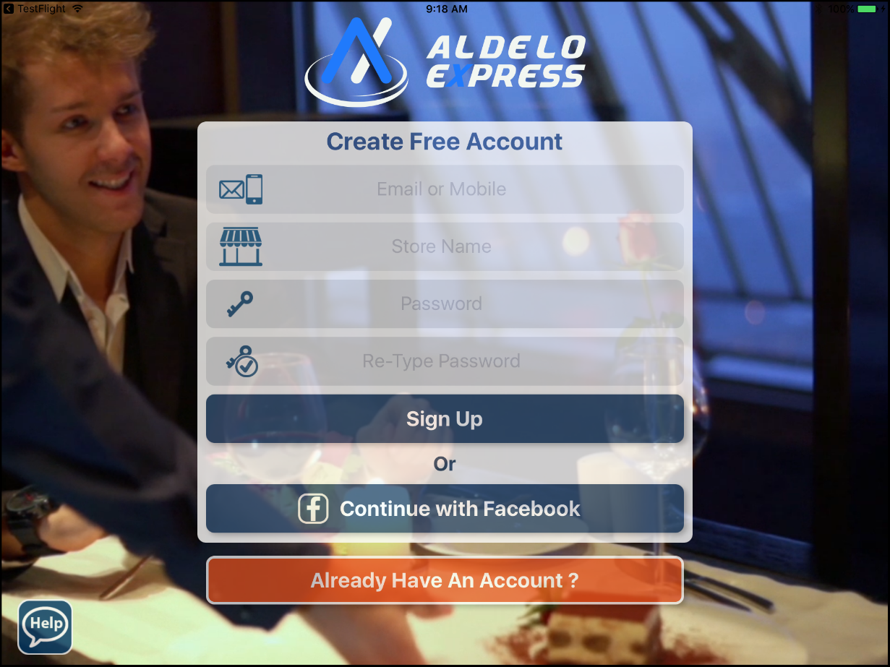
Figure 1-1

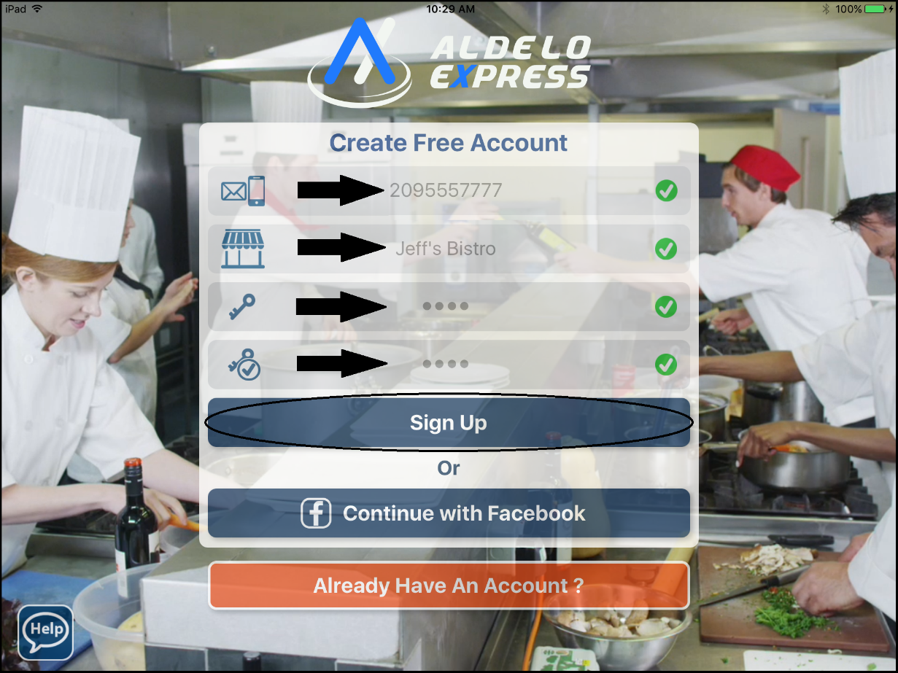
Figure 1-2

Creating an Account with Facebook

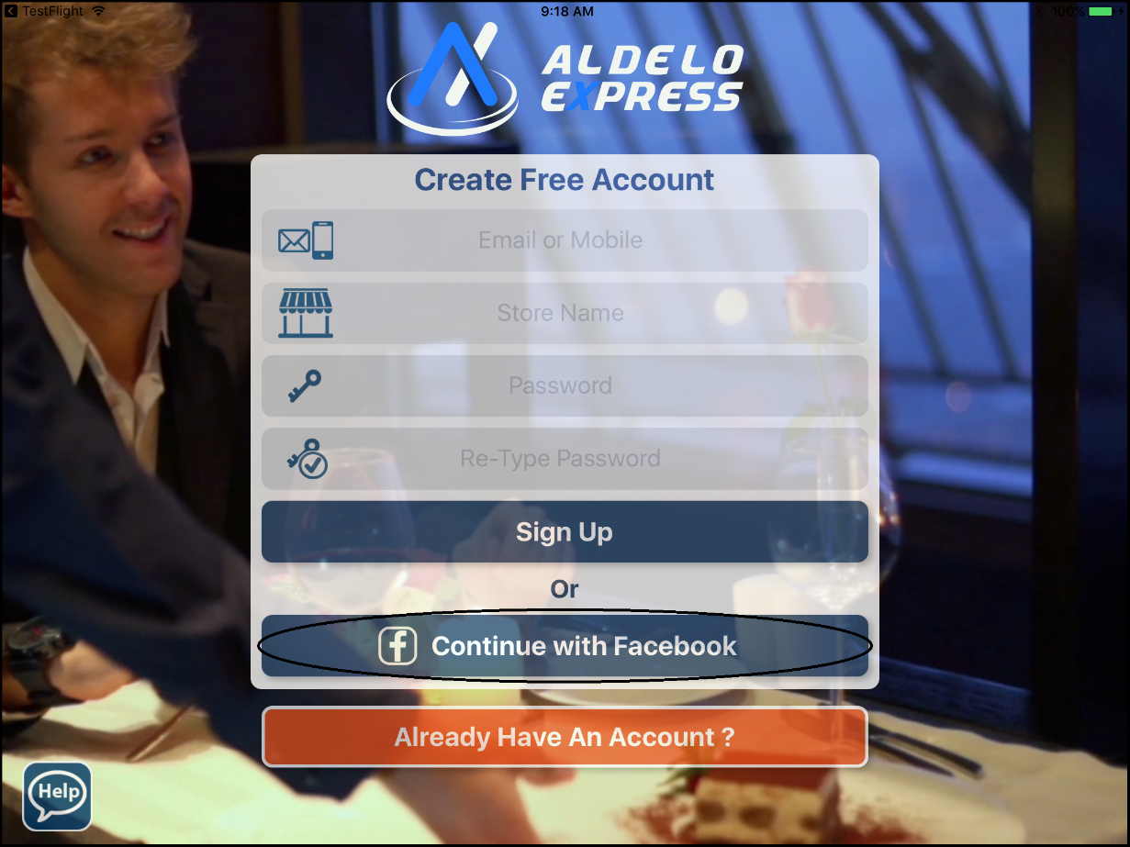
Figure 1-3

Logging In

Logging In to Your Existing Account

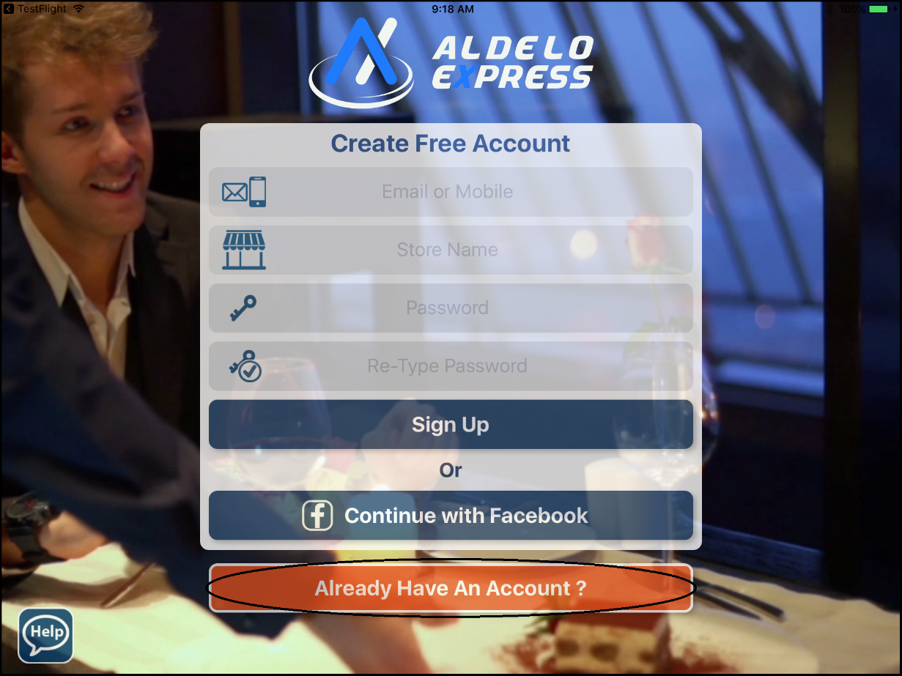
Figure 1-4

Logging In with E-mail Address or Mobile Phone Number

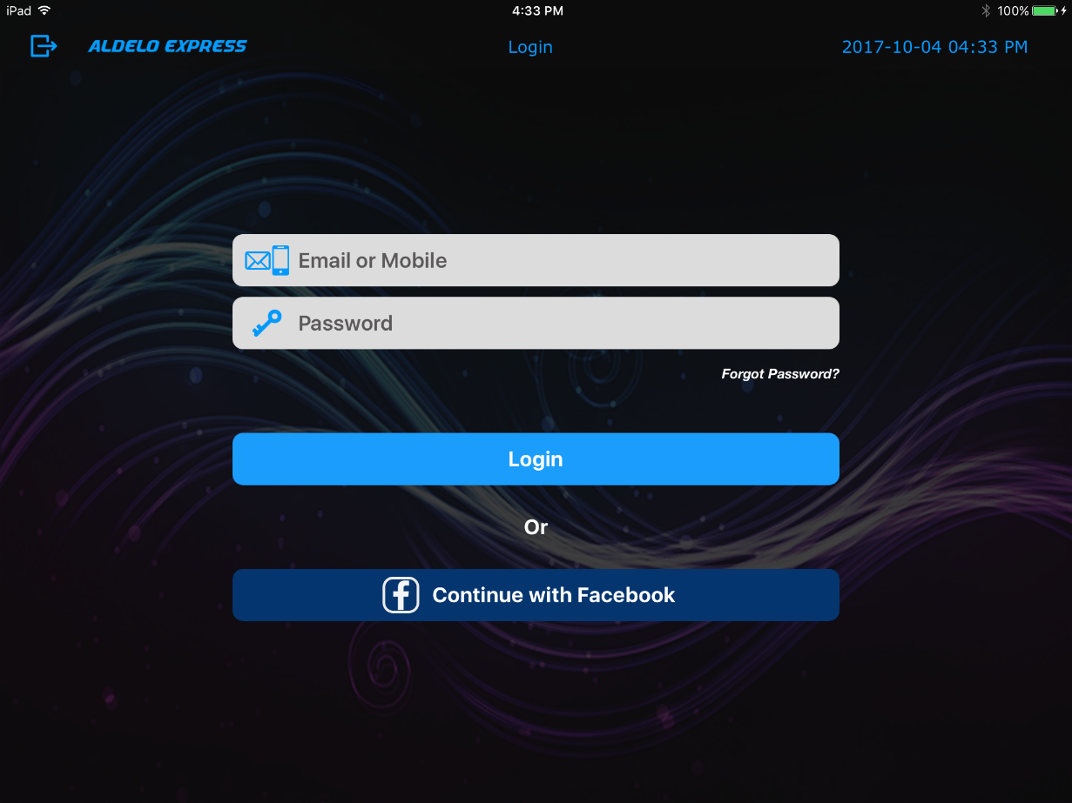
Figure 1-5

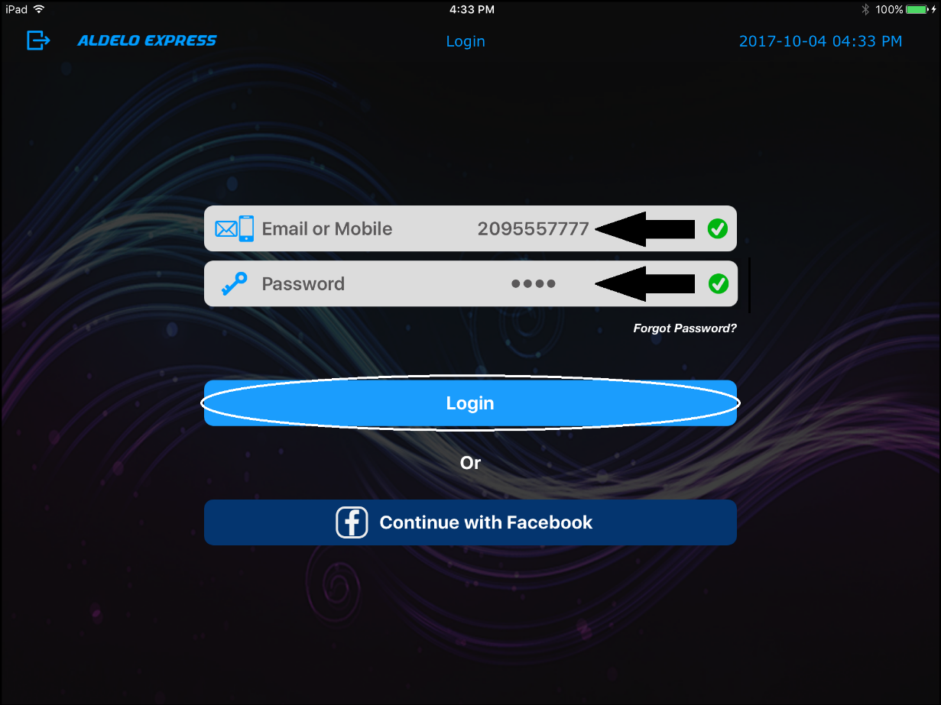
Figure 1-6

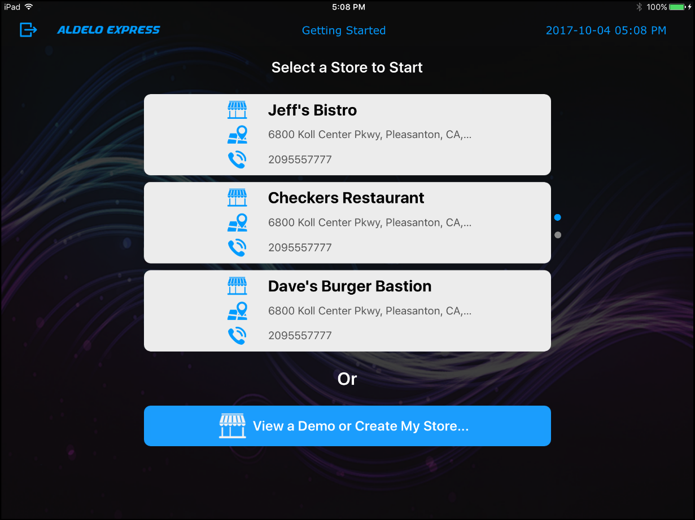
Figure 1-7

Logging In with Facebook

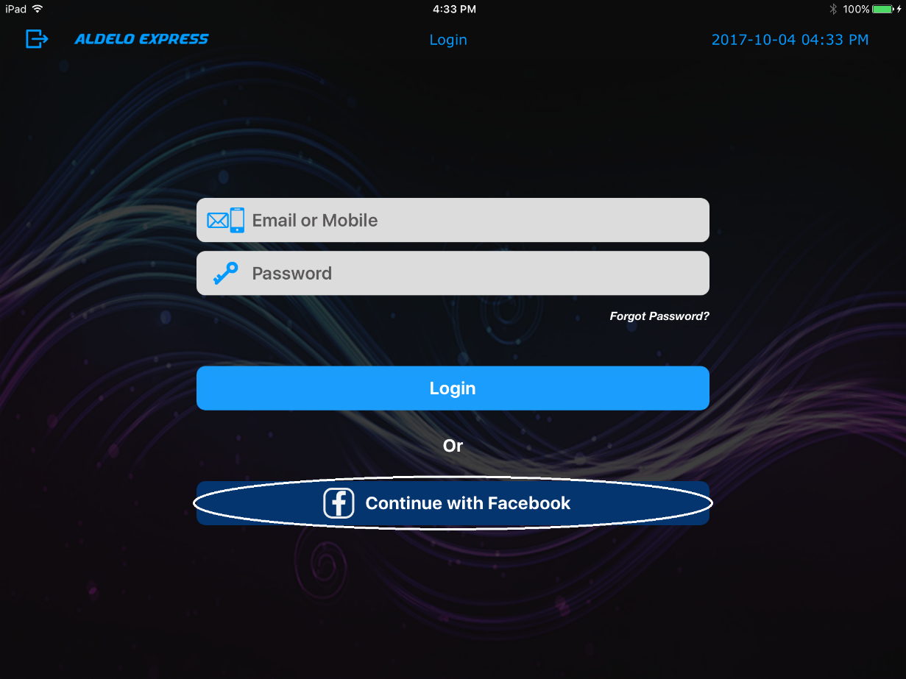
Figure 1-8

Program Demo

View the Demo

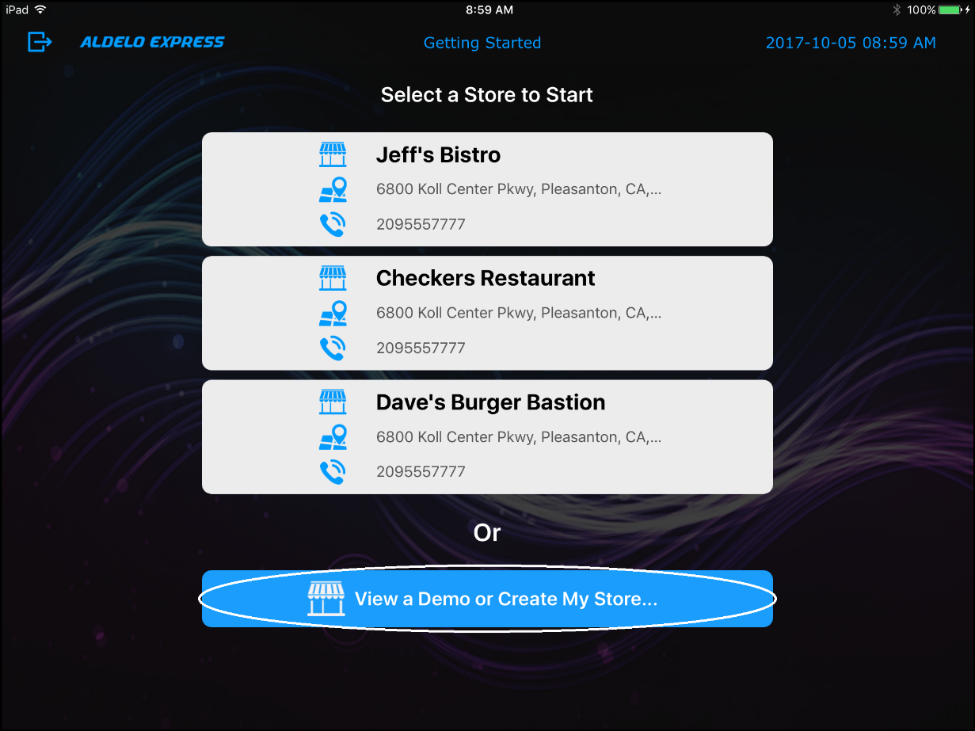
Figure 2-1

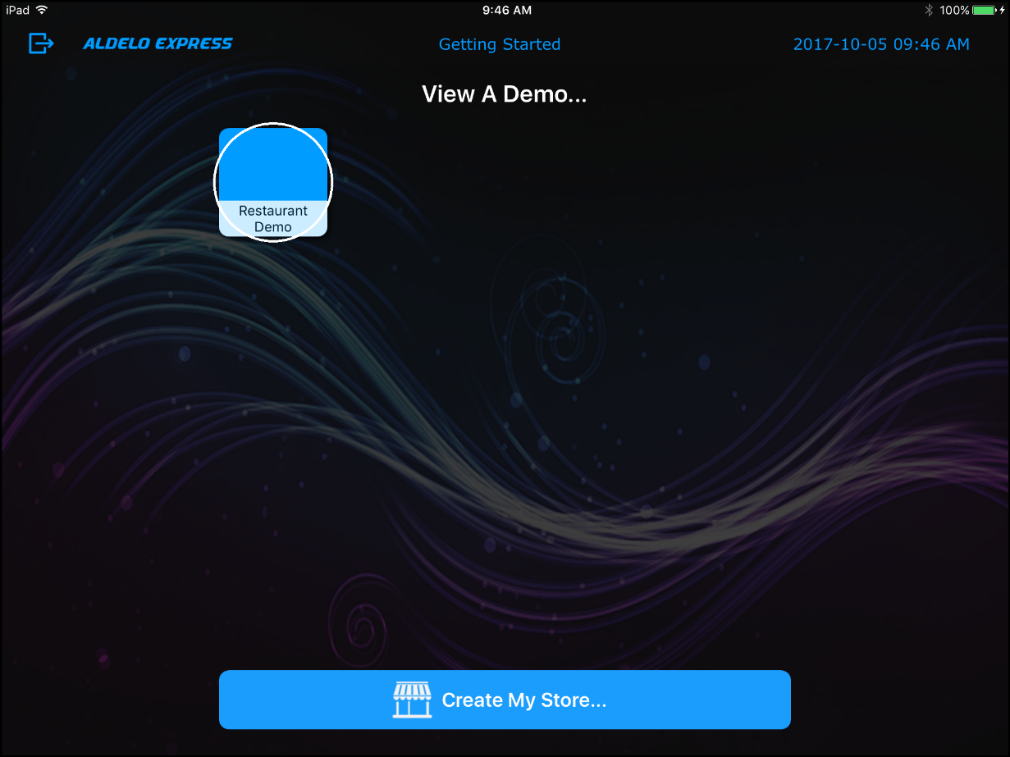
Figure 2-2

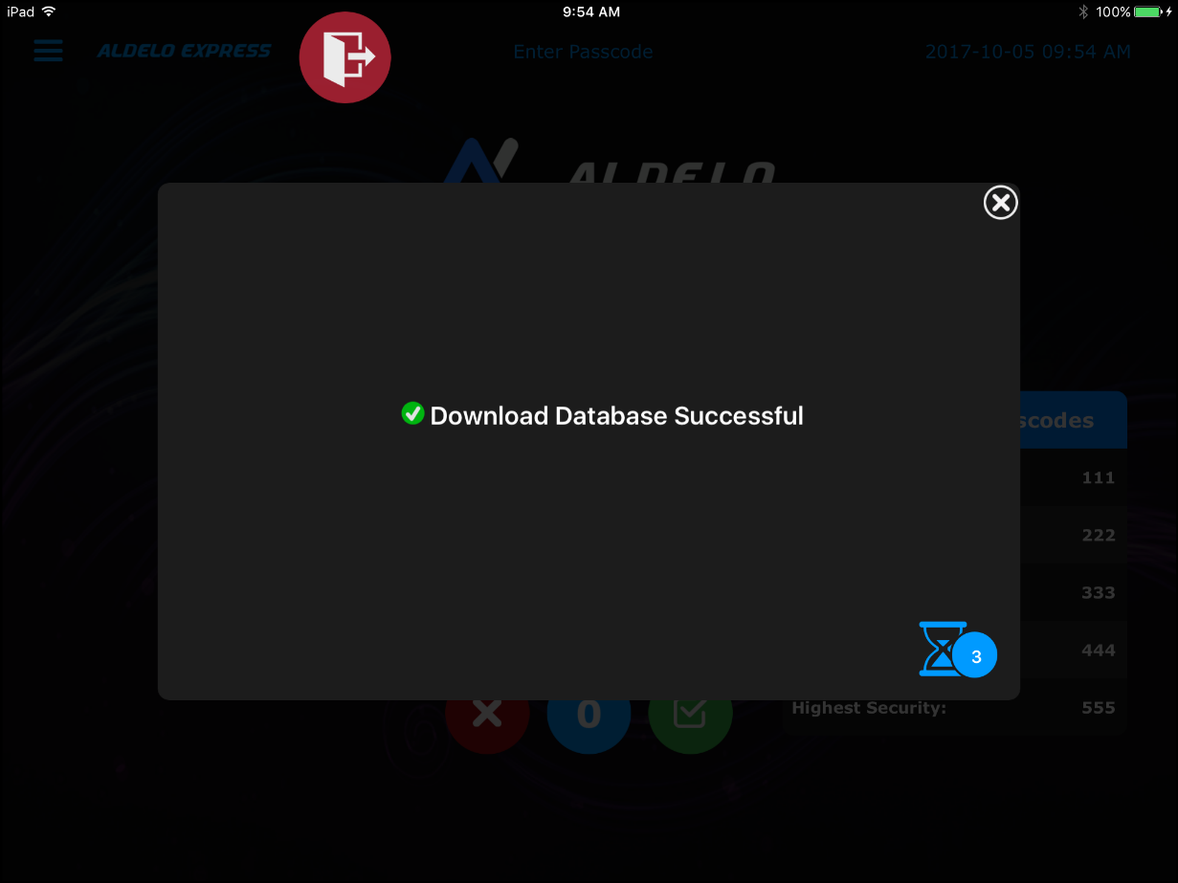
Figure 2-3

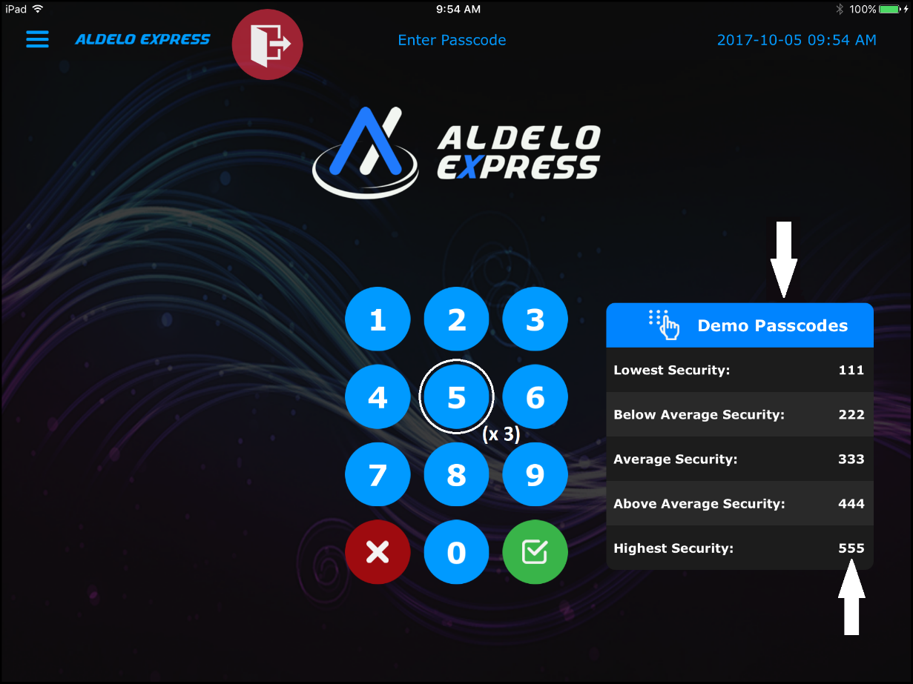
Figure 2-4

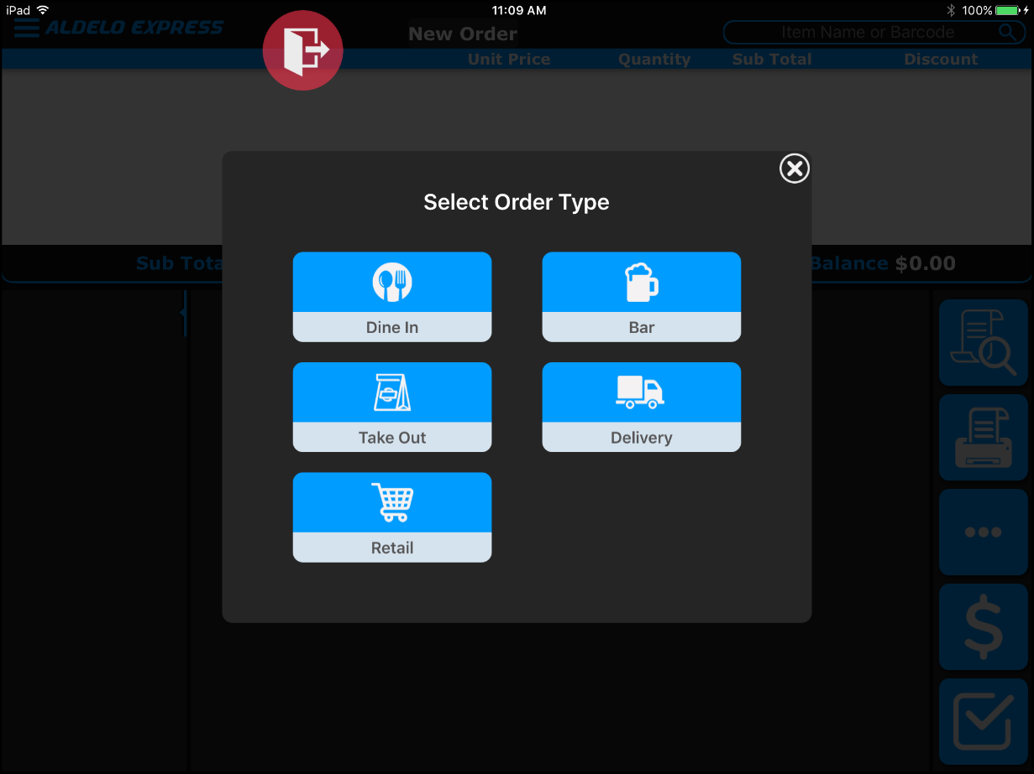
Figure 2-5

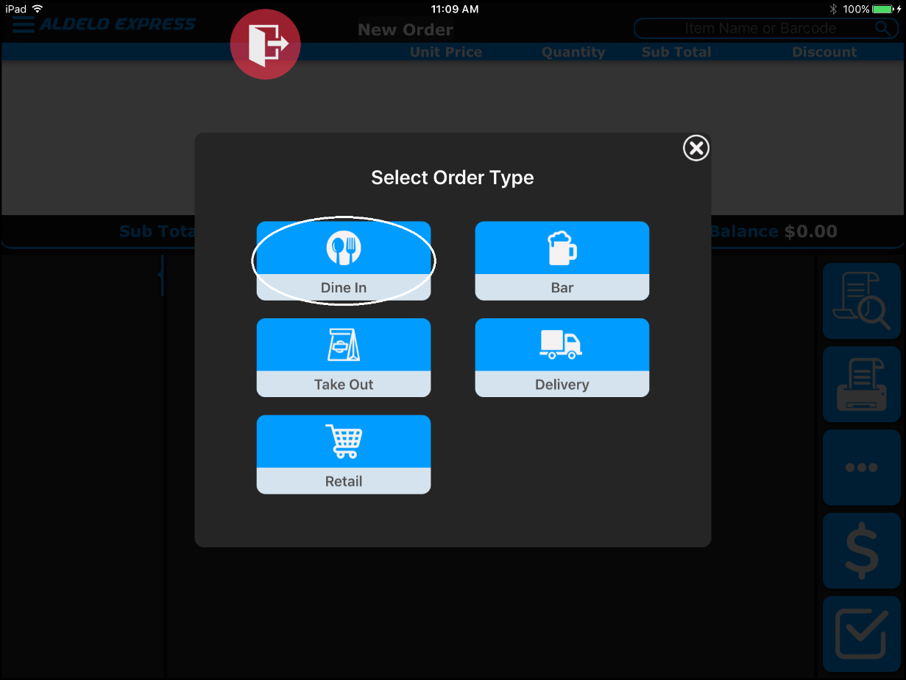
Figure 2-6

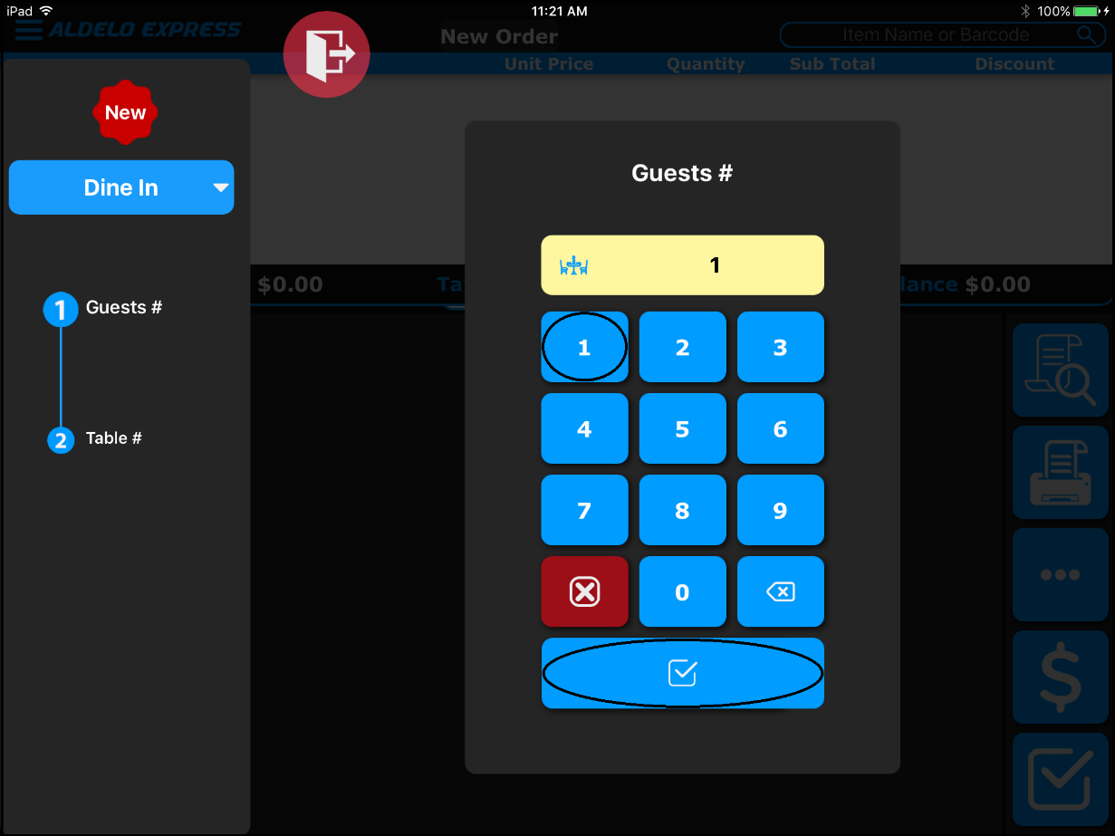
Figure 2-7

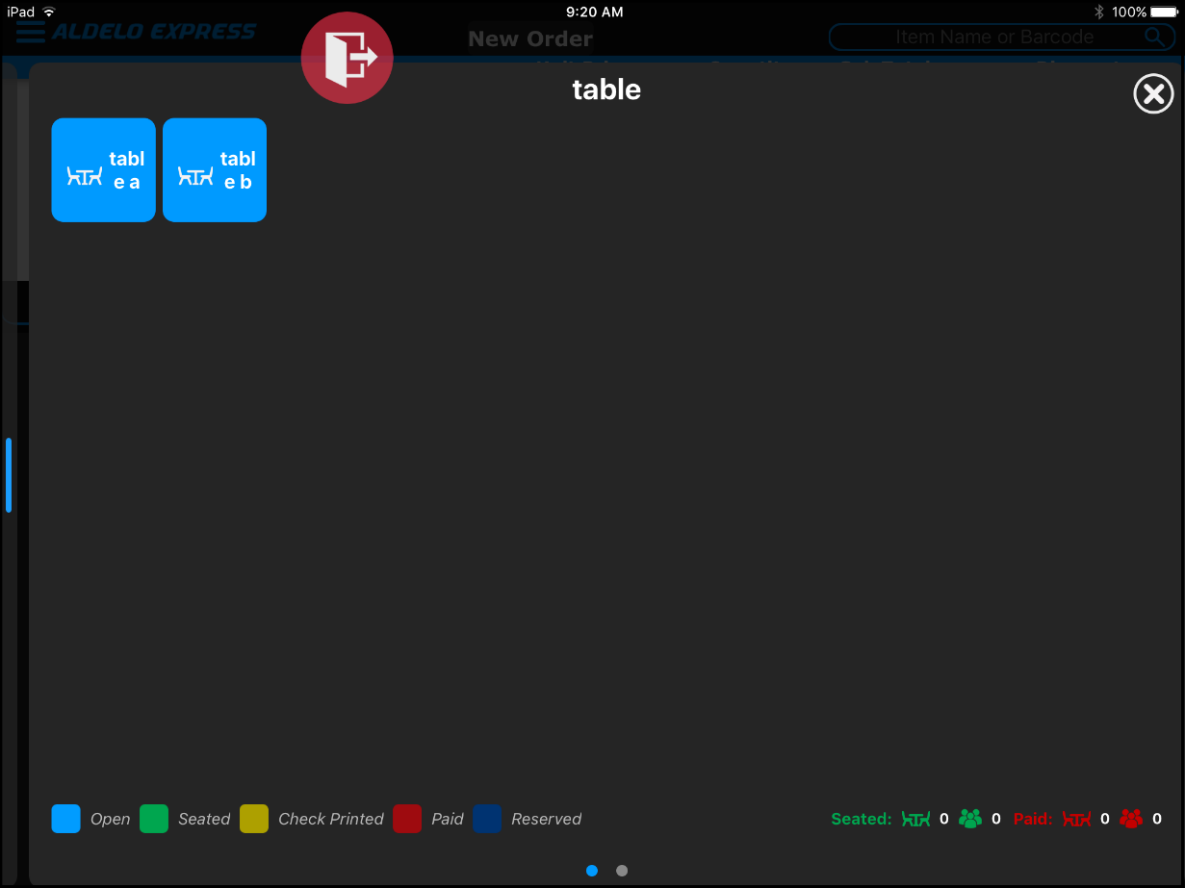
Figure 2-8

Existing Orders

Opening an Existing Order

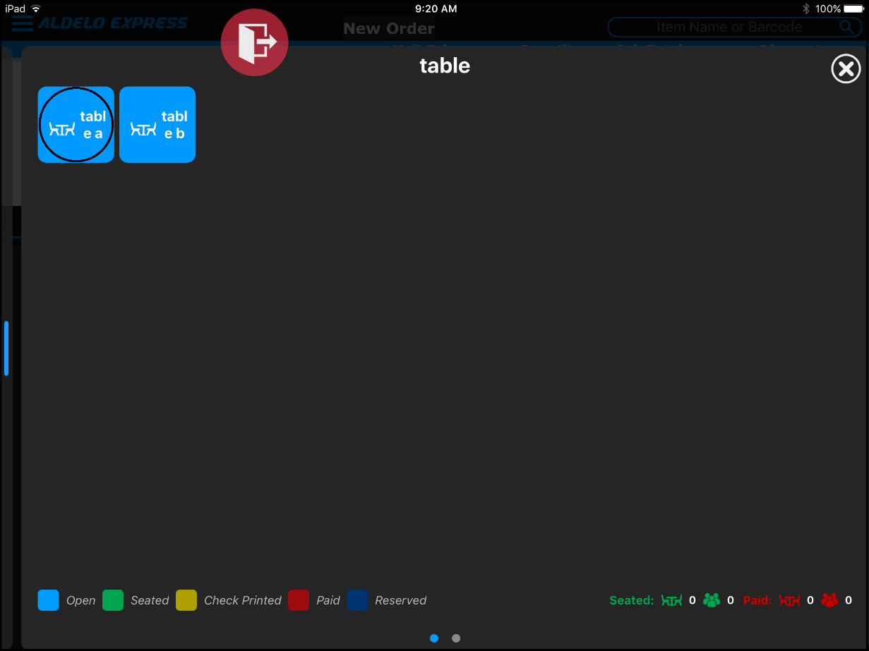
Figure 2-9

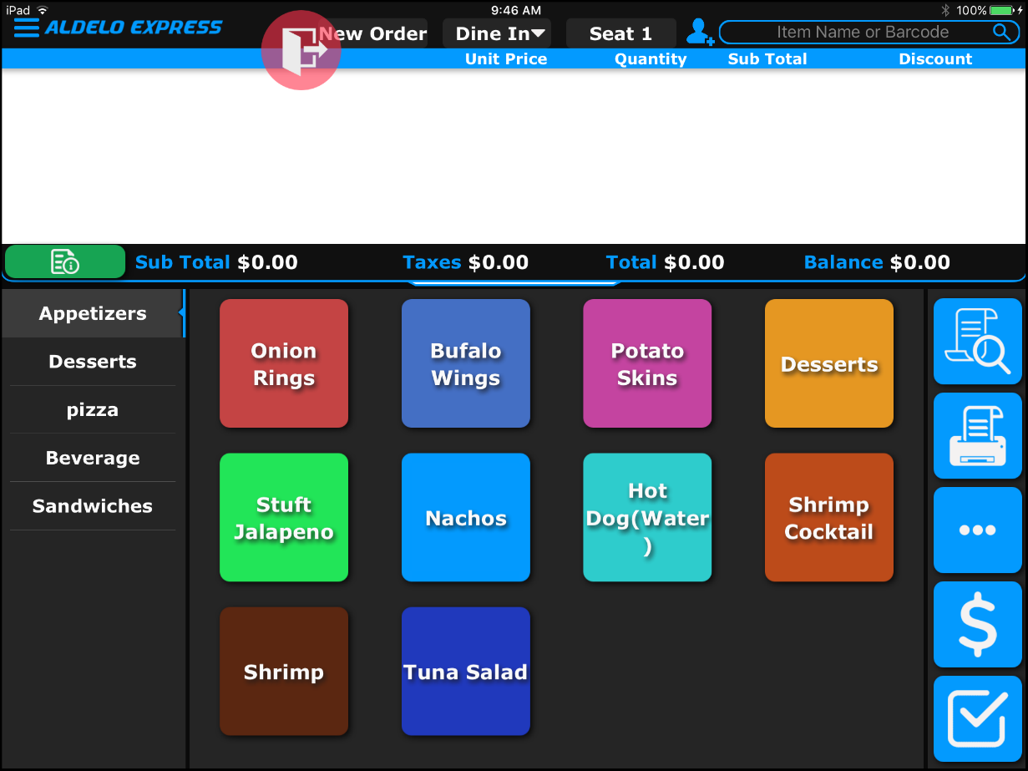
Figure 2-10

Adding a Menu Item

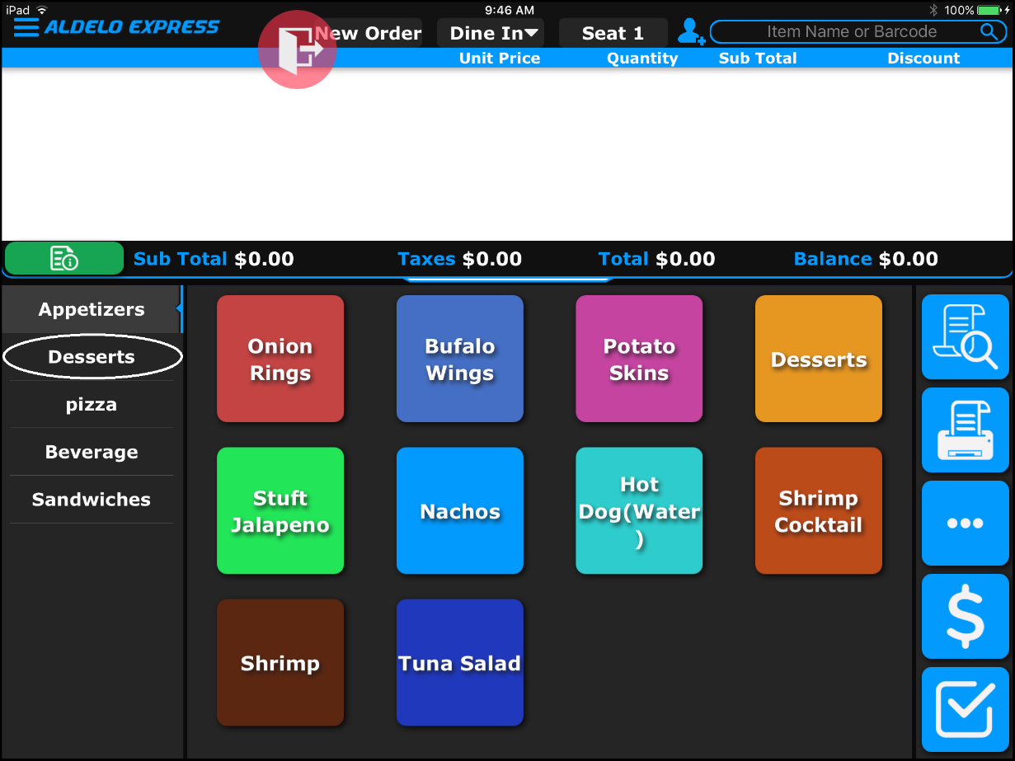
Figure 2-11

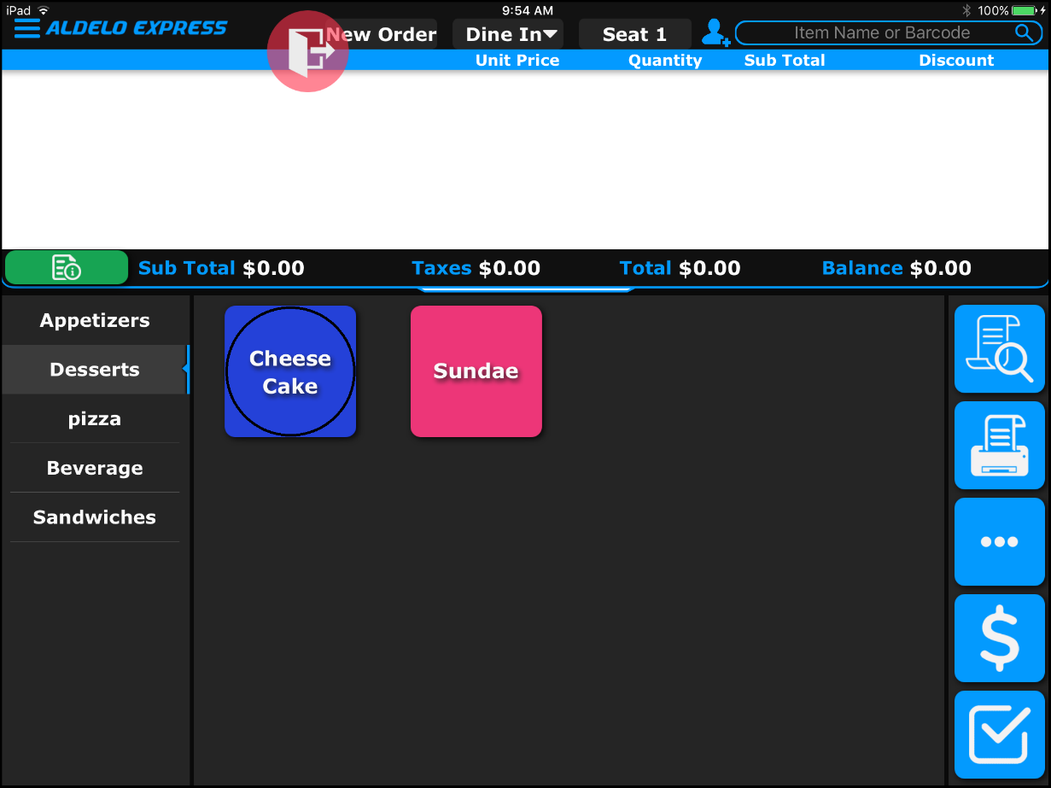
Figure 2-12

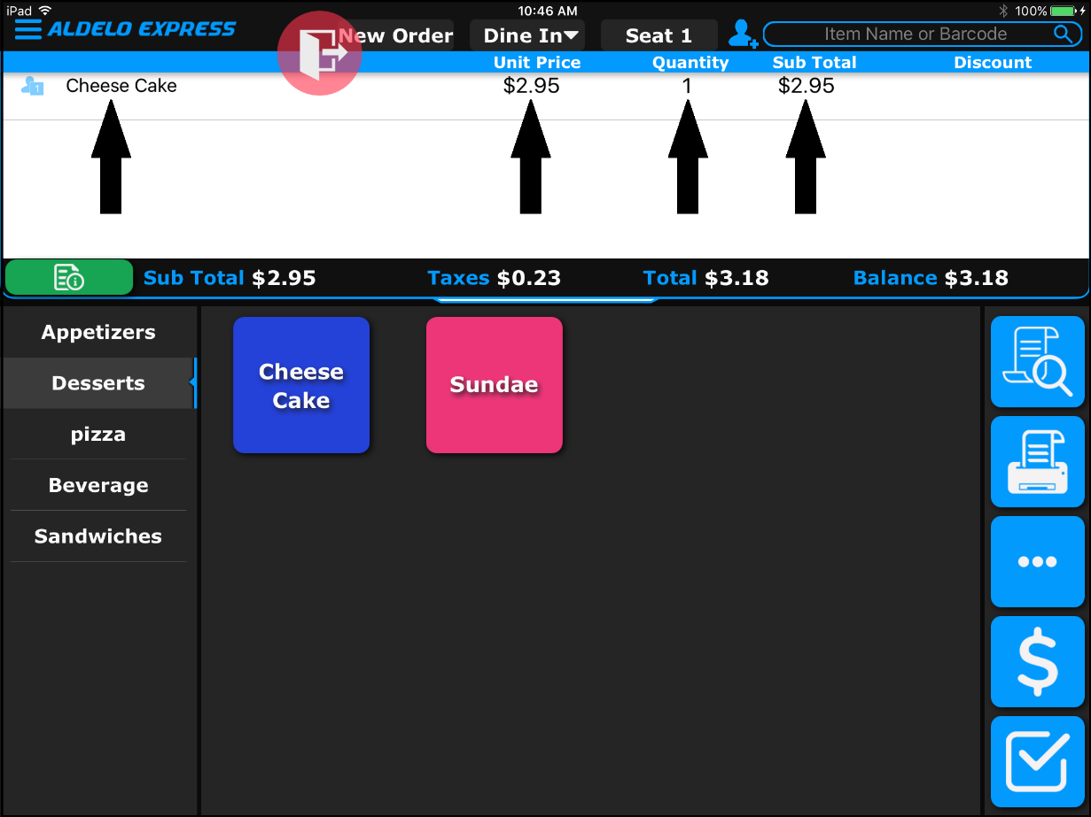
Figure 2-13

Recalling an Order

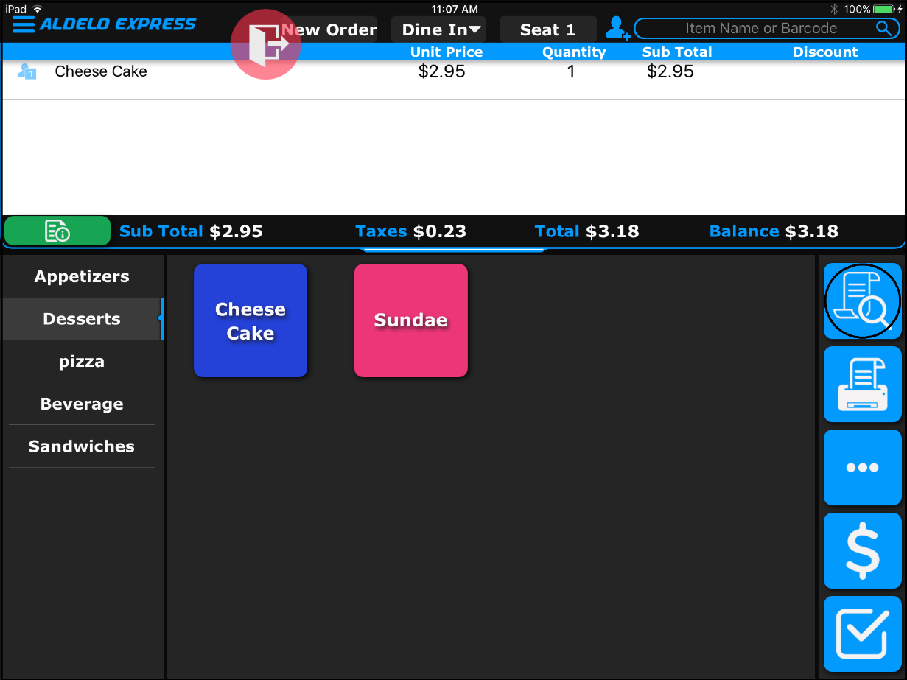
Figure 2-14

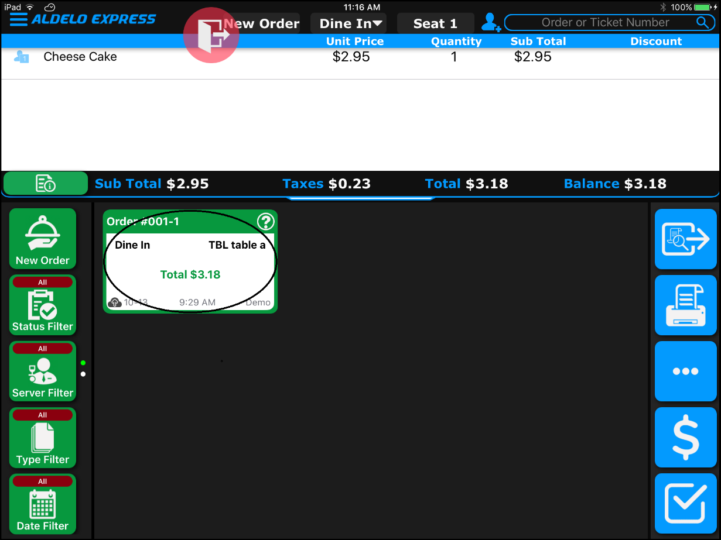
Figure 2-15

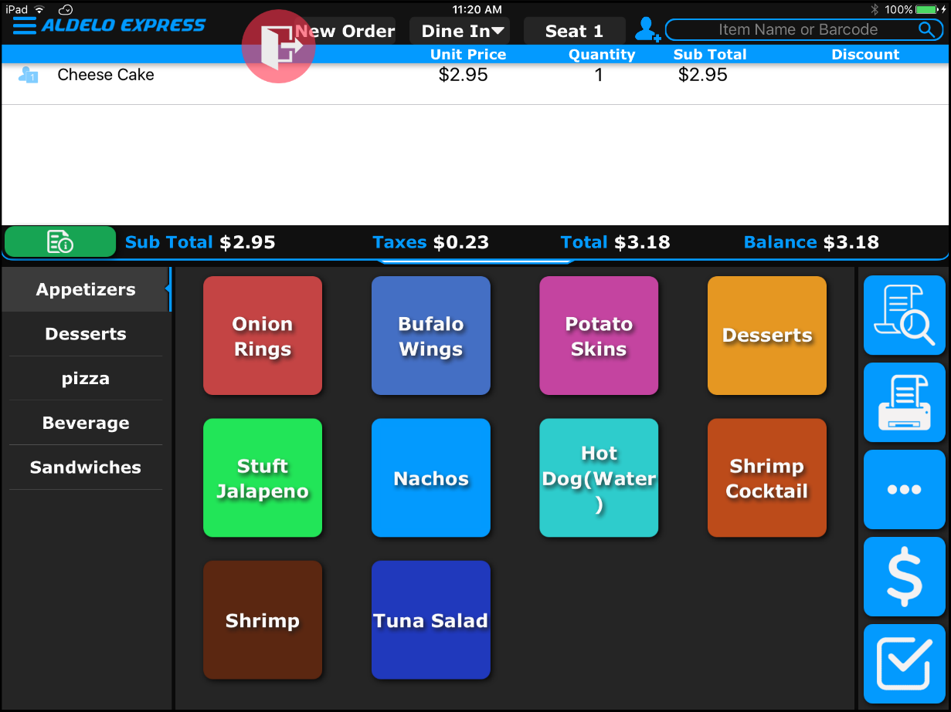
Figure 2-16

Printing an Order Receipt
This feature is not available in Demo Mode.

Miscellaneous Features

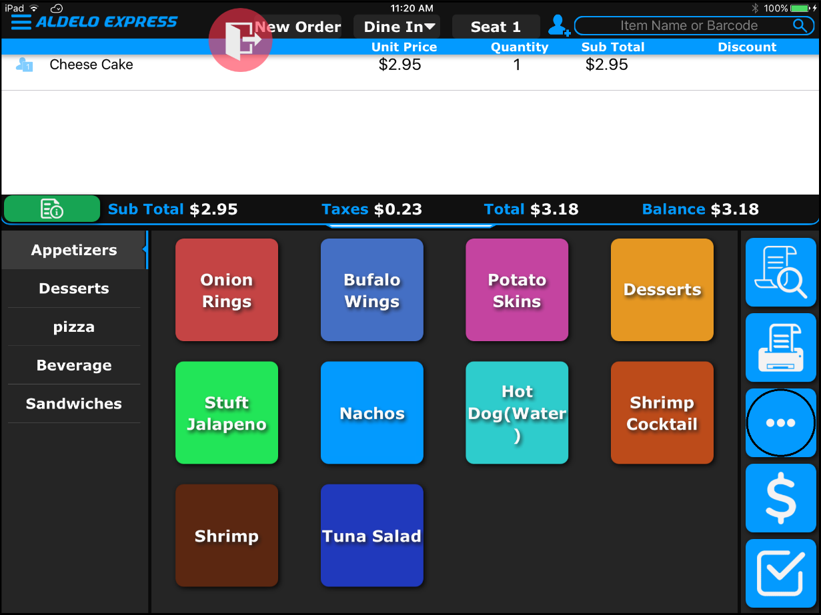
Figure 2-17

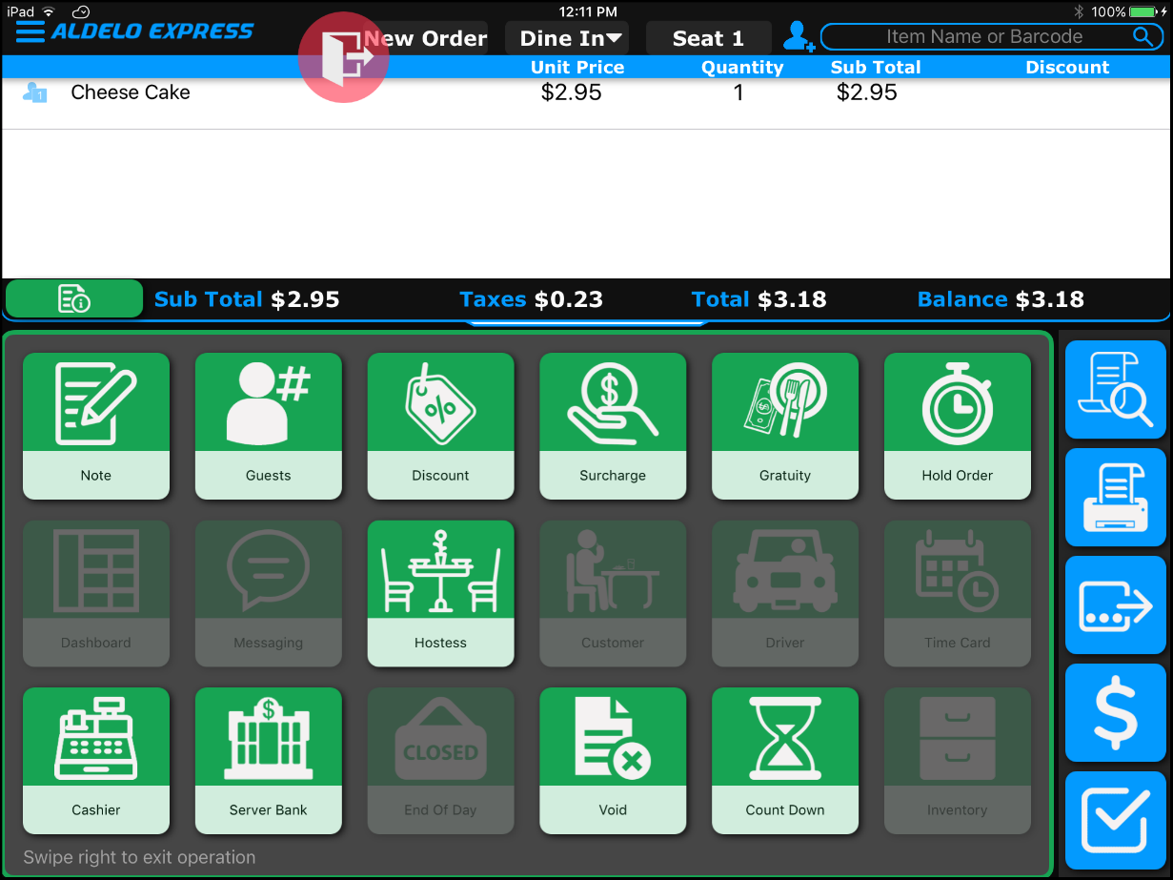
Figure 2-18

Settling an Order

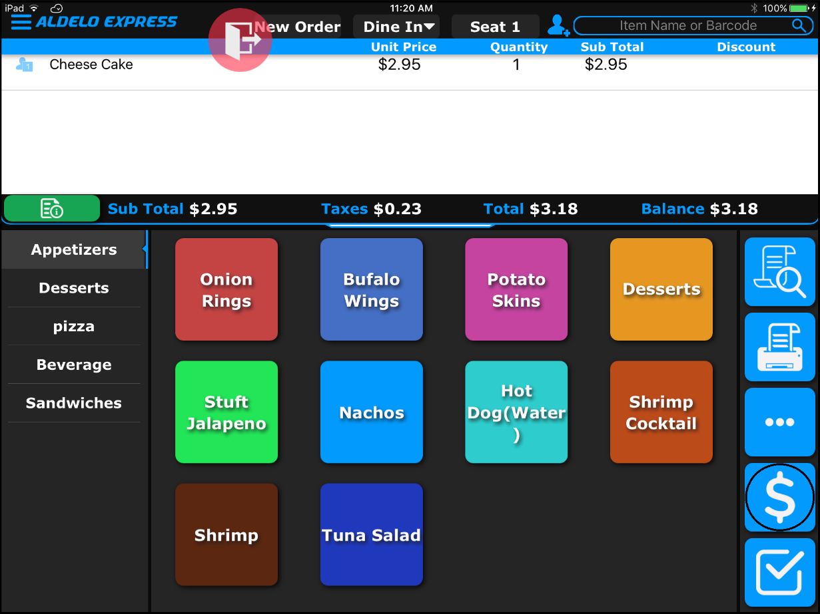
Figure 2-19

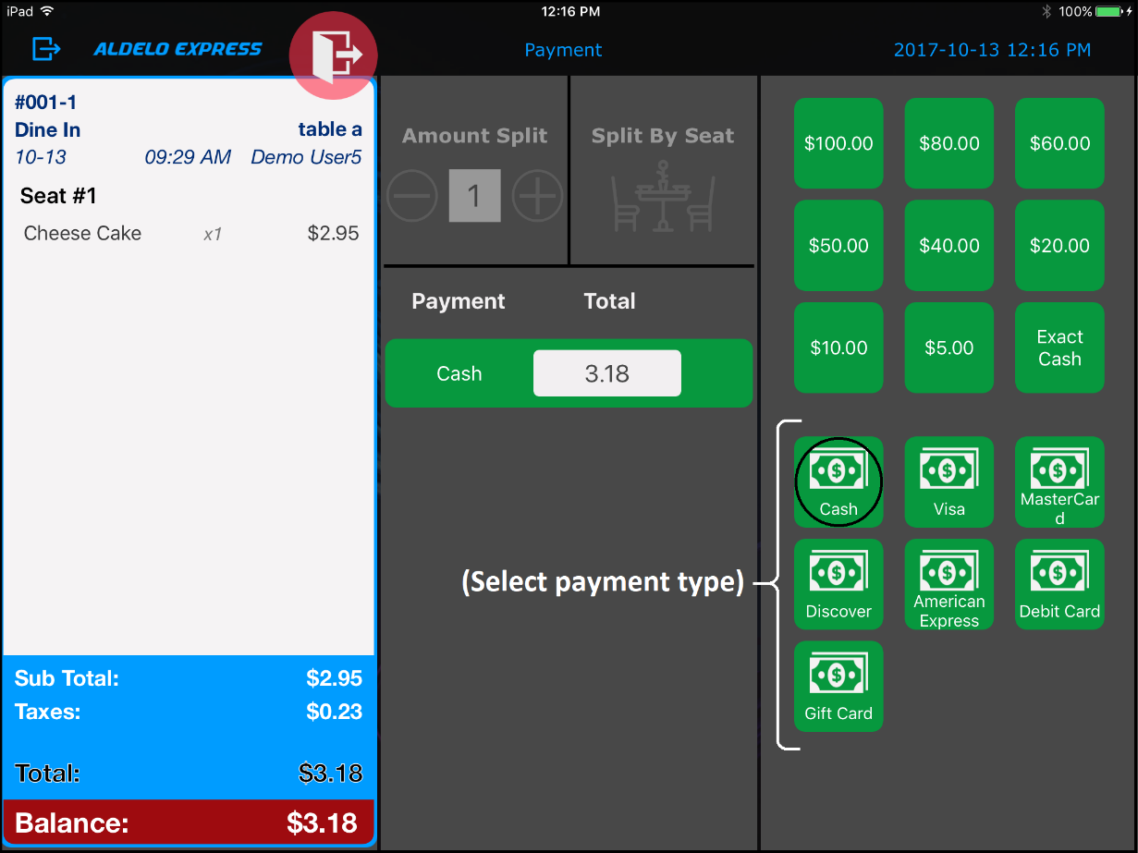
Figure 2-20

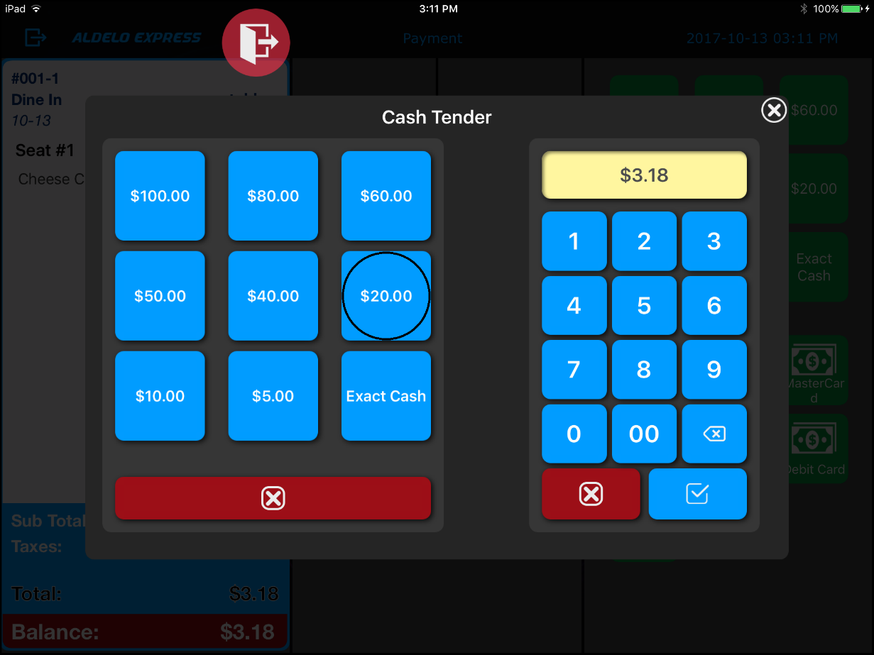
Figure 2-21

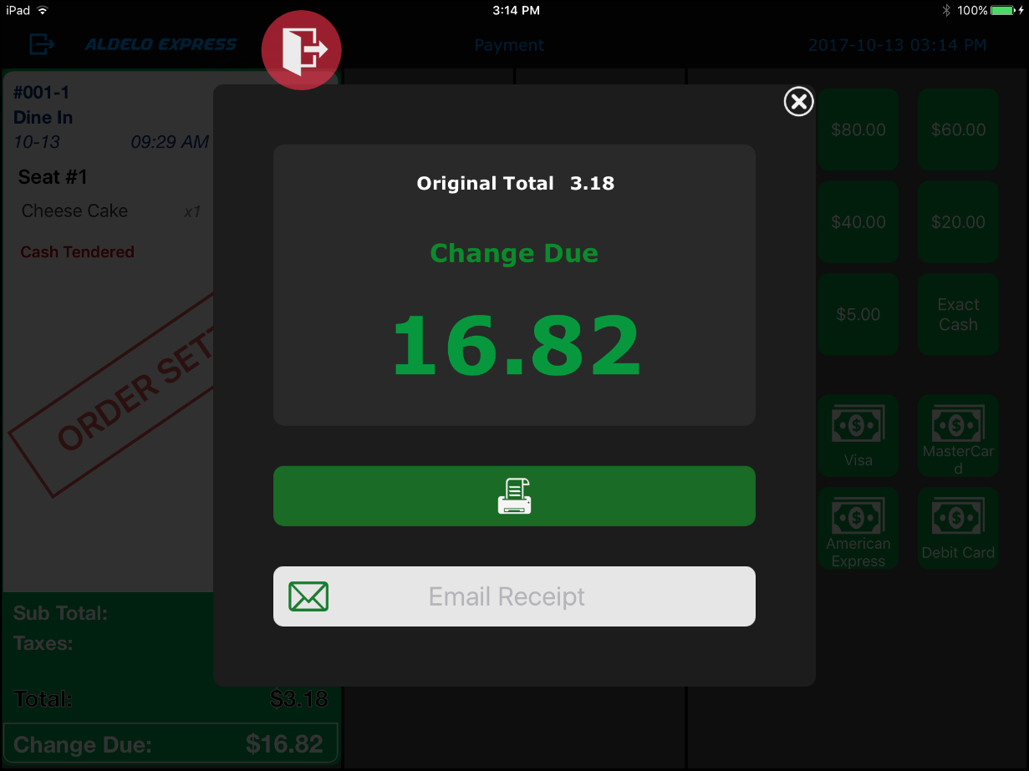
Figure 2-22

Exiting the Order Entry Screen

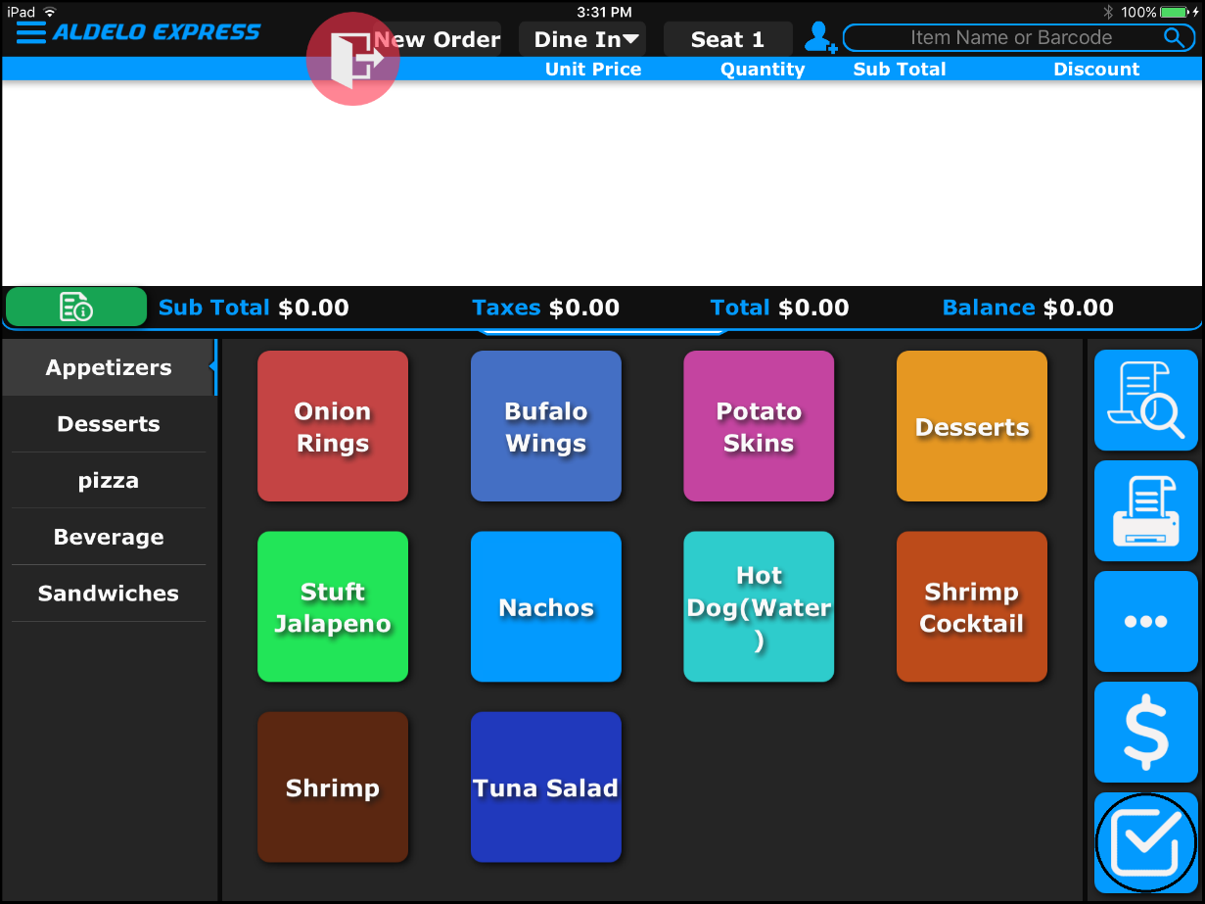
Figure 2-23

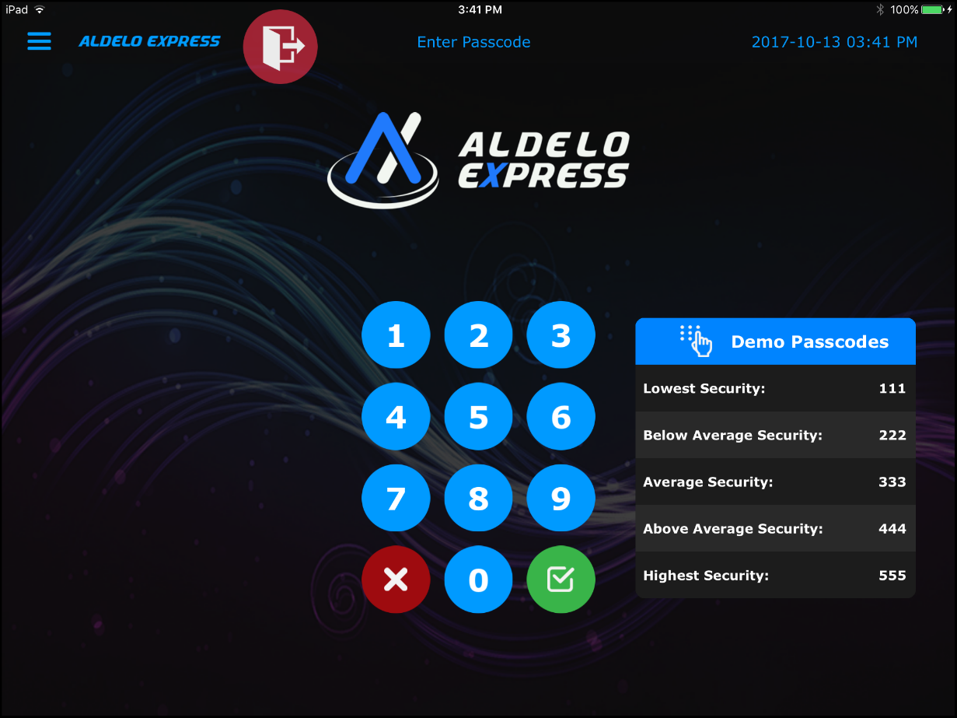
Figure 2-24

Stores

Creating a Store

General Settings

Figure 3-1

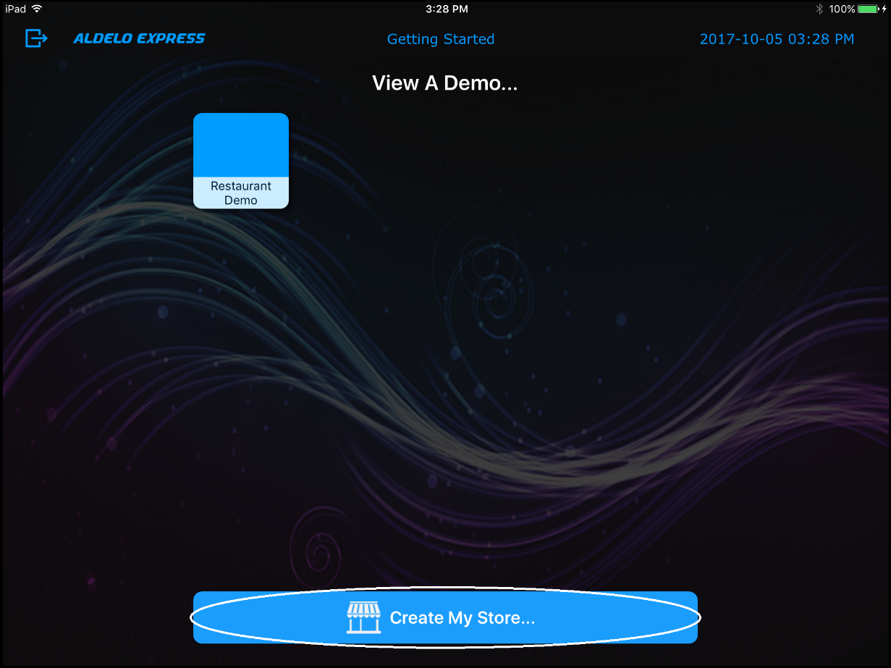
Figure 3-2

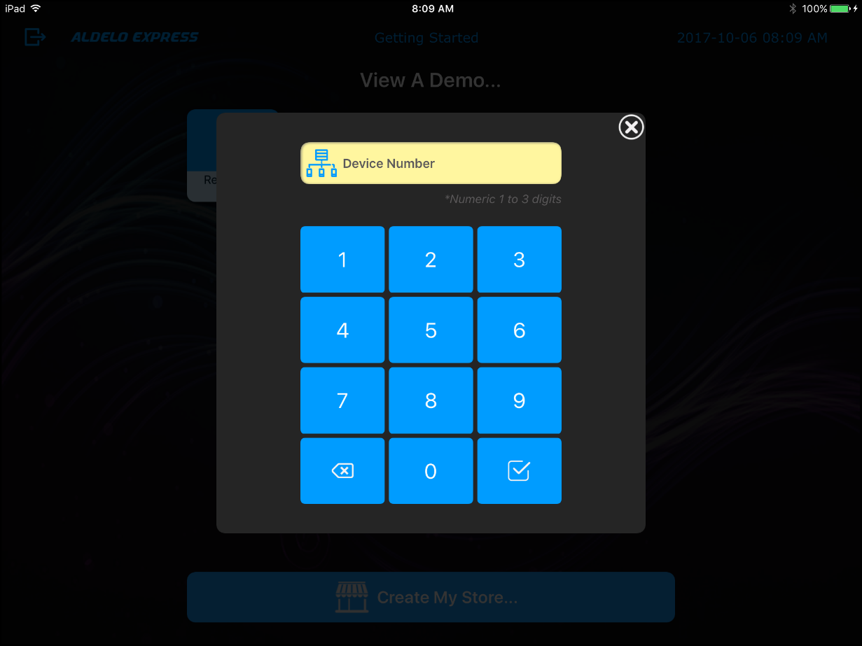
Figure 3-3

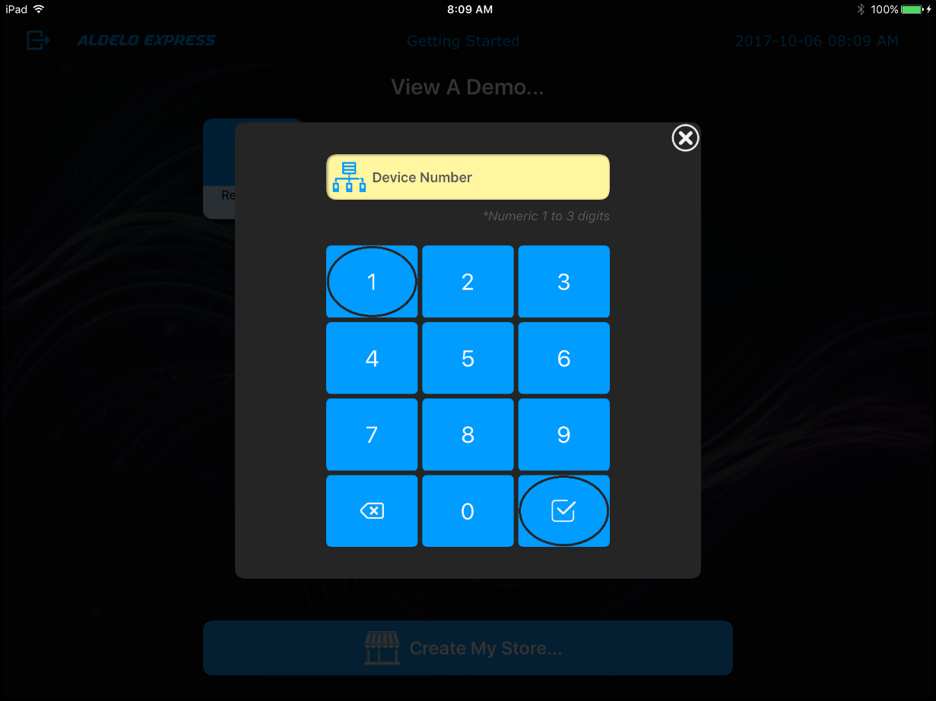
Figure 3-4

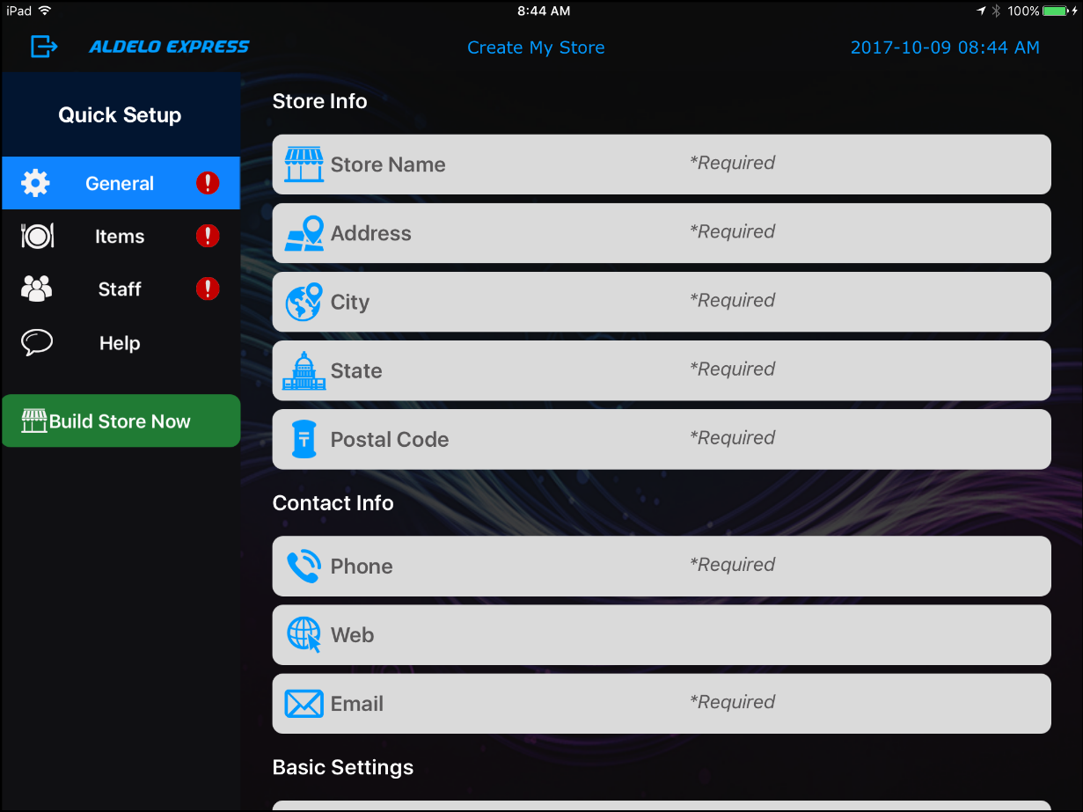
Figure 3-5

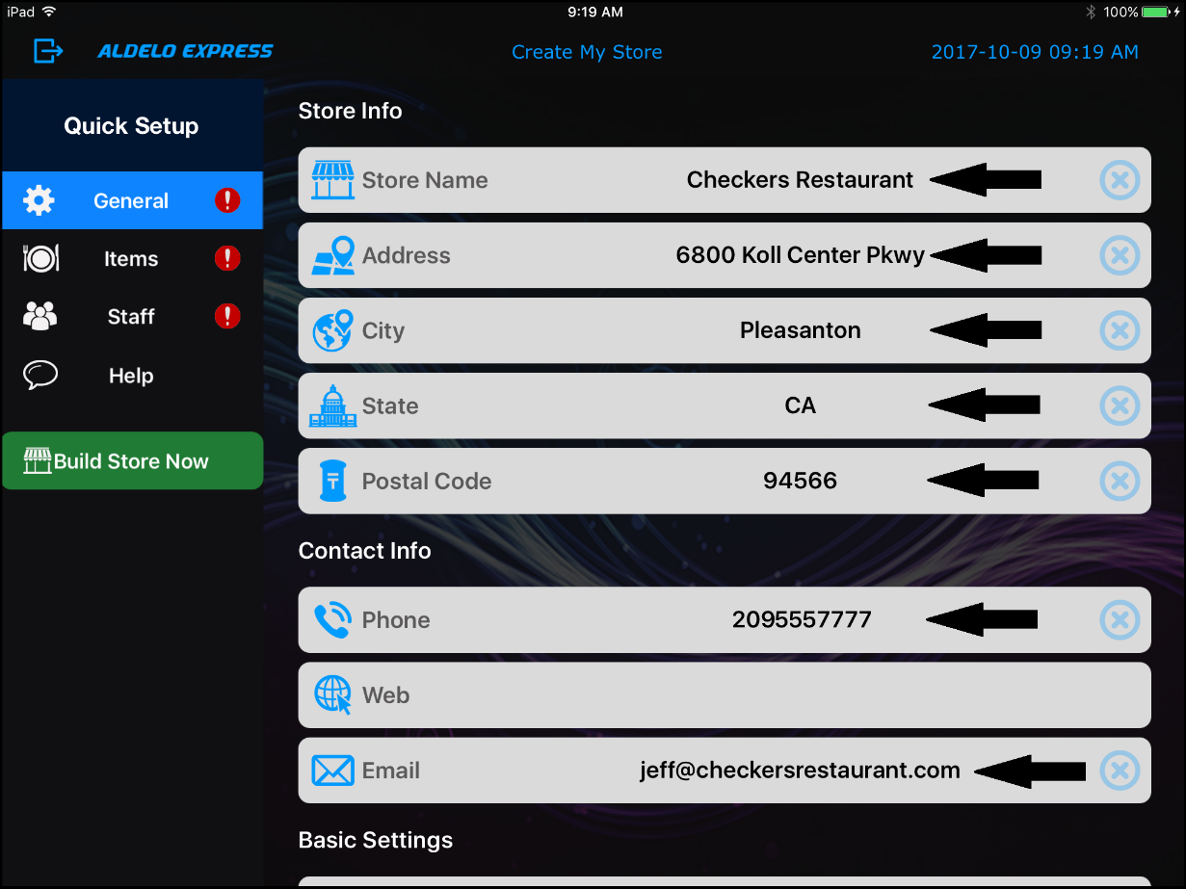
Figure 3-6

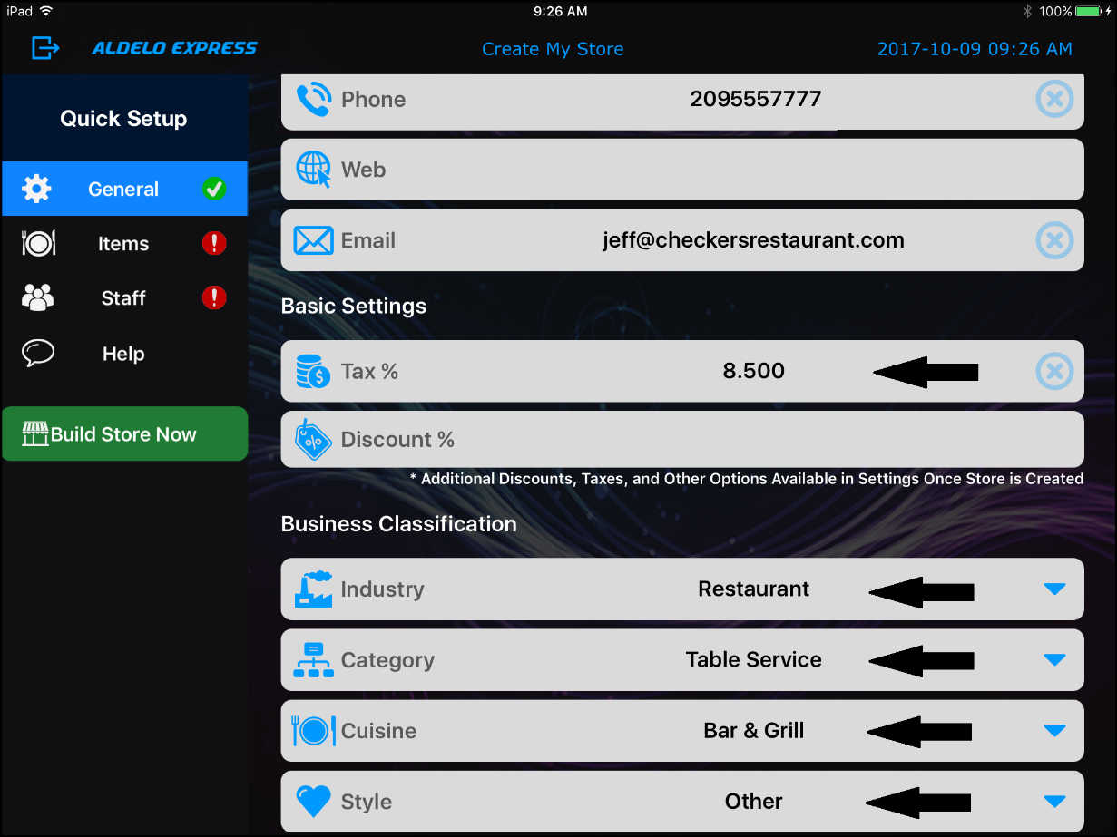
Figure 3-7

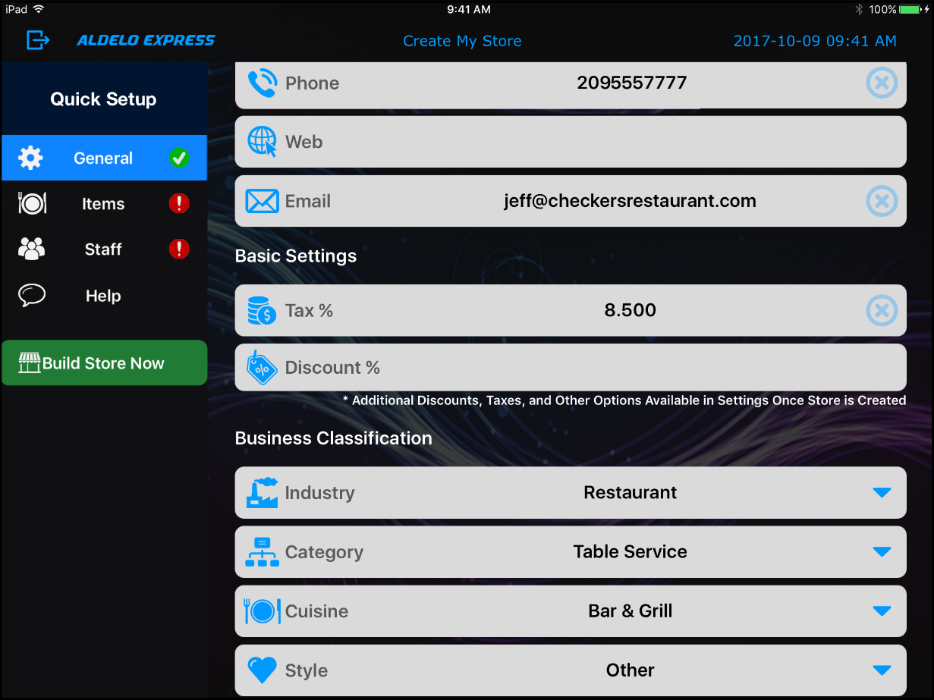
Figure 3-8

Items Settings

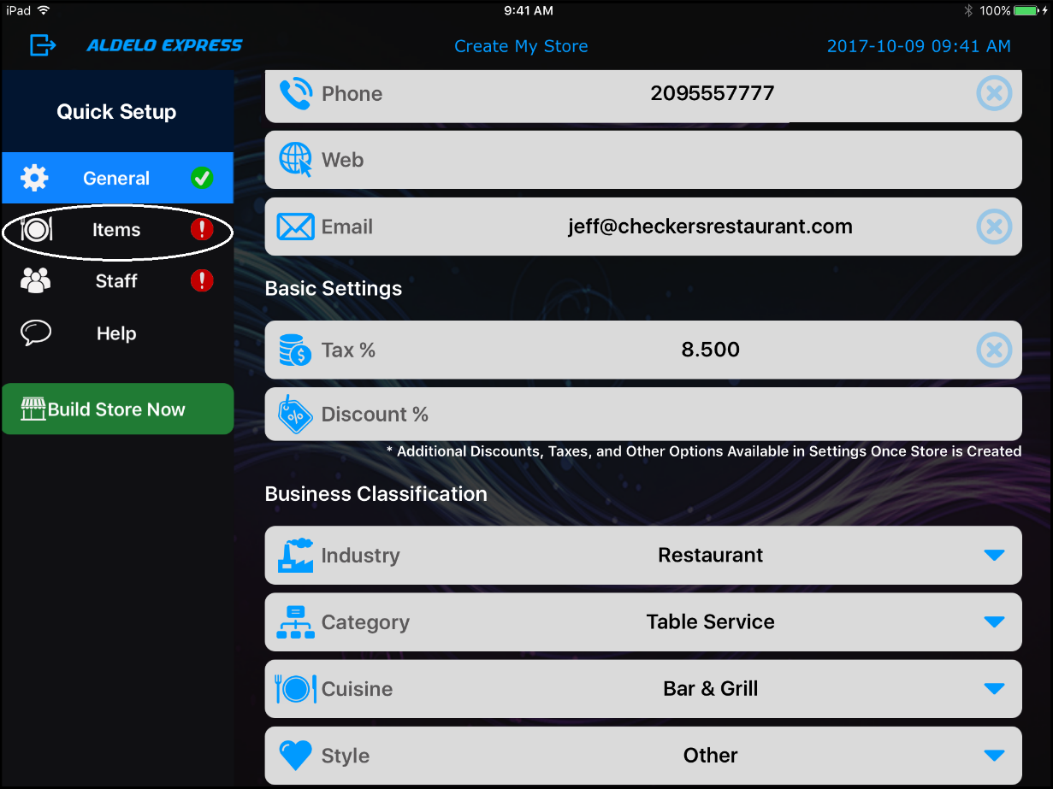
Figure 3-9

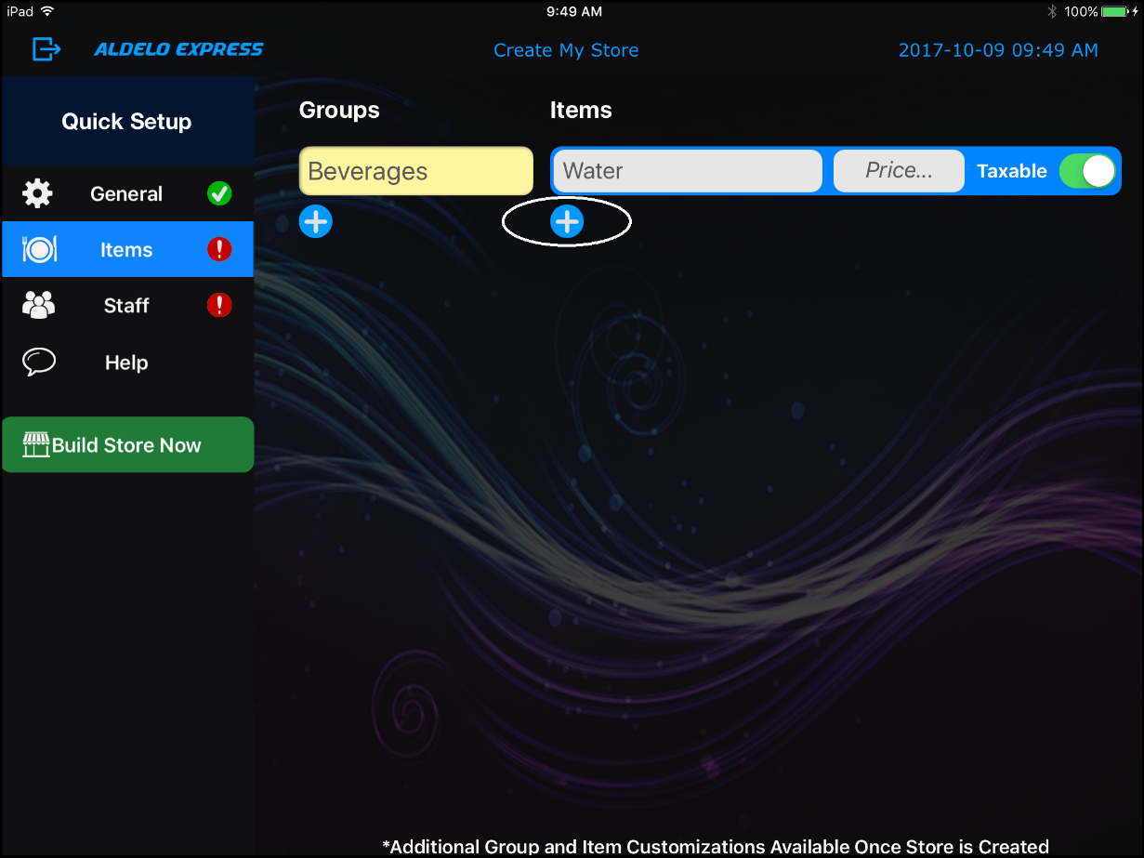
Figure 3-10

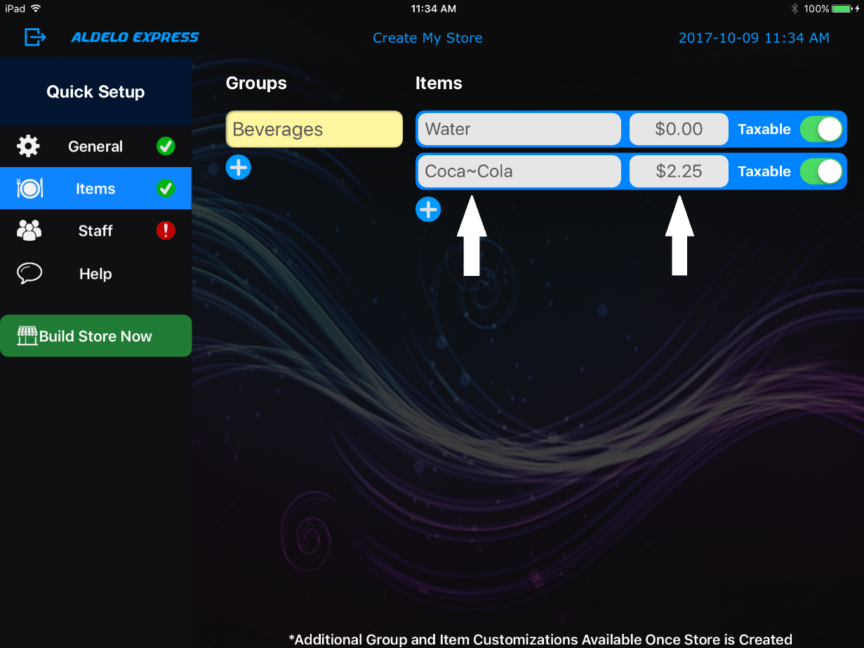
Figure 3-11

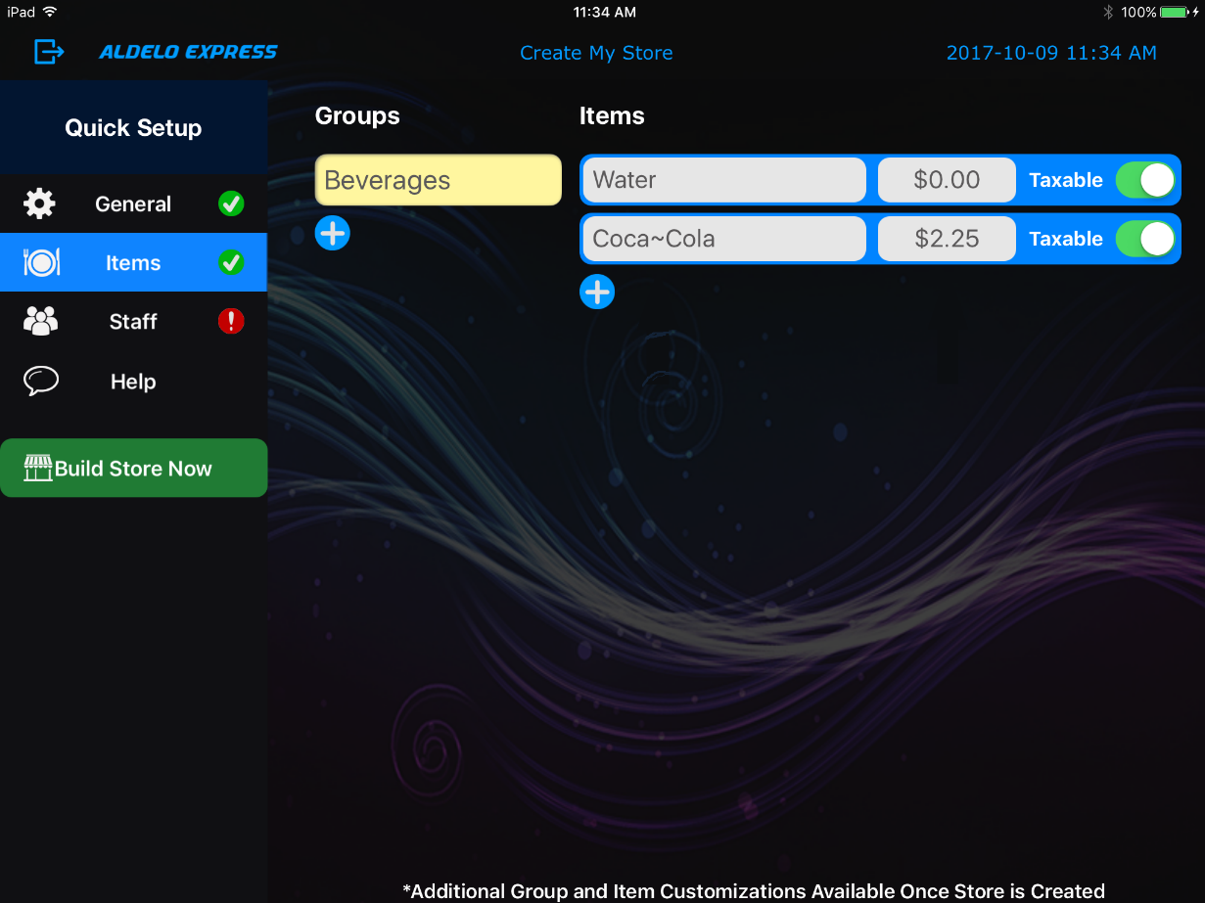
Figure 3-12

Staff Settings

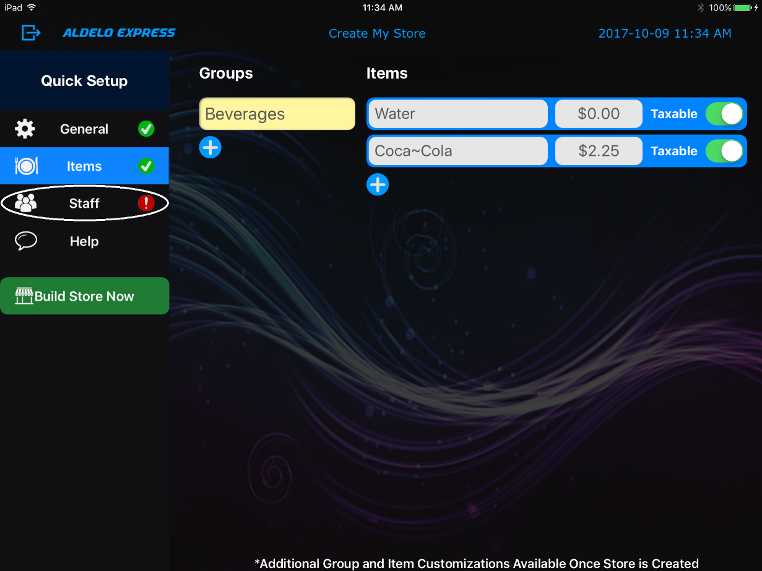
Figure 3-13

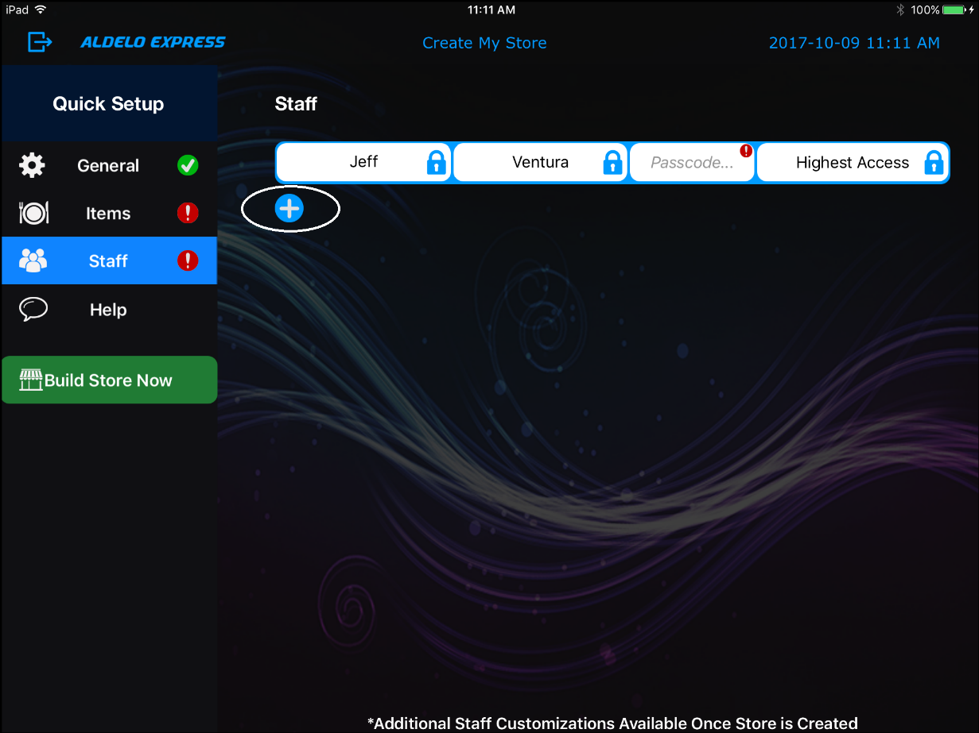
Figure 3-14

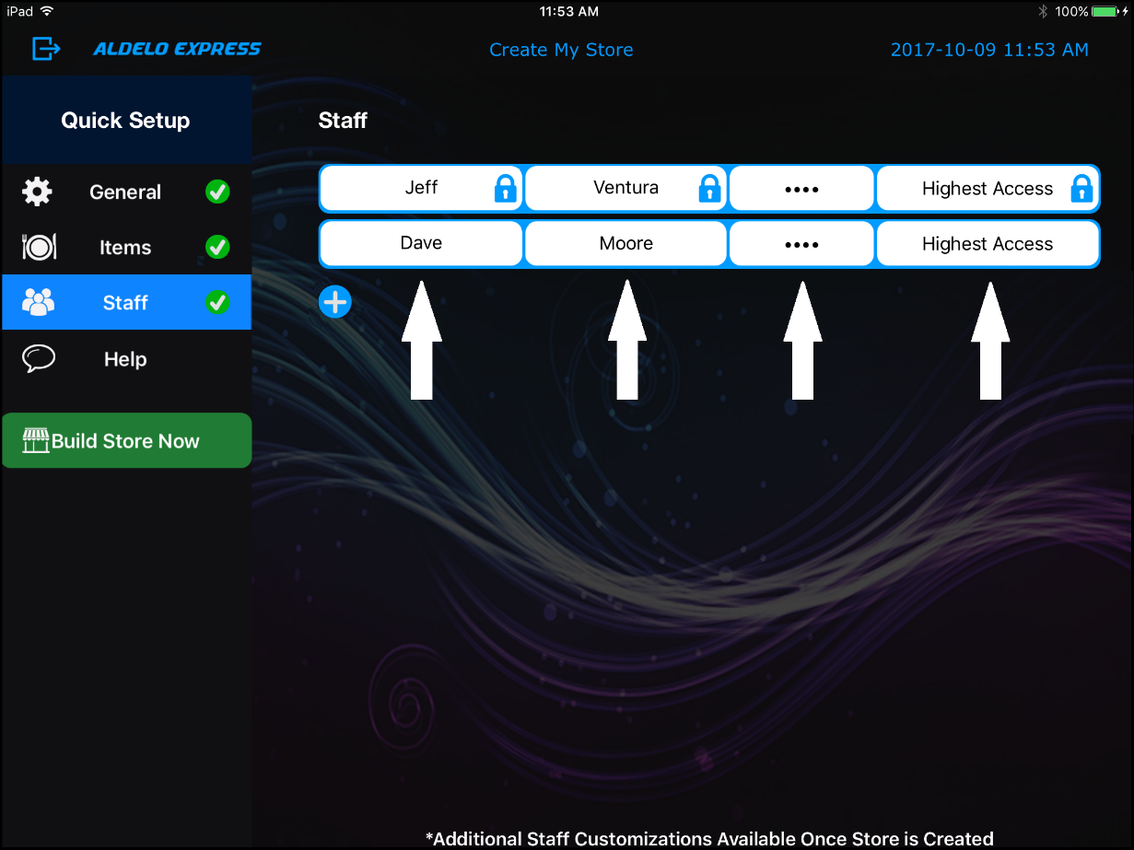
Figure 3-15

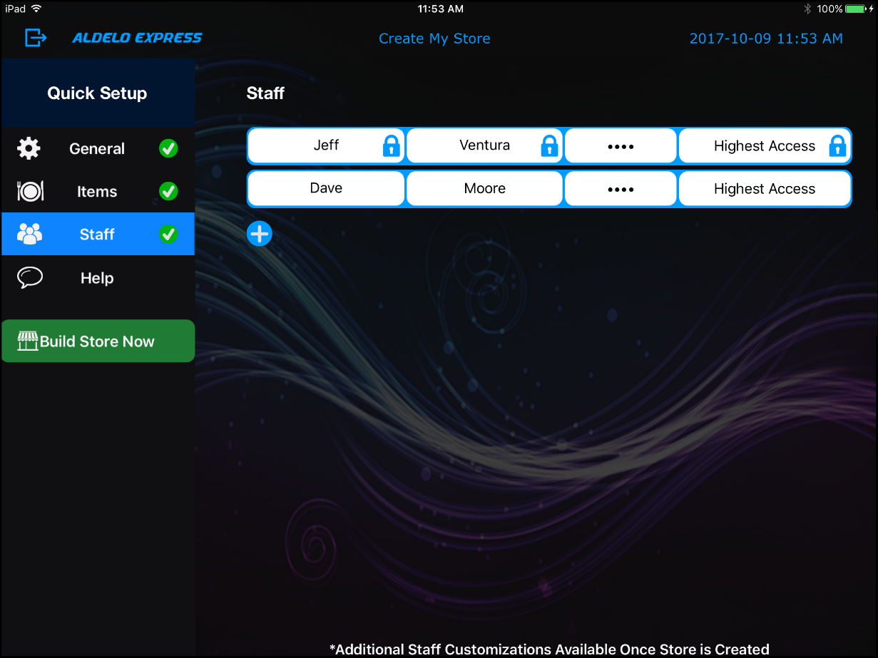
Figure 3-16

Building Your Store

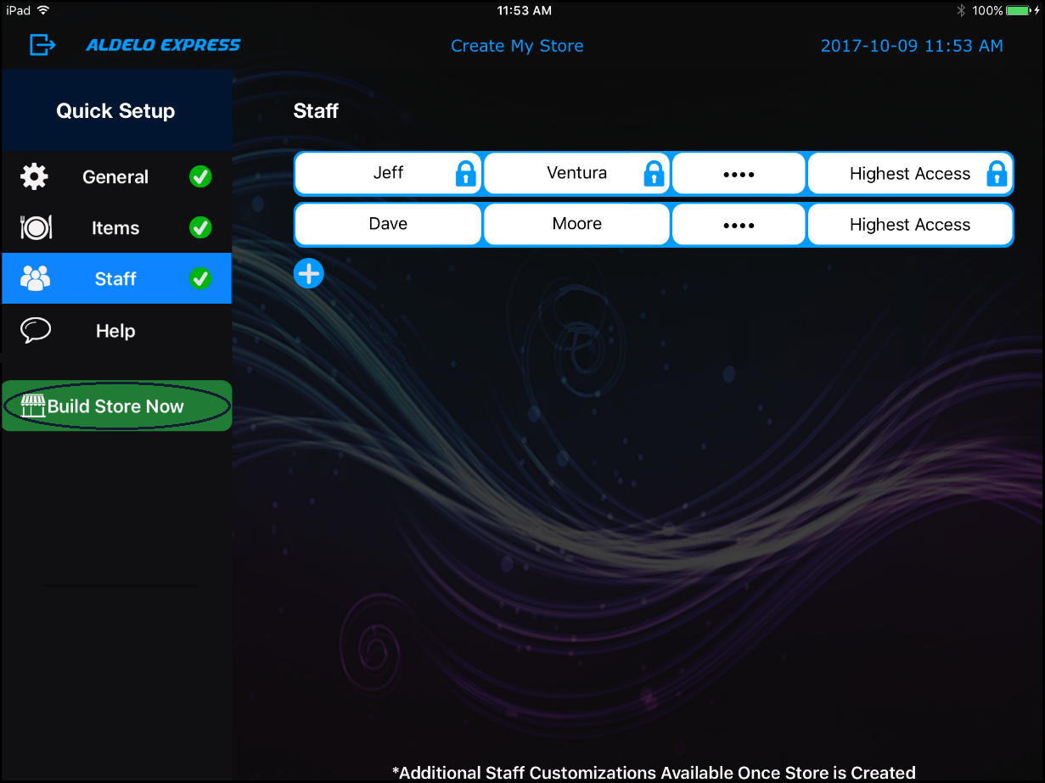
Figure 3-17

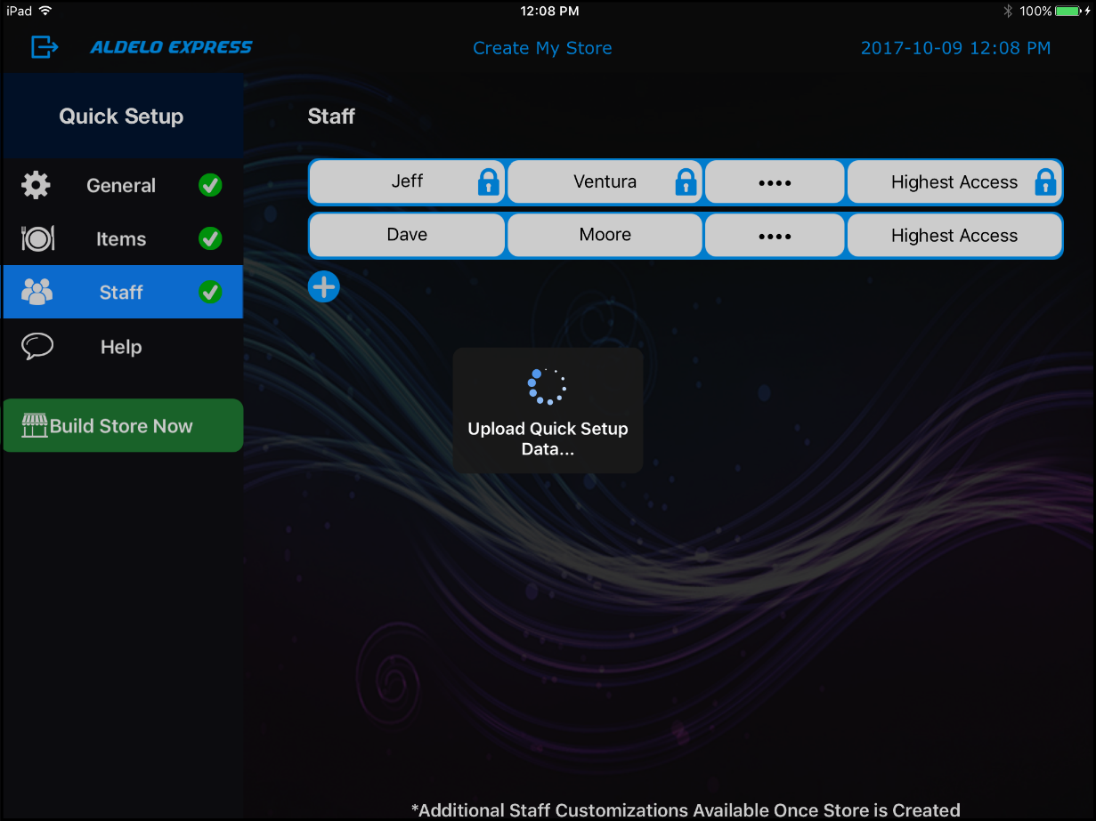
Figure 3-18

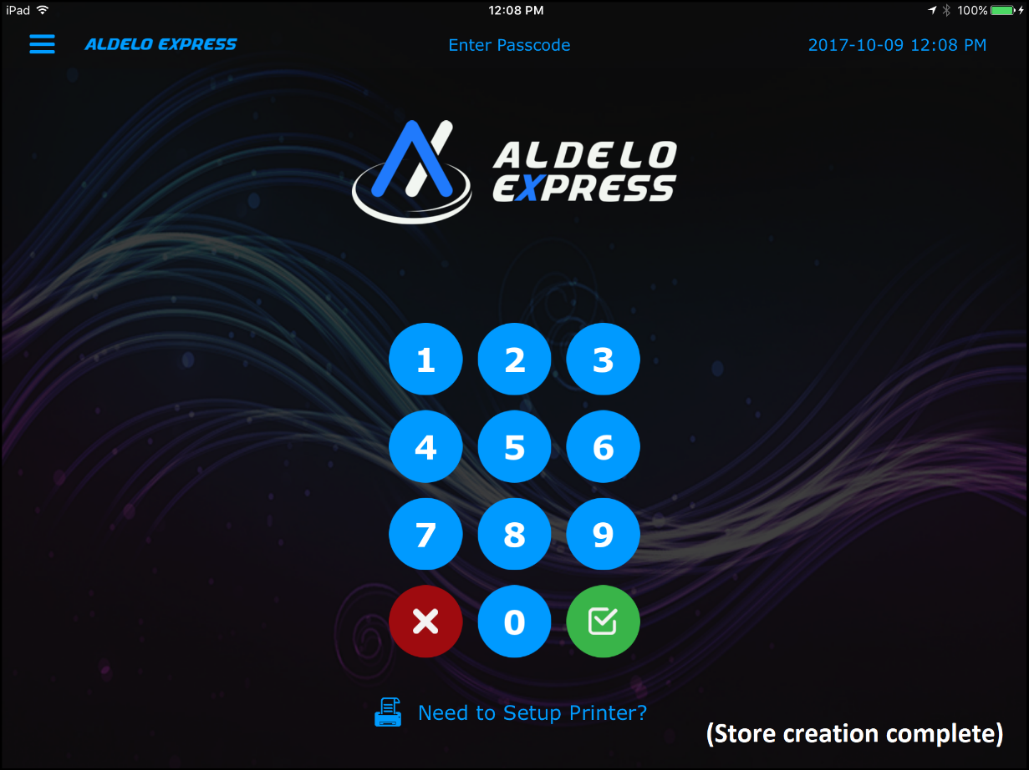
Figure 3-19

Activating a Device

Figure 3-20

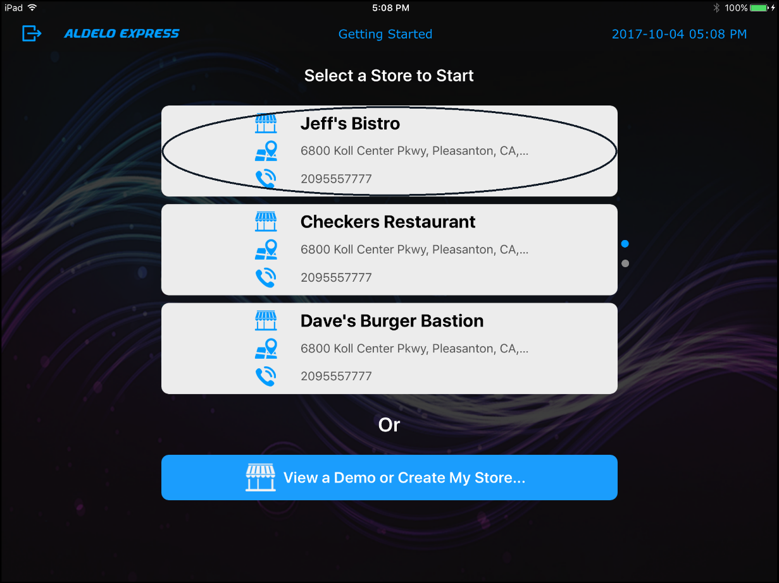
Figure 3-21

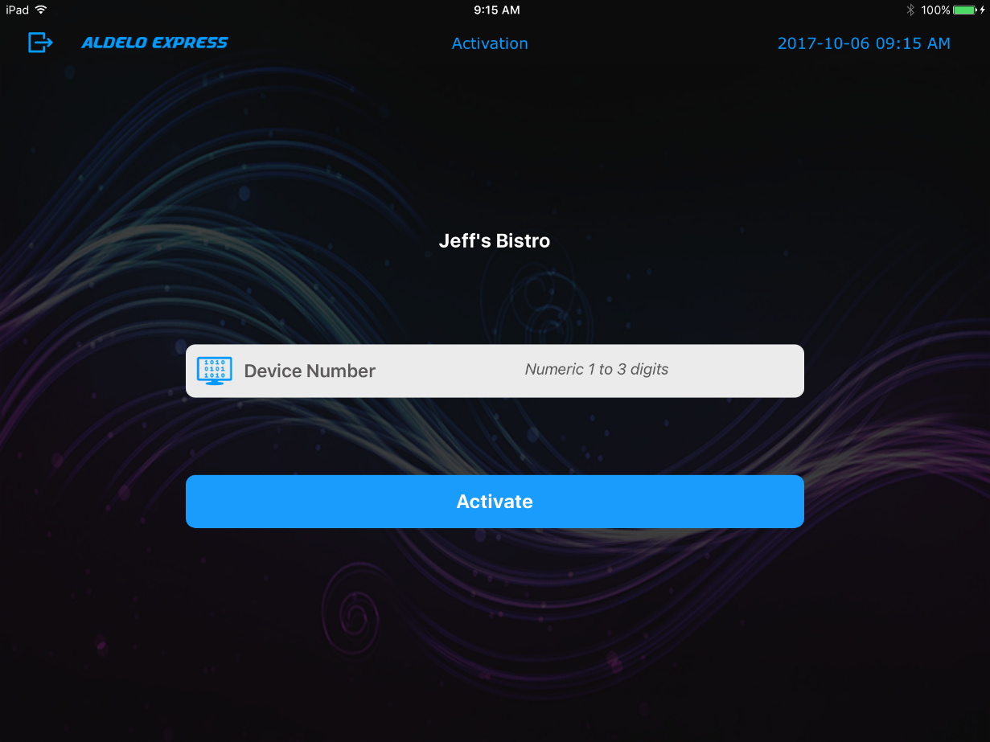
Figure 3-22

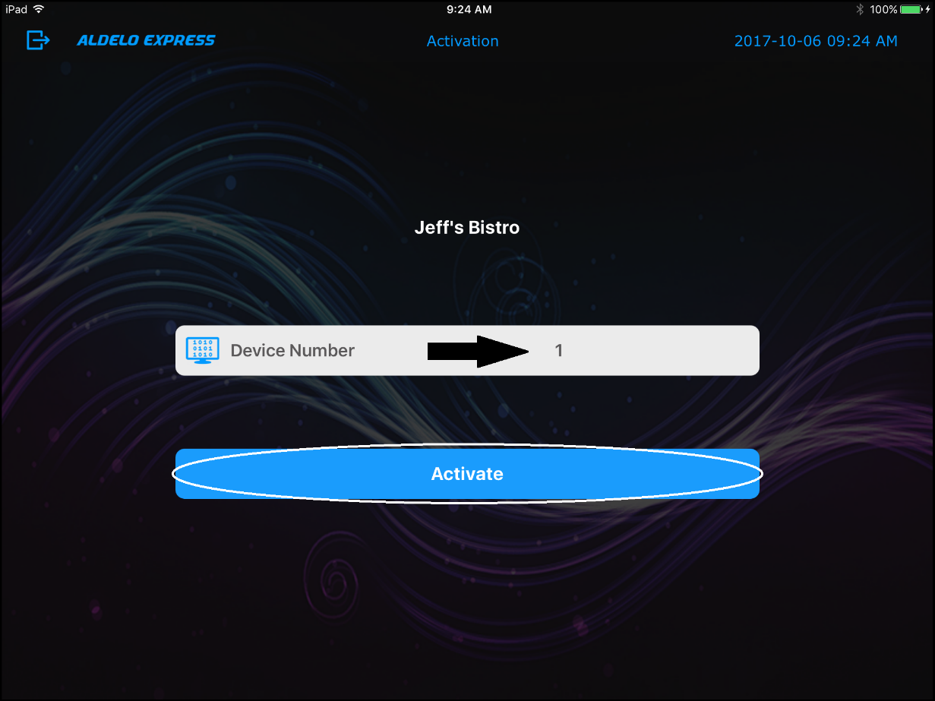
Figure 3-23

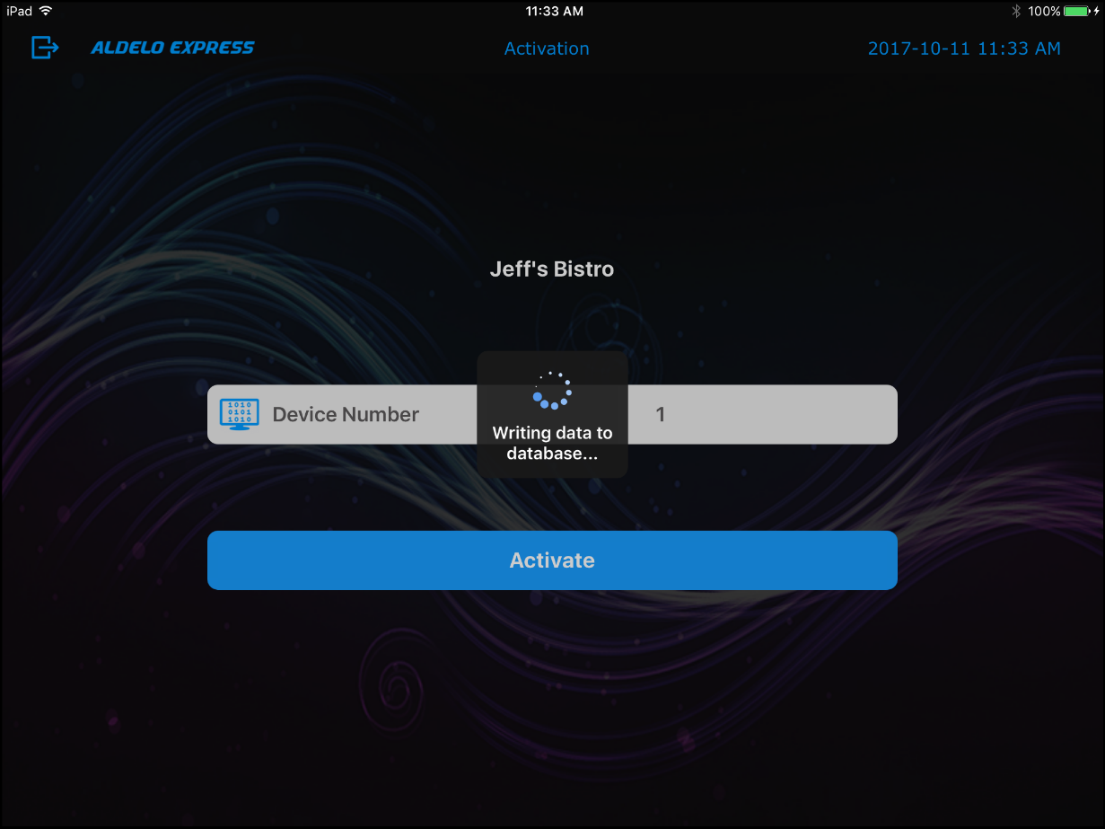
Figure 3-24

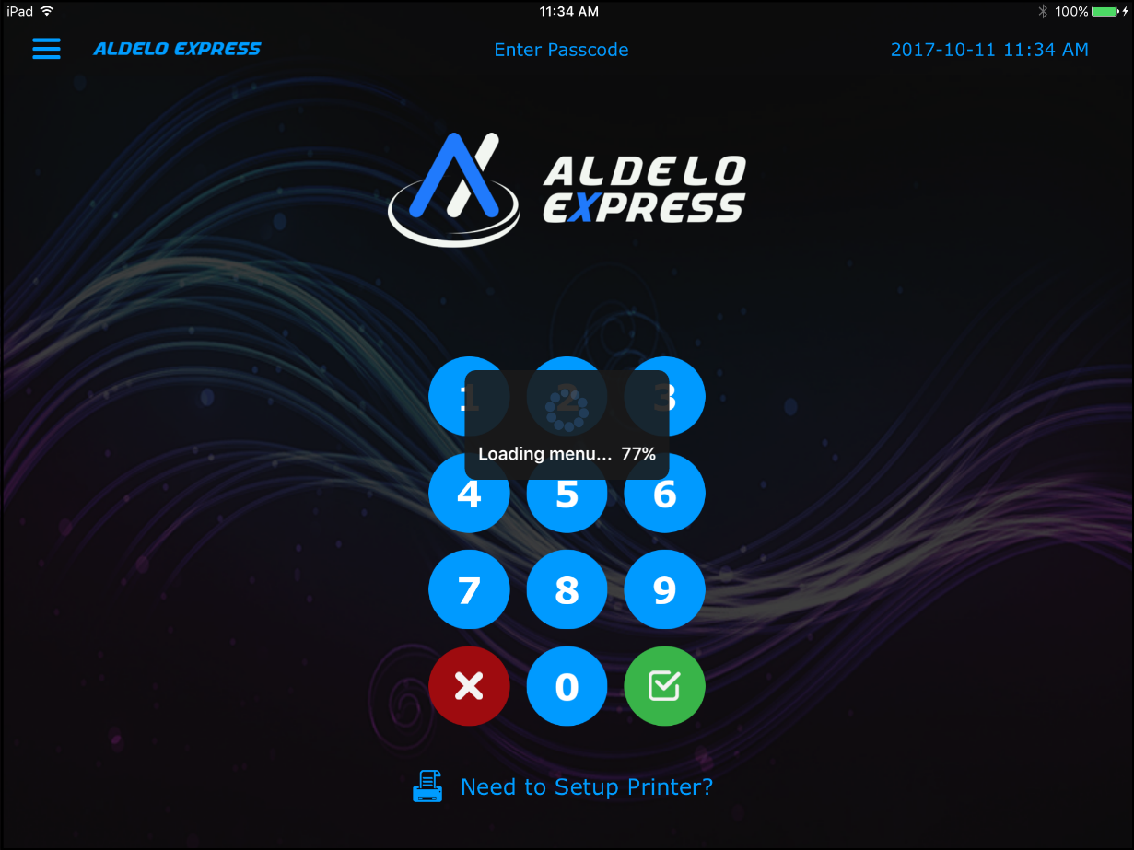
Figure 3-25

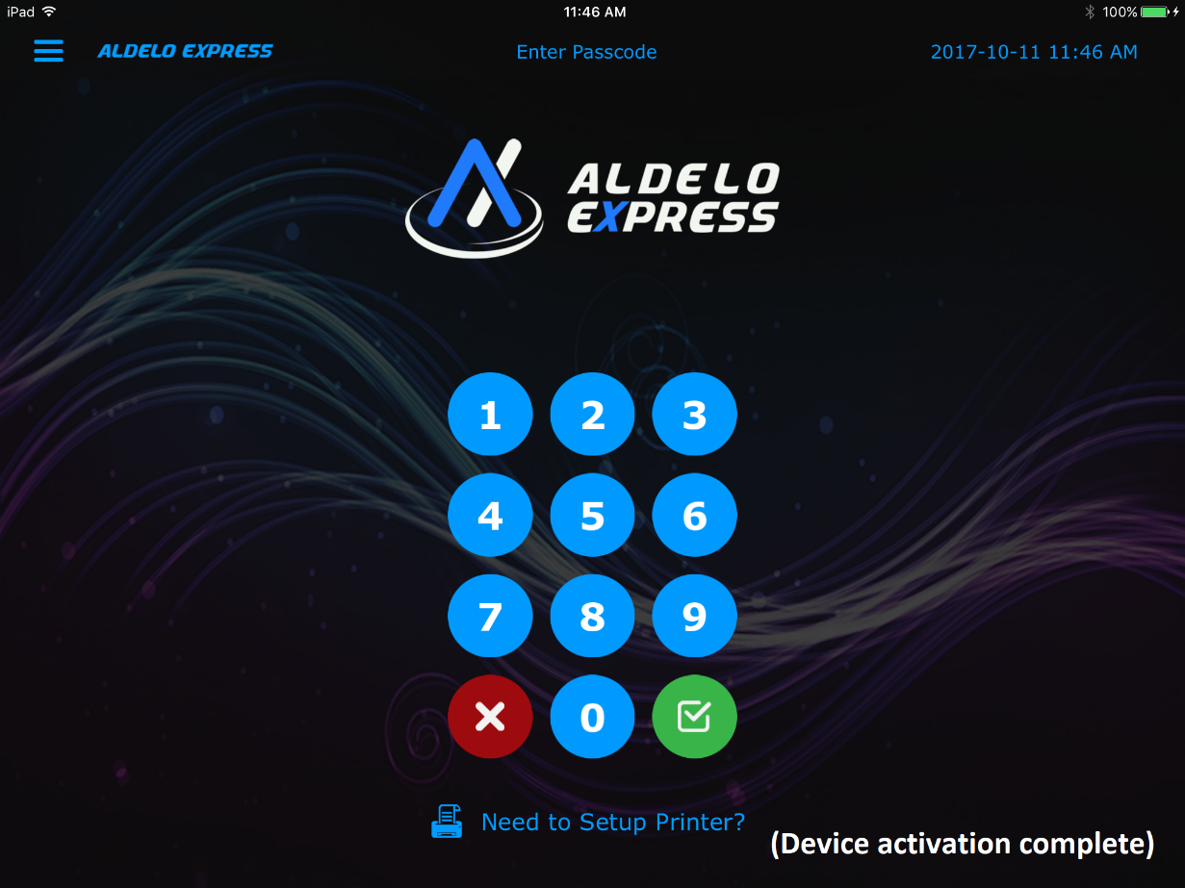
Figure 3-26

Customer Orders

Creating a New Order

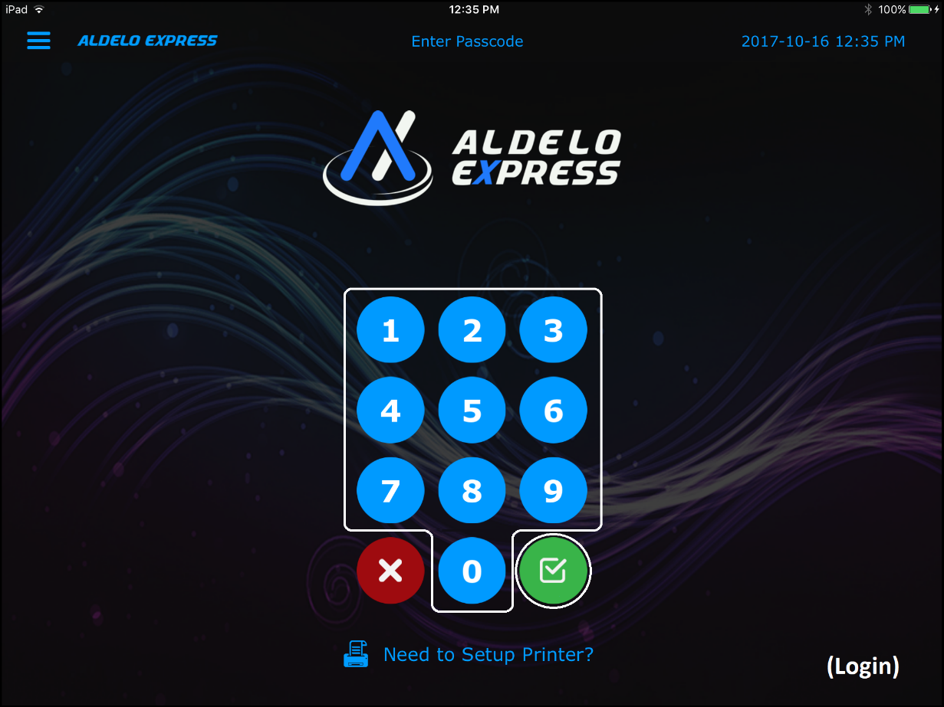
Figure 4-1

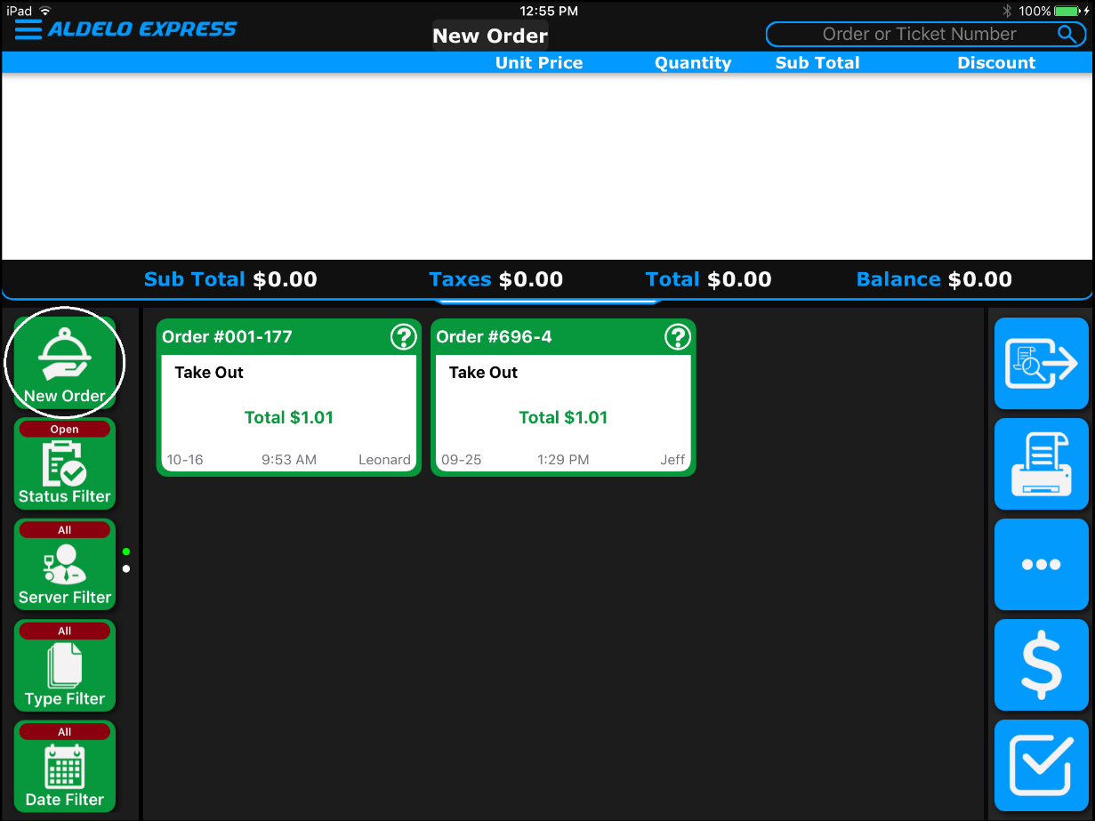
Figure 4-2

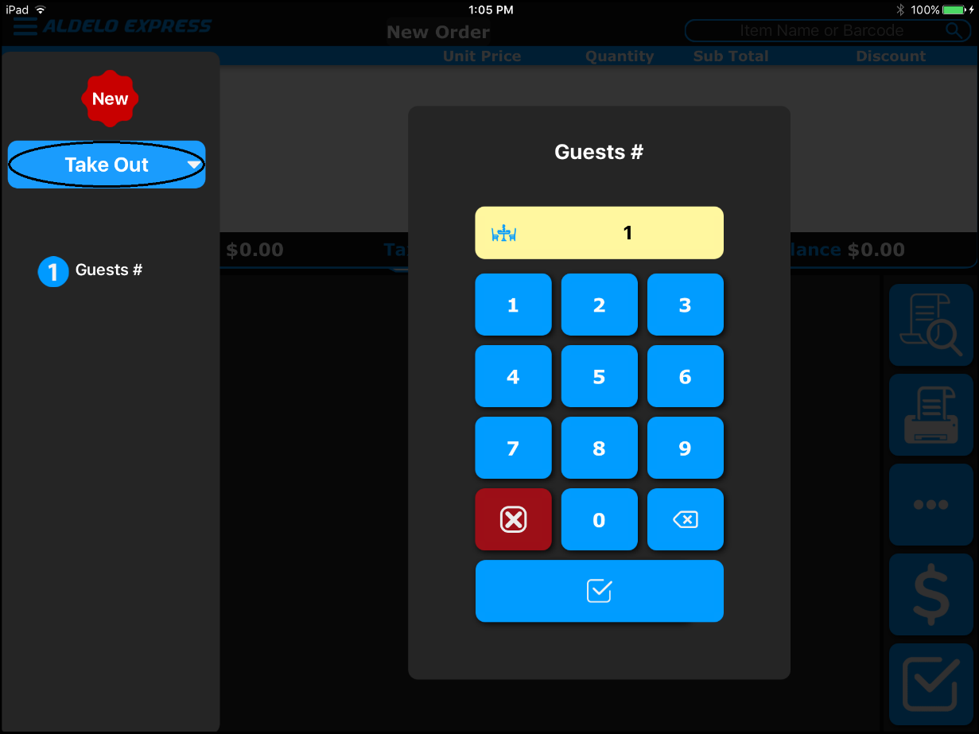
Figure 4-3

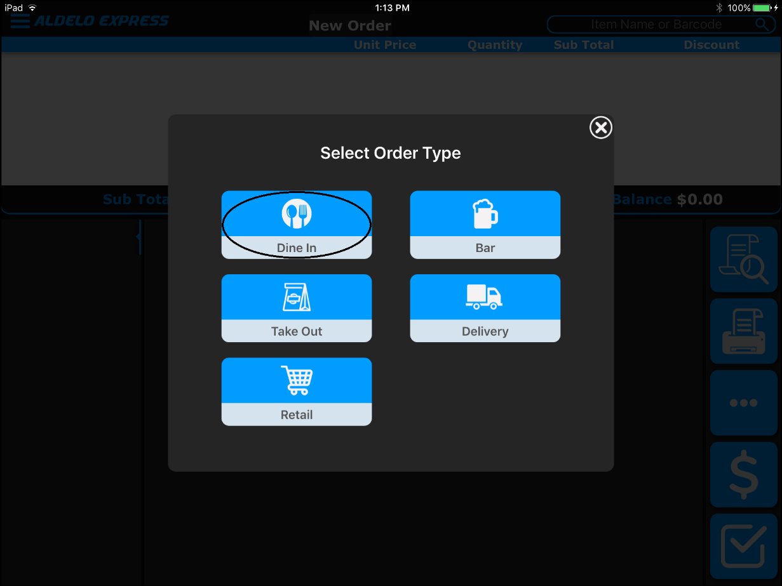
Figure 4-4

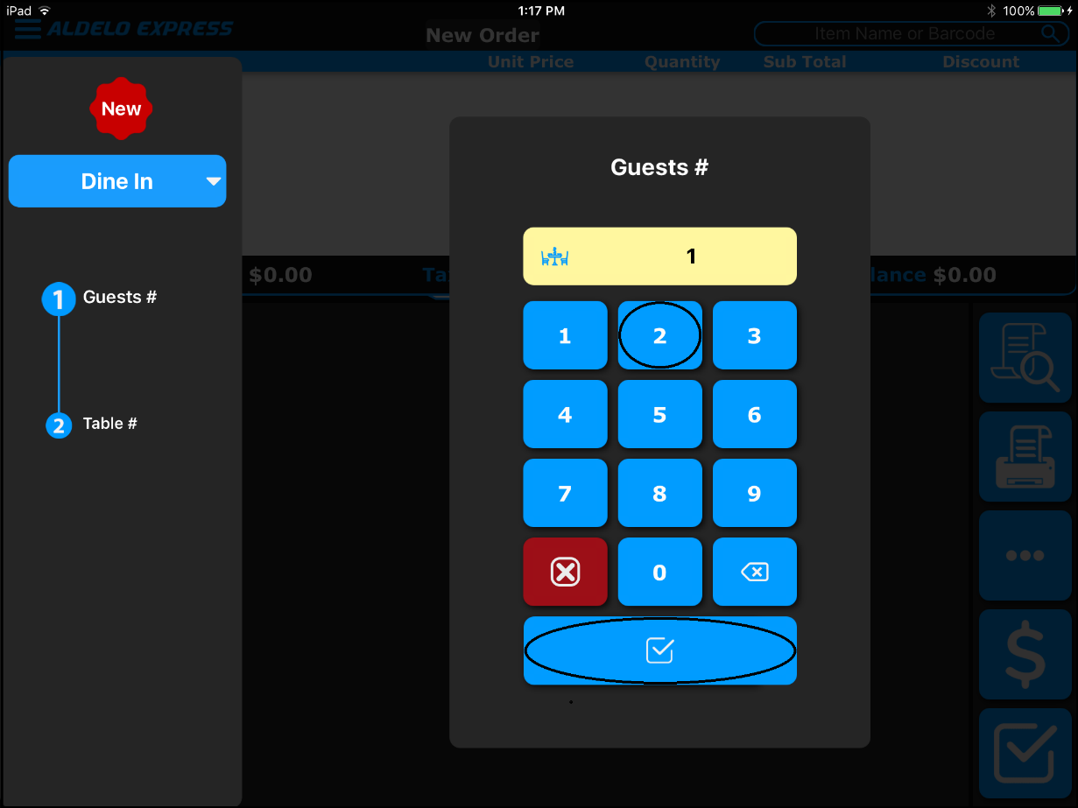
Figure 4-5

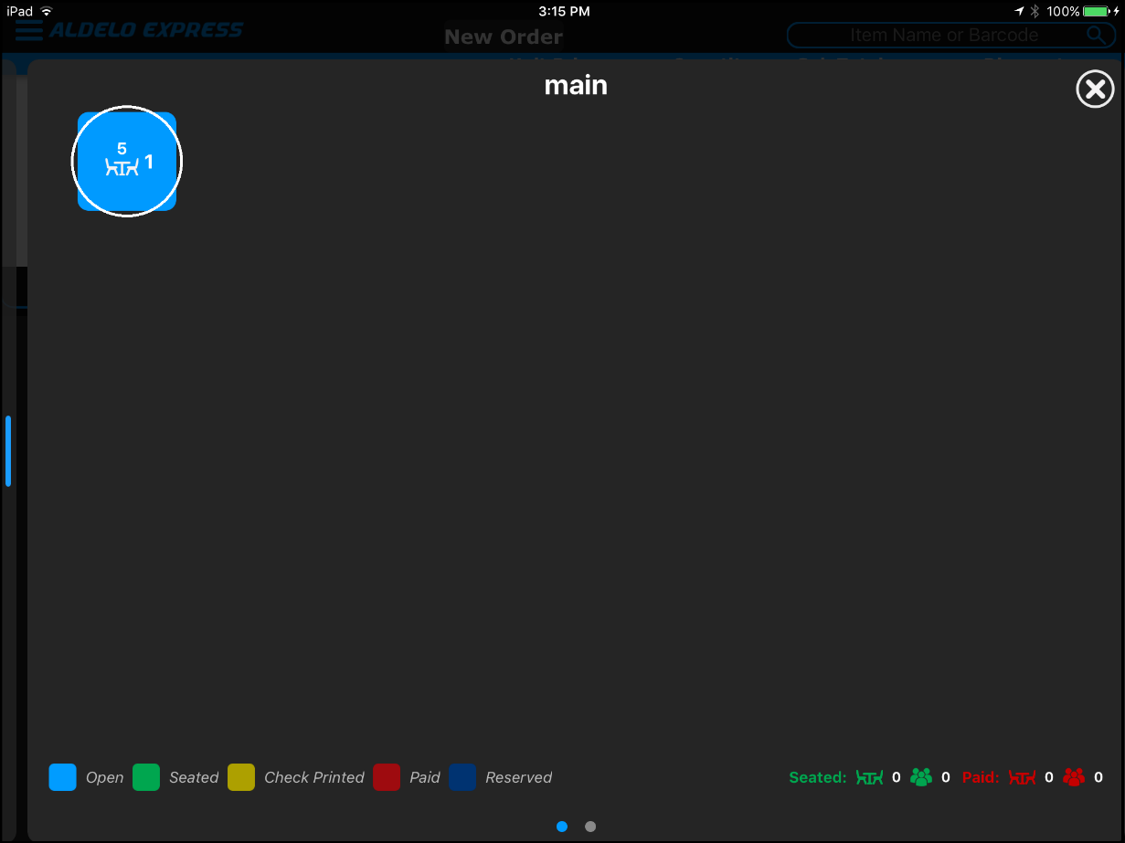
Figure 4-6

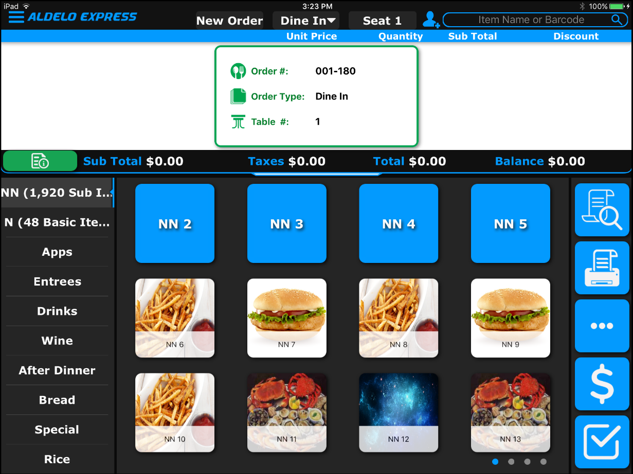
Figure 4-7

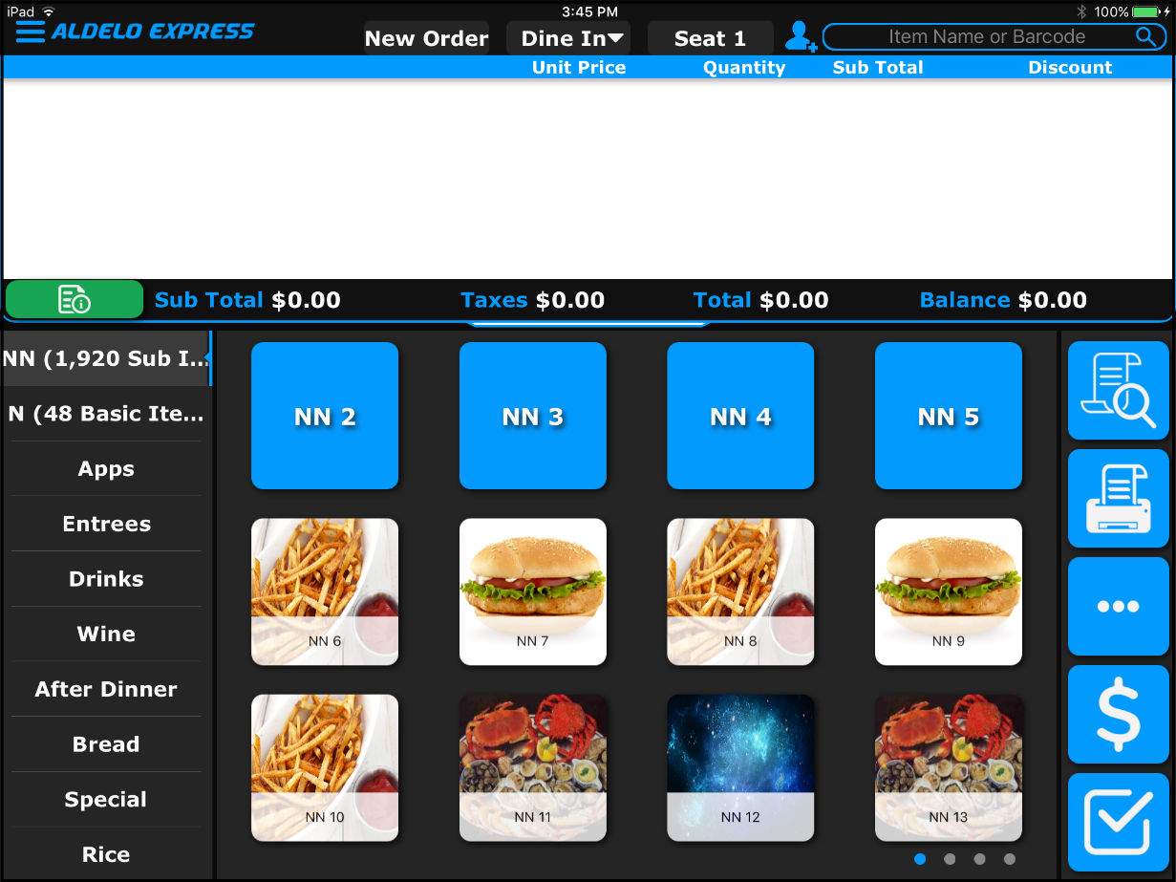
Figure 4-8

Adding a Menu Item

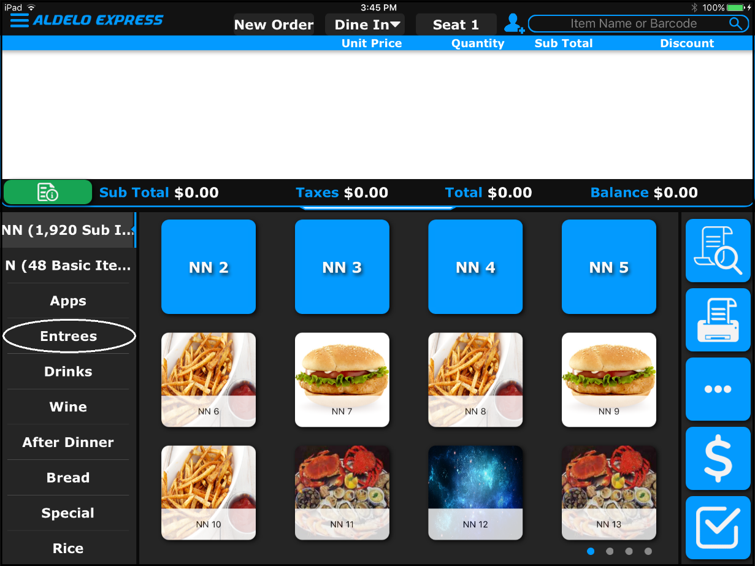
Figure 4-9

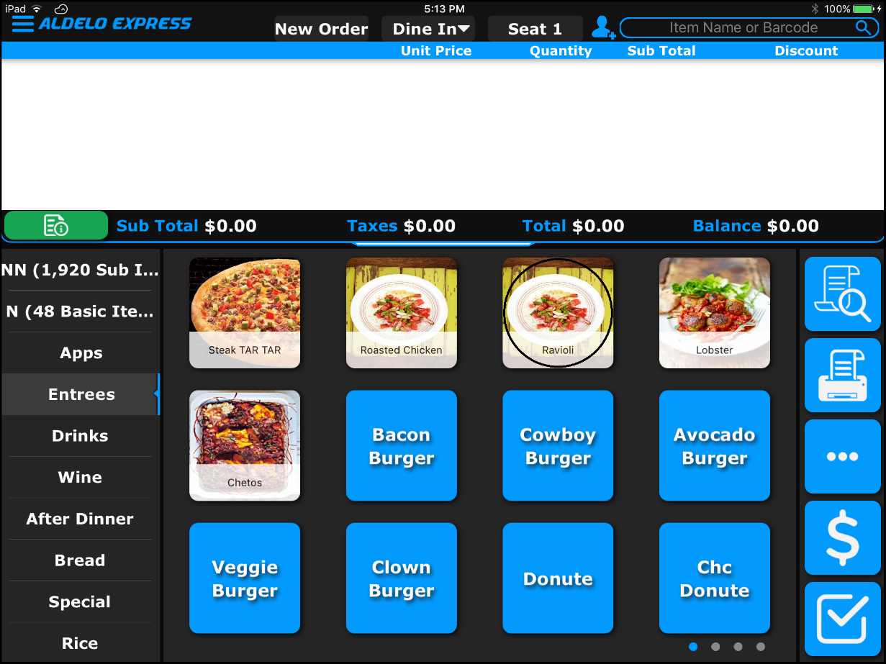
Figure 4-10

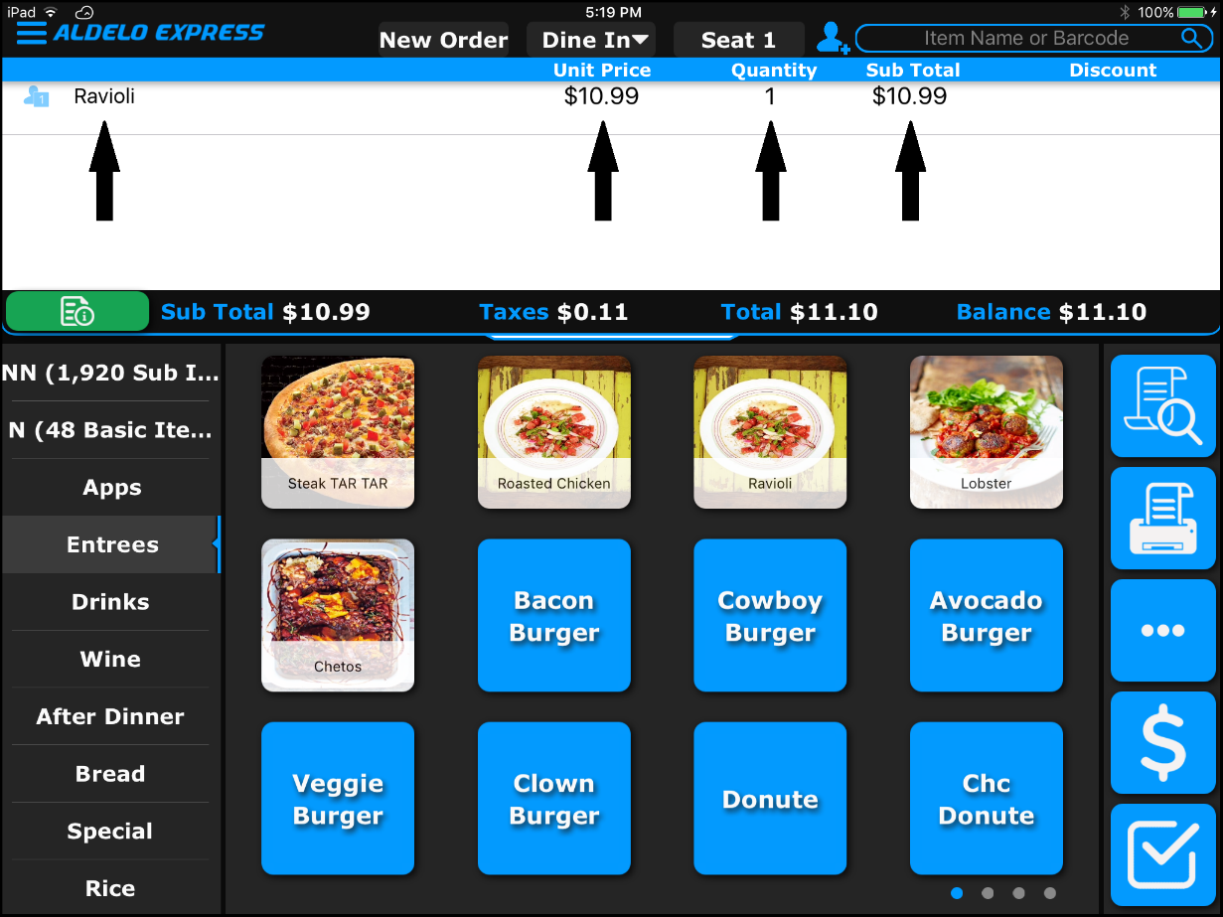
Figure 4-11

Printing an Order Receipt

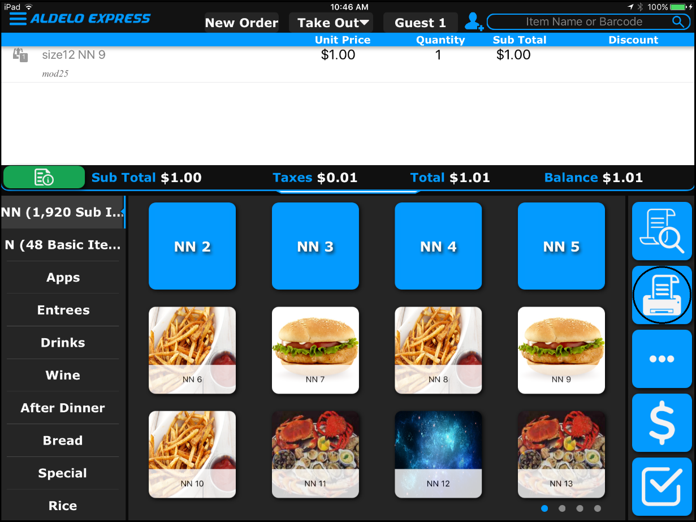
Figure 4-12

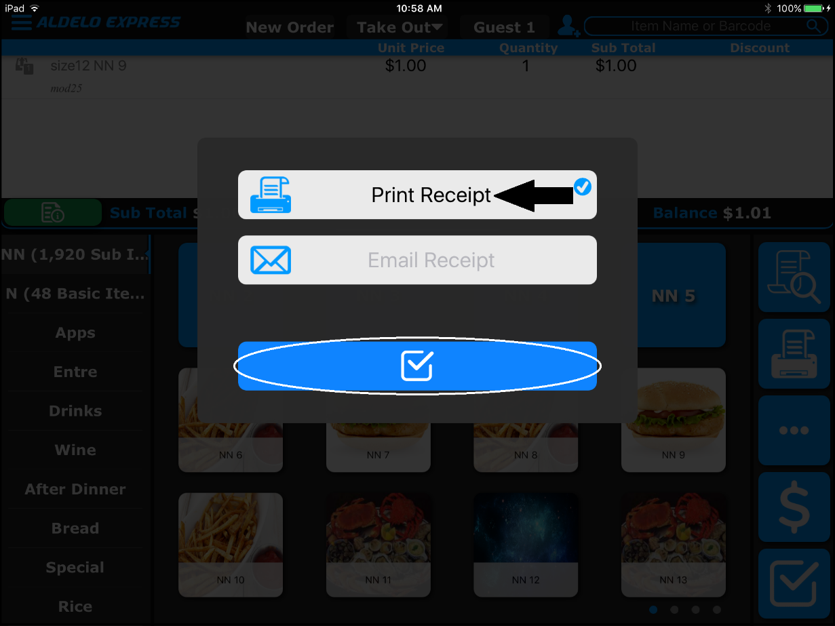
Figure 4-13

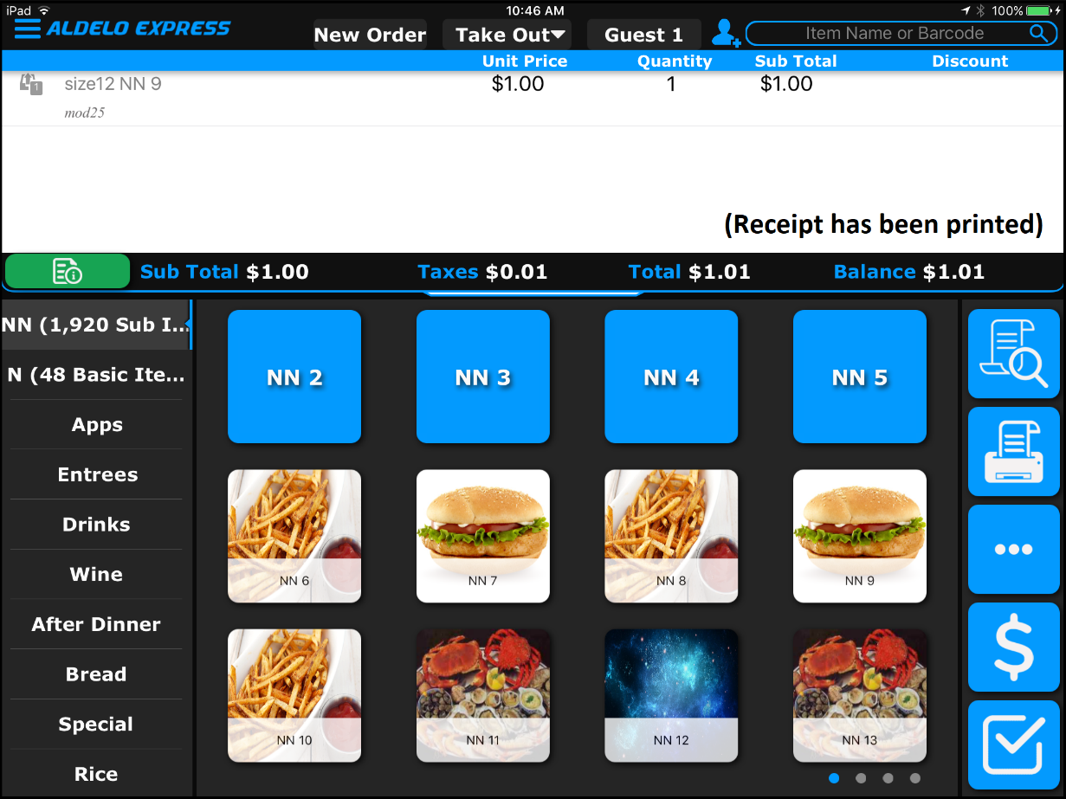
Figure 4-14

Miscellaneous Features

Printer Setup

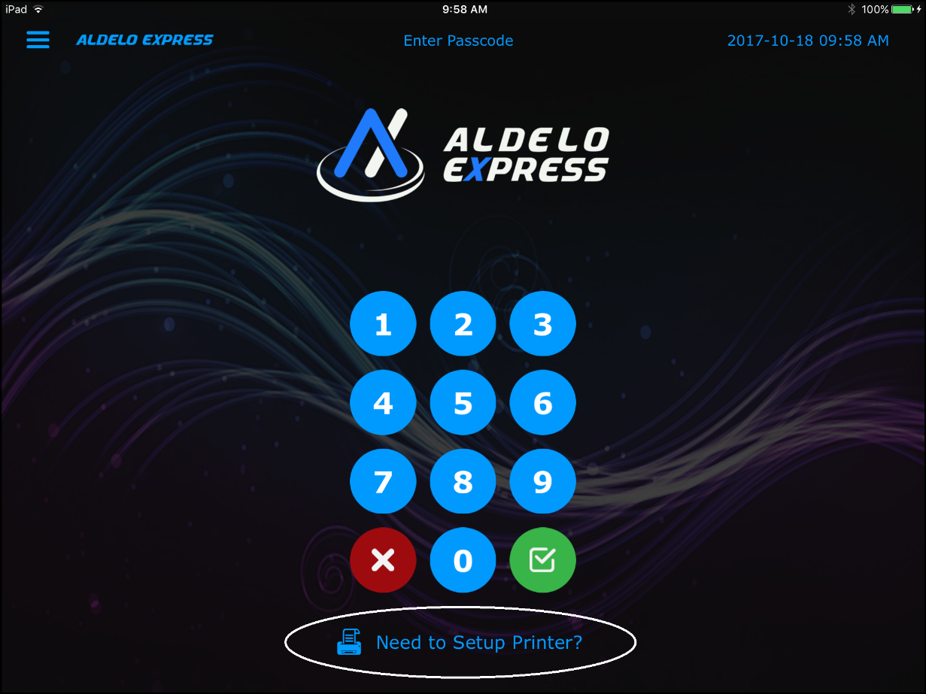
Figure 5-1

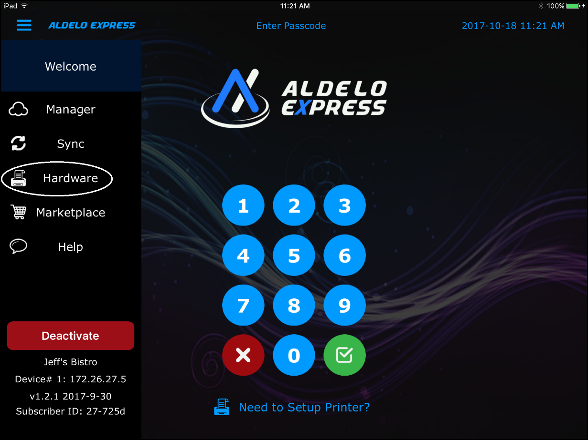
Figure 5-2

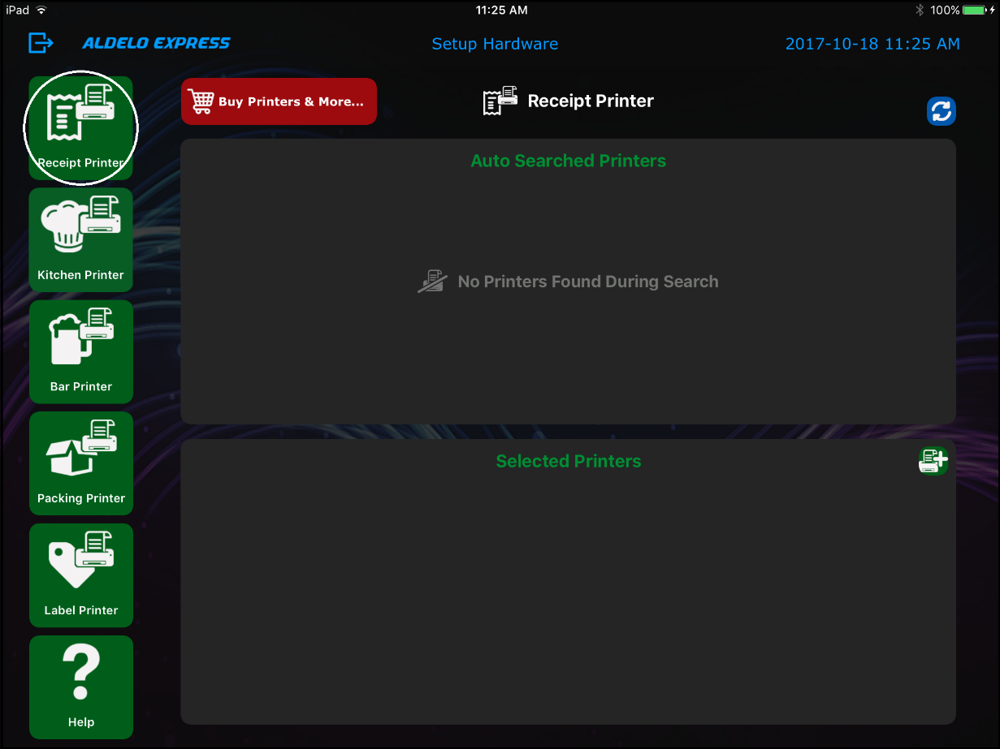
Figure 5-3

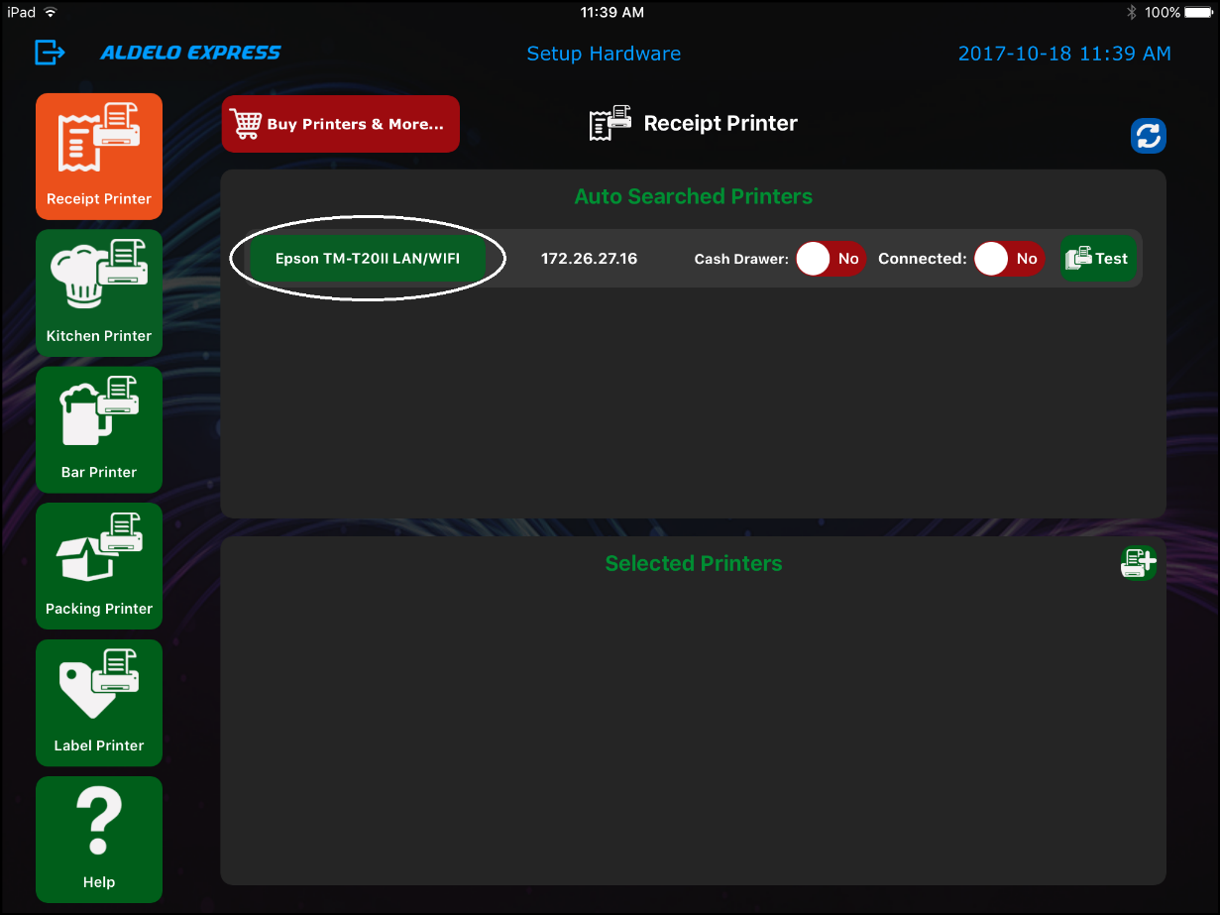
Figure 5-4

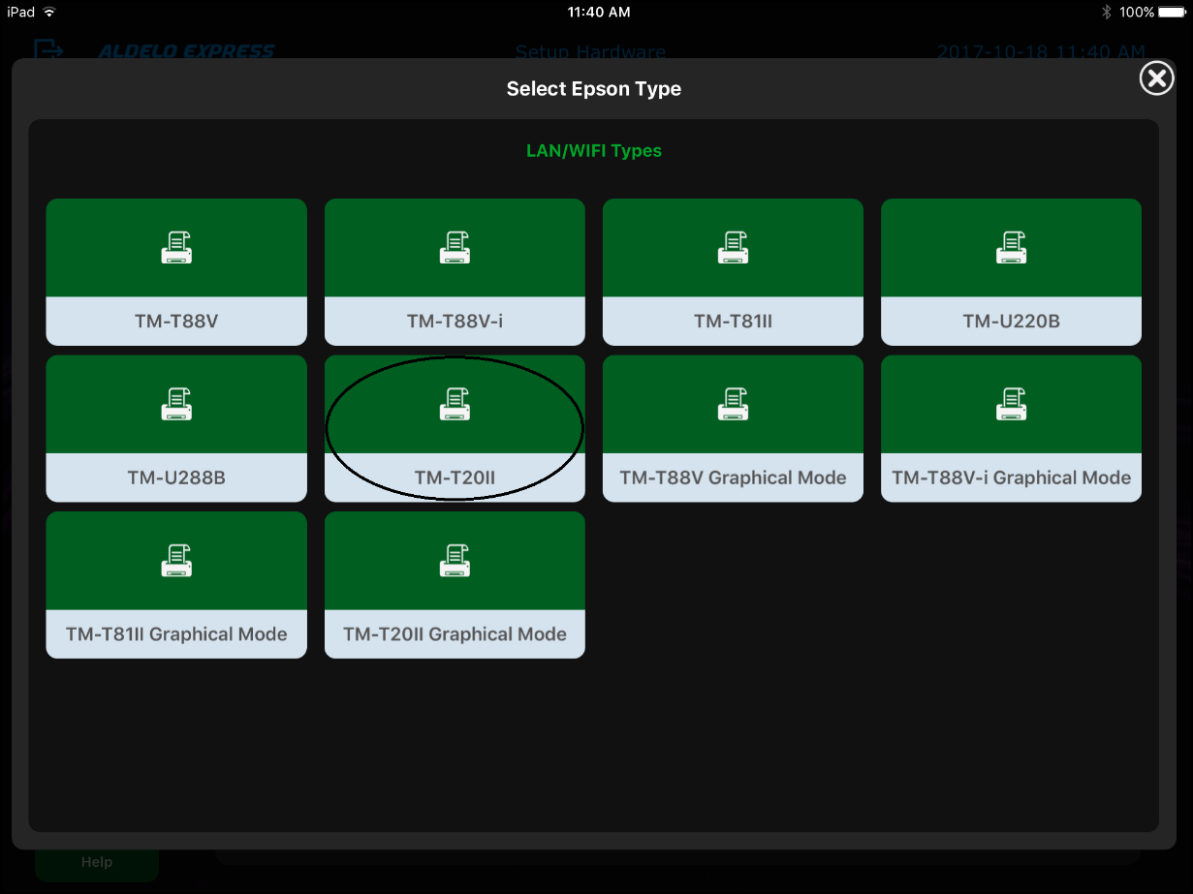
Figure 5-5

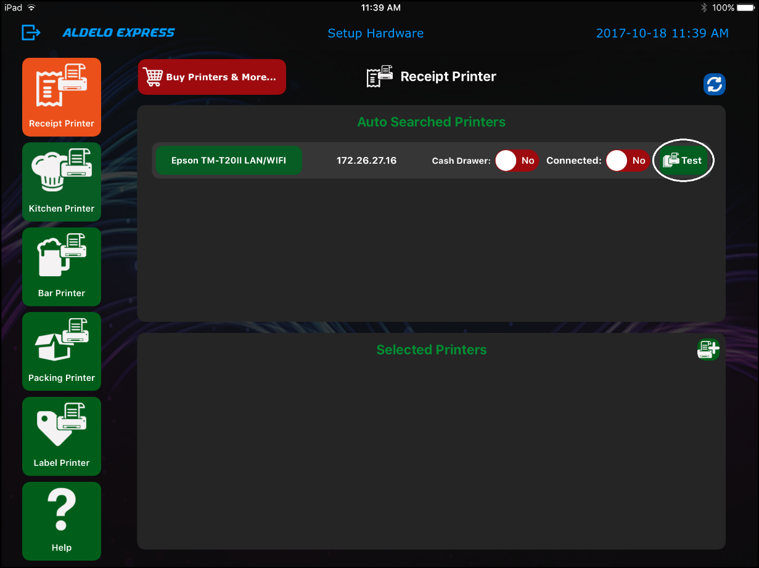
Figure 5-6

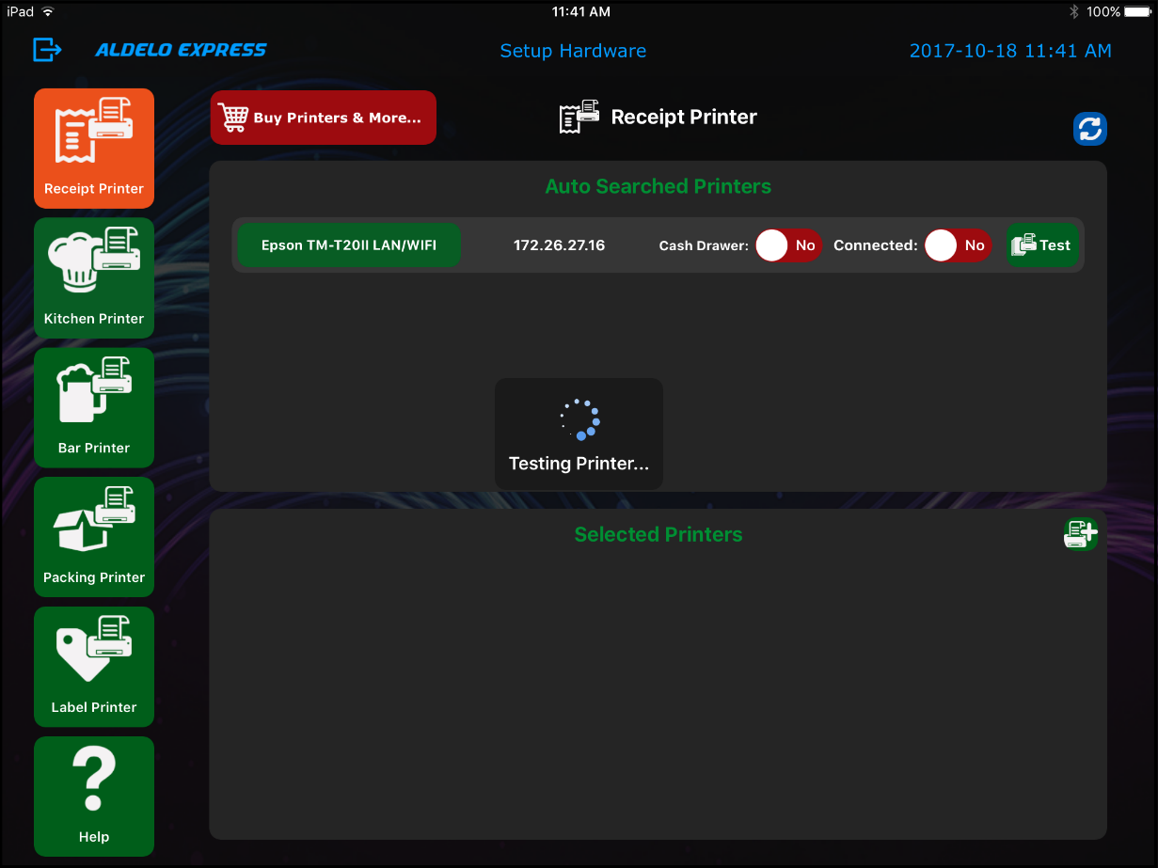
Figure 5-7

If the printer has been setup successfully, it prints a confirmation chit.

Synchronizing the Aldelo® Express App with the Aldelo® Express Cloud Back Office

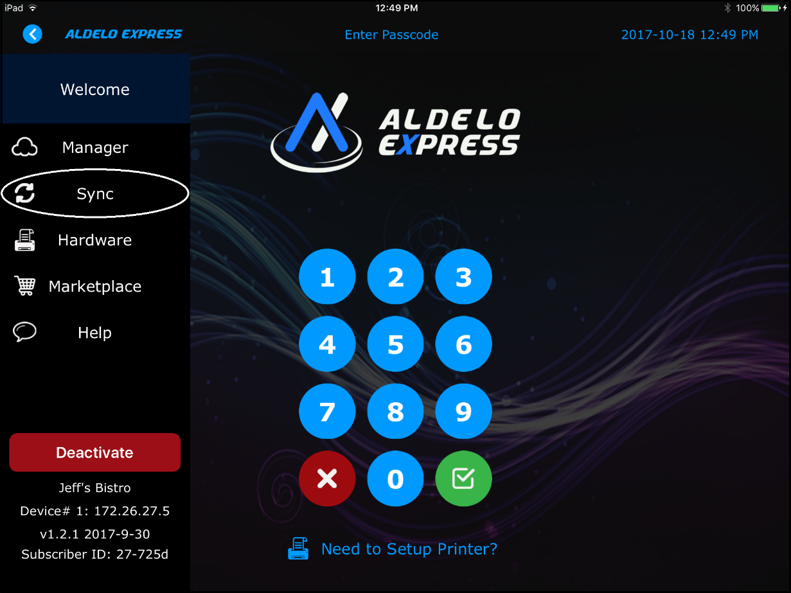
Figure 5-8

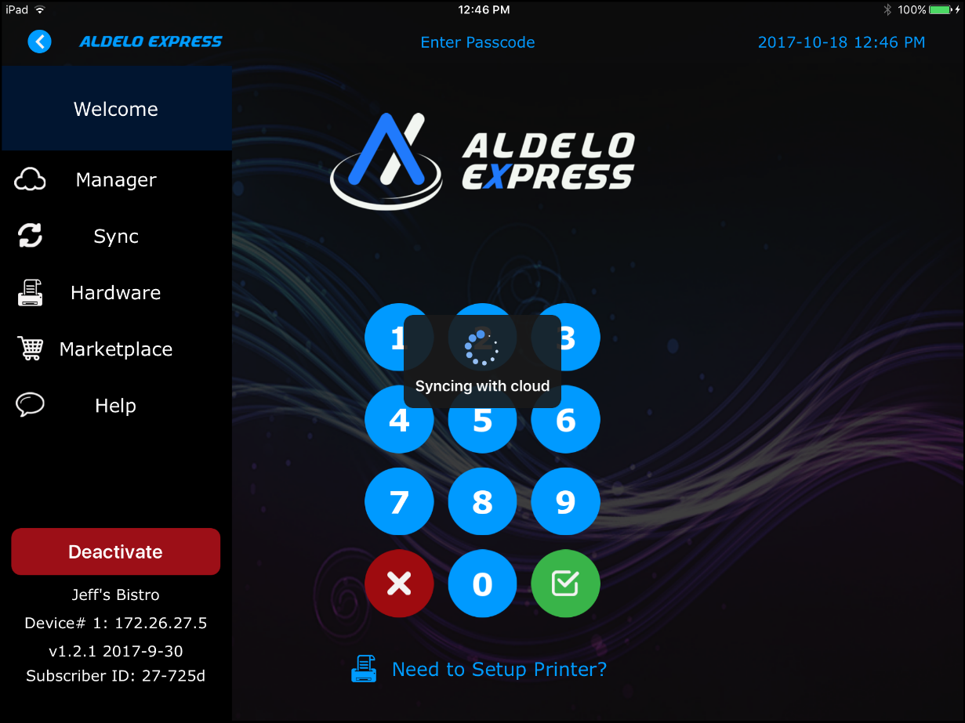
Figure 5-9

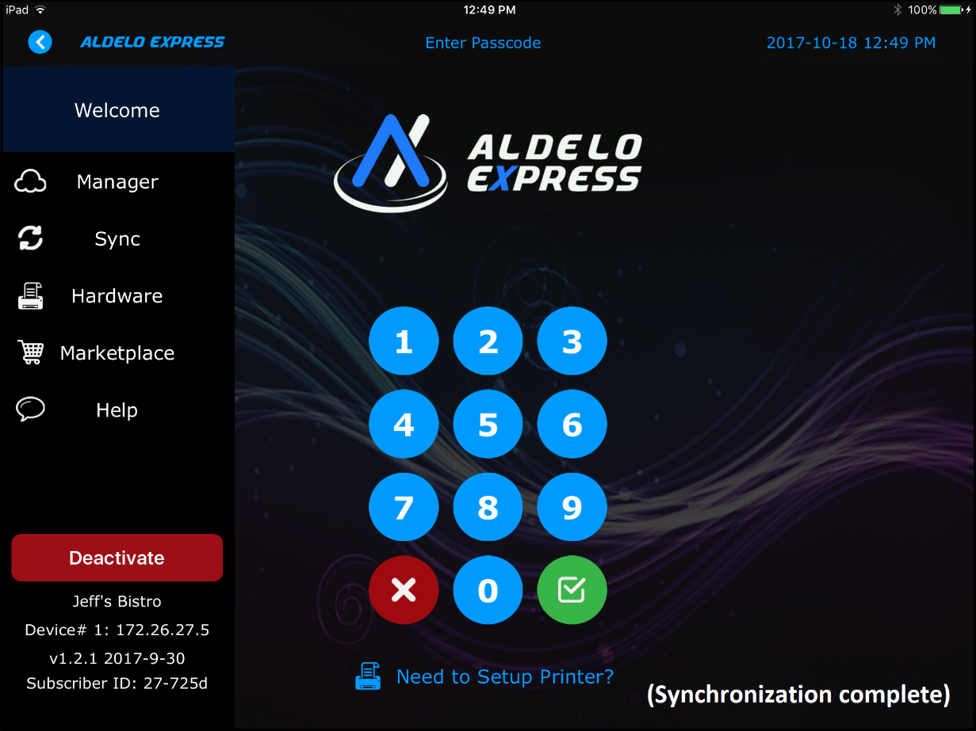
Figure 5-10

Accessing the Aldelo Marketplace

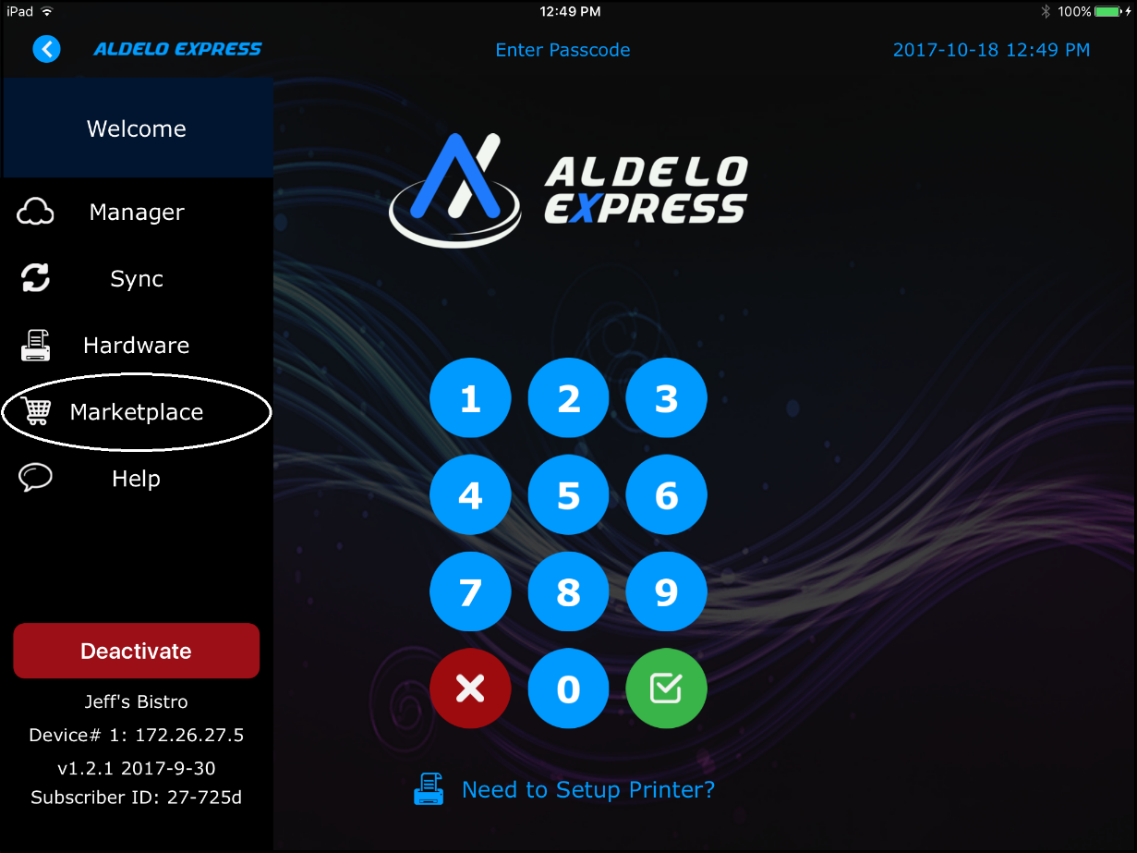
Figure 5-11

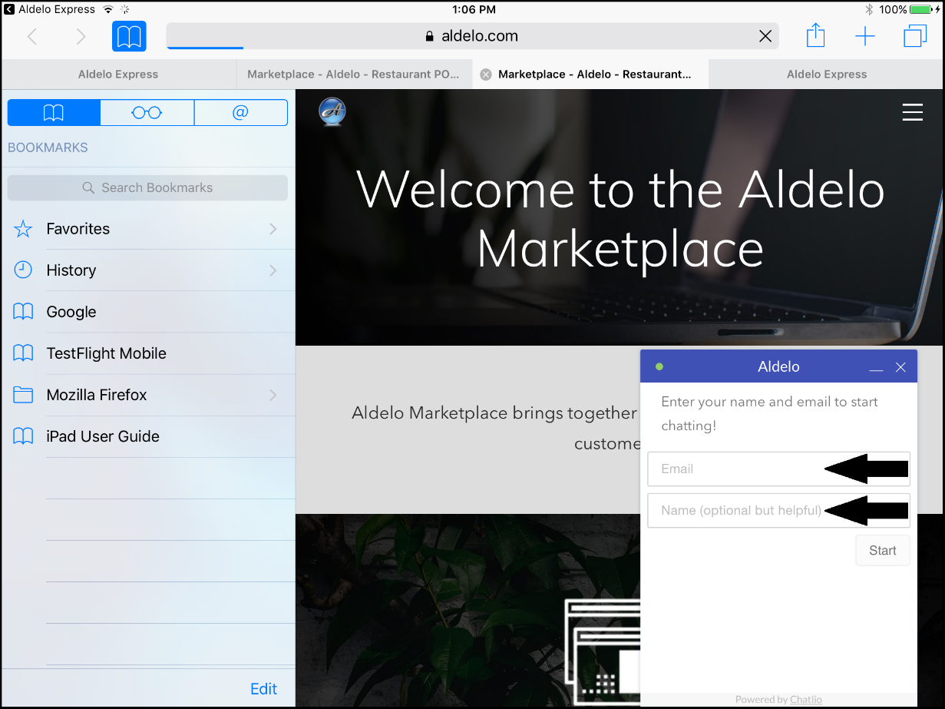
Figure 5-12

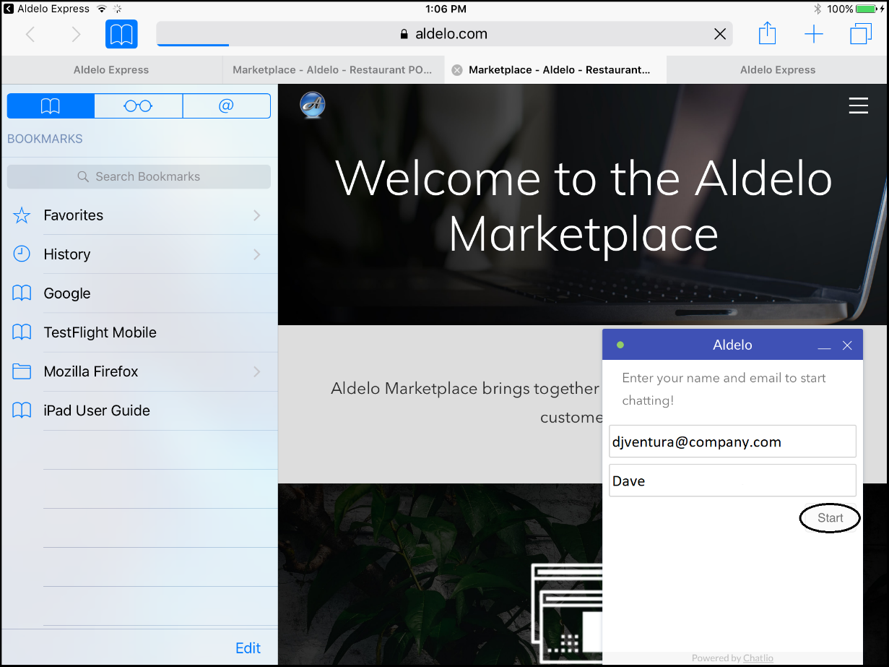
Figure 5-13

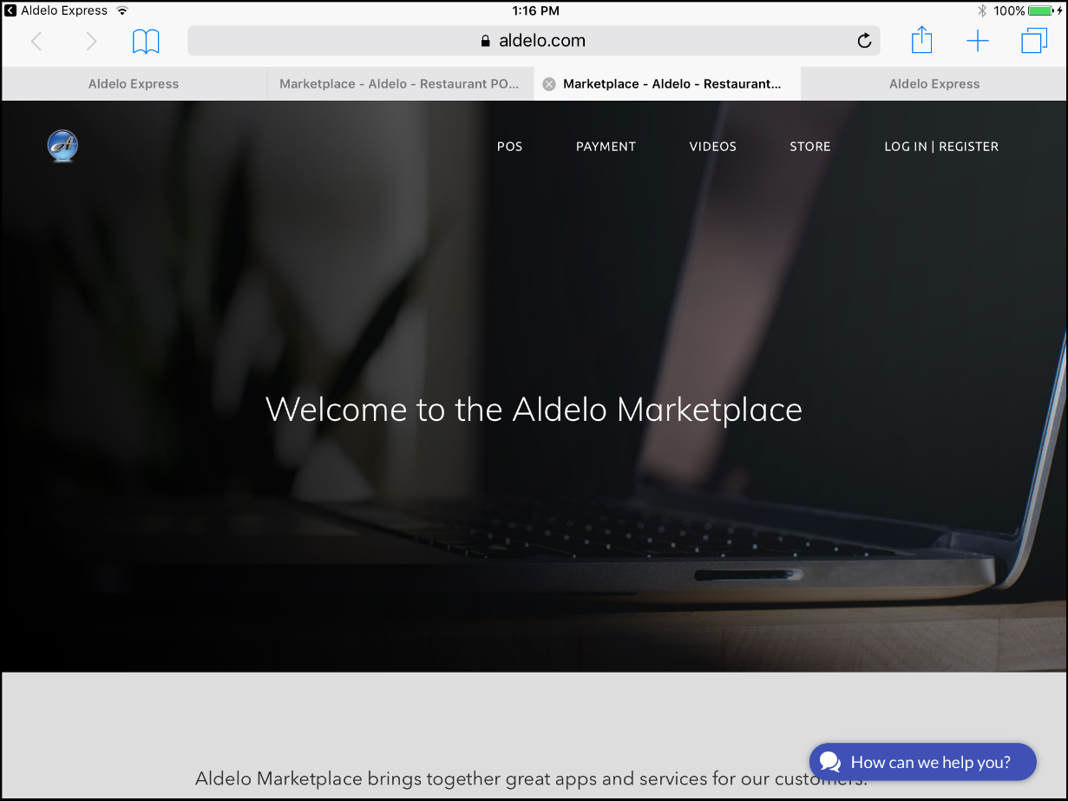
Figure 5-14

Deactivating the Current Device

Deactivation Using E-mail Address or Mobile Phone Number

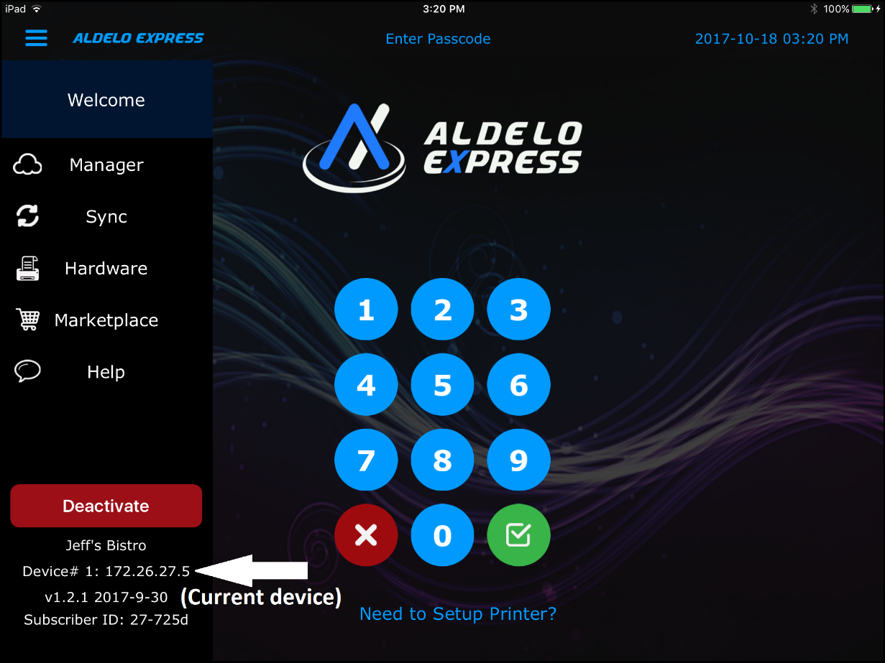
Figure 5-15

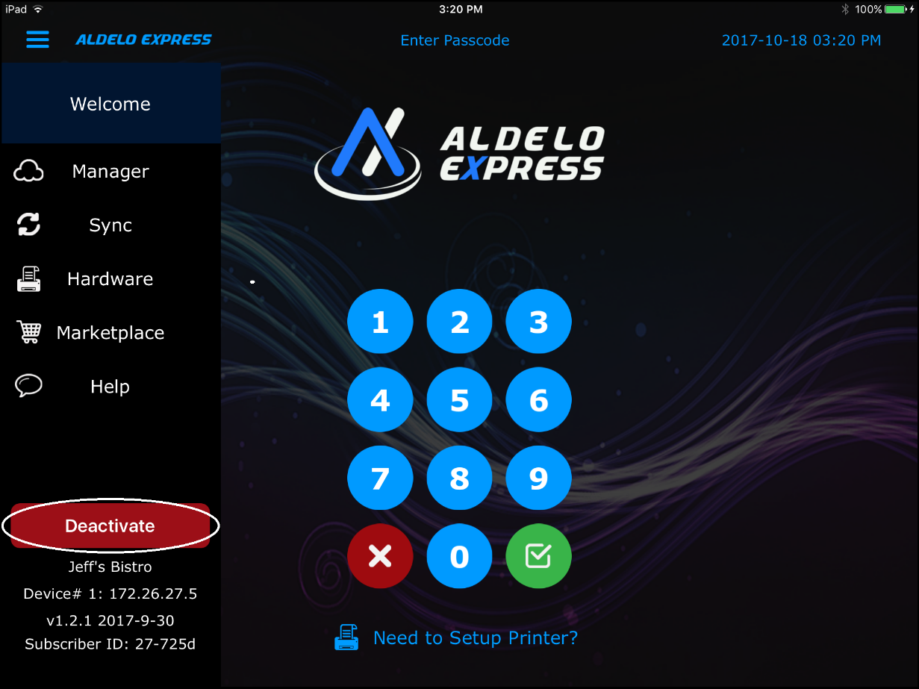
Figure 5-16

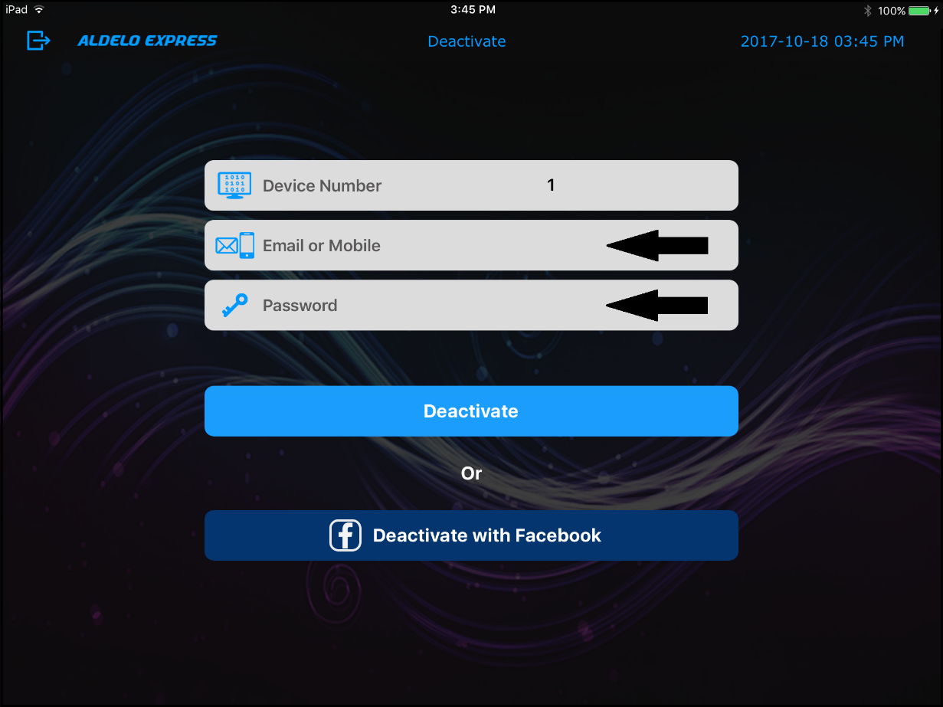
Figure 5-17

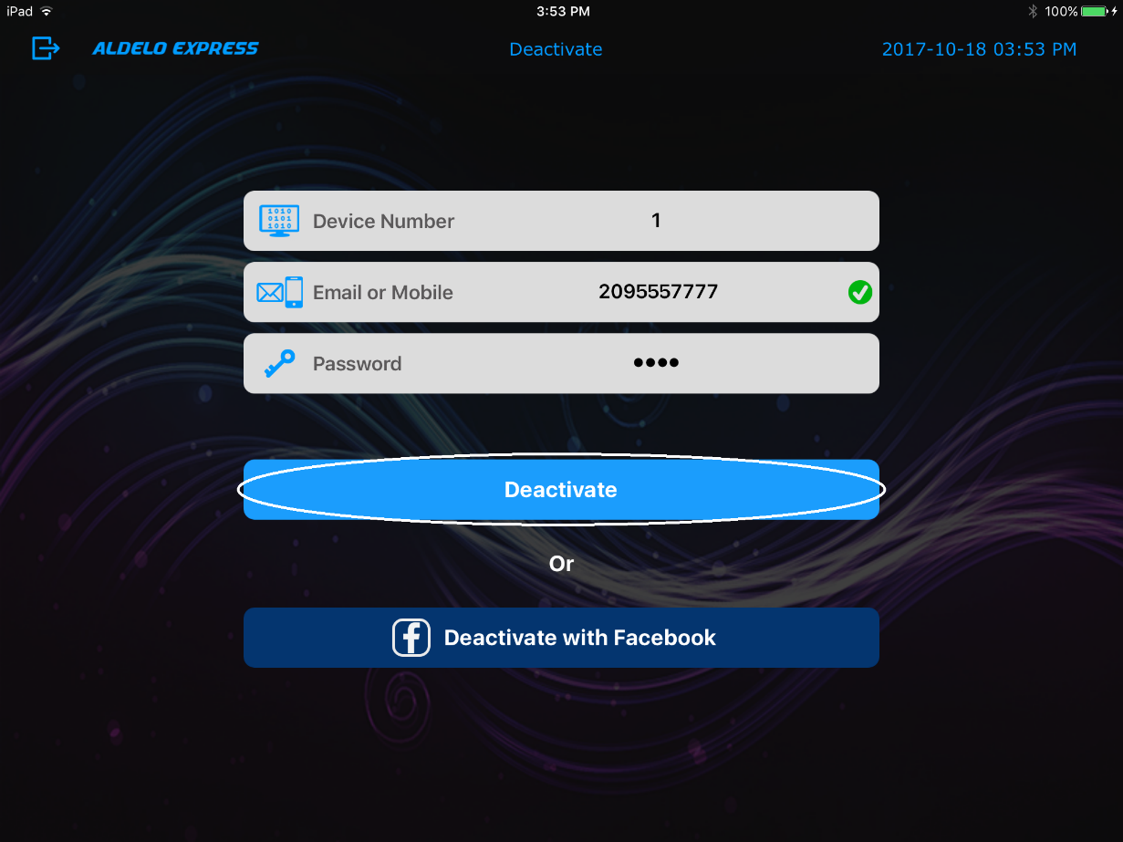
Figure 5-18

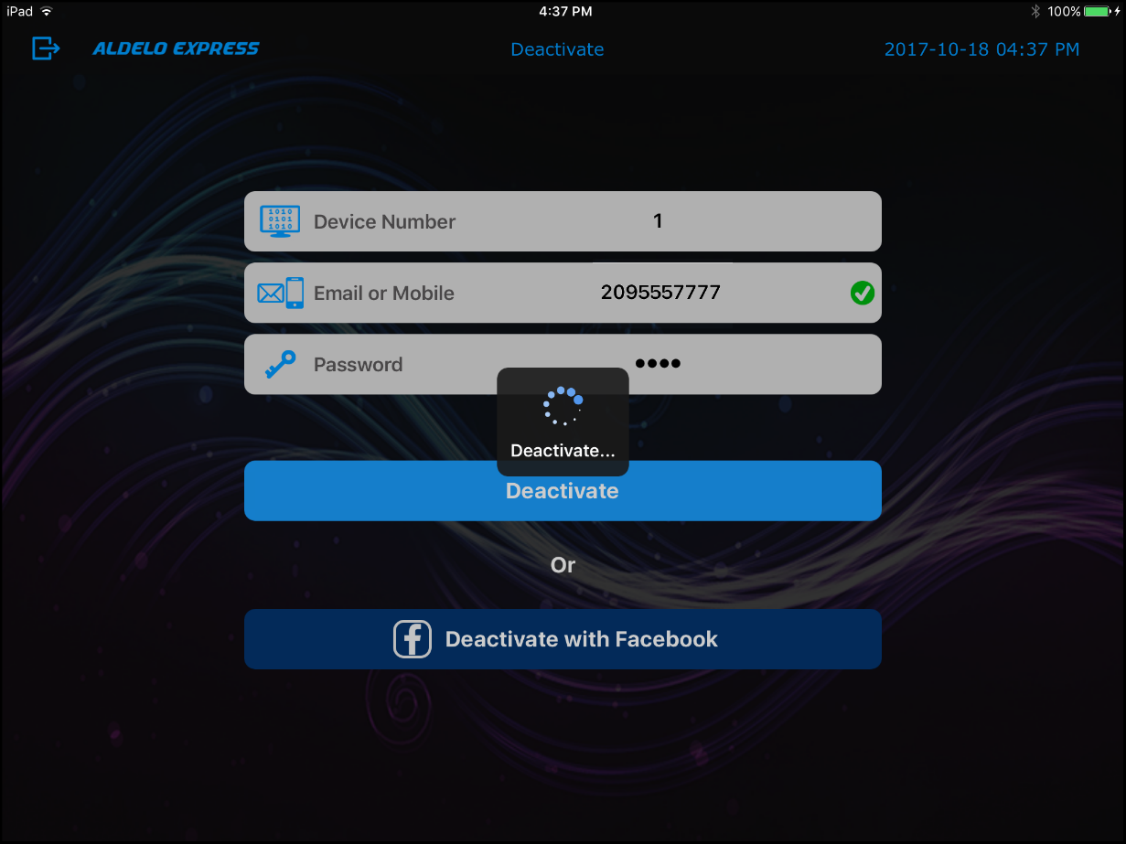
Figure 5-19

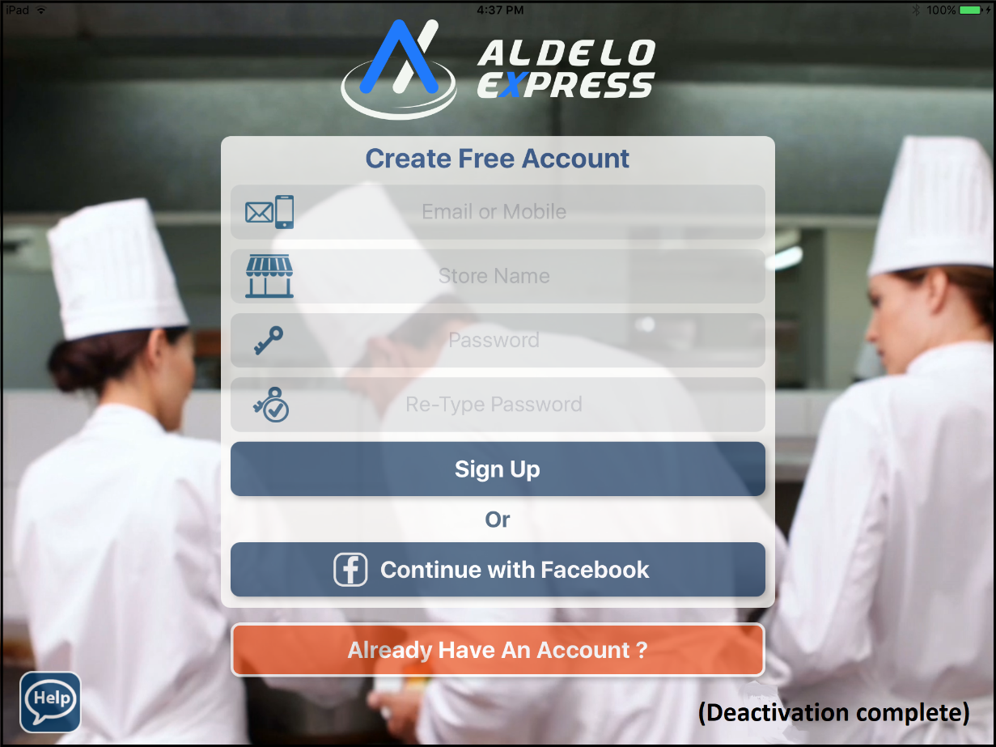
Figure 5-20

Deactivation Using Facebook

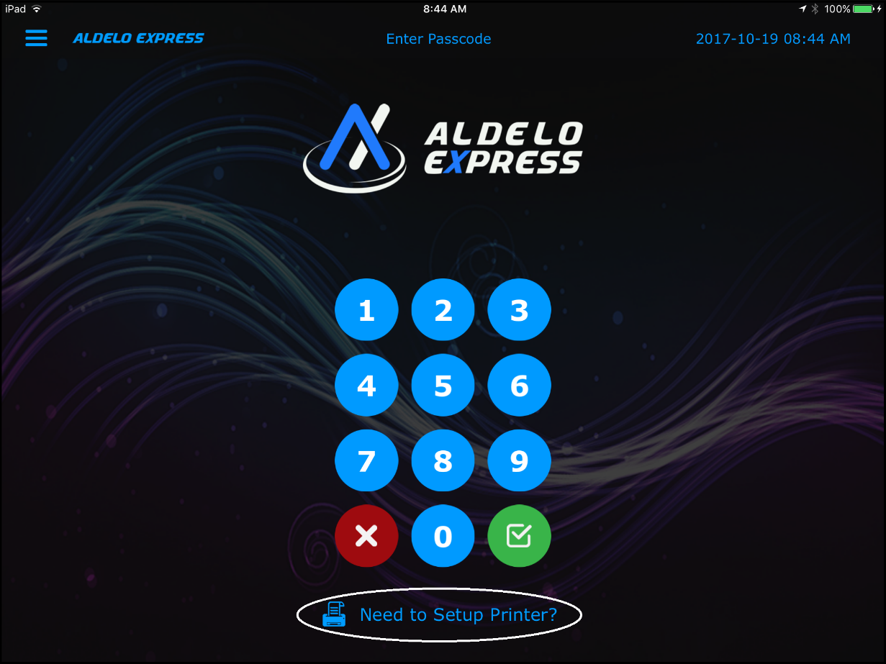
Figure 5-21

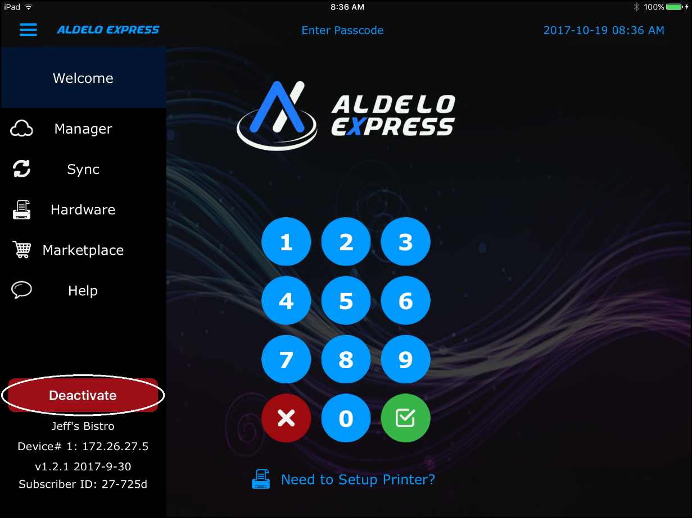
Figure 5-22

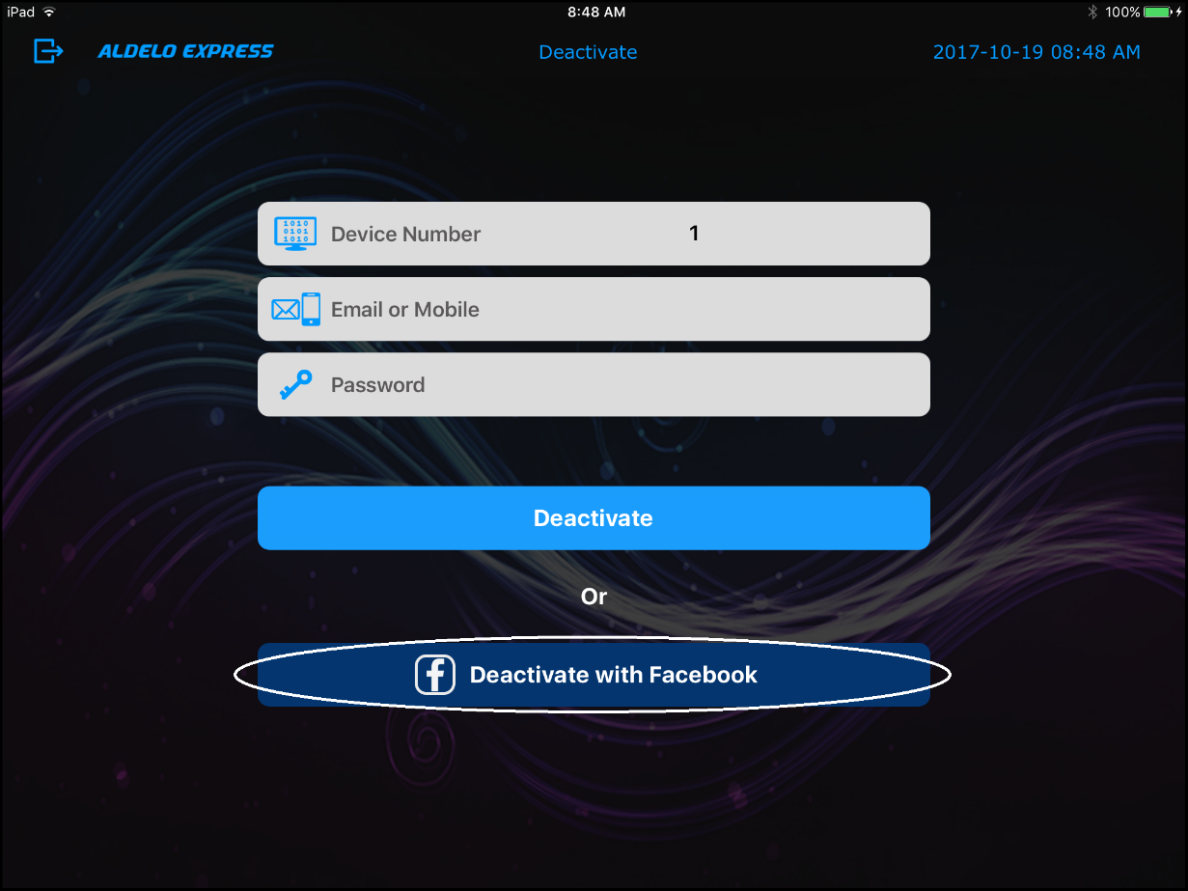
Figure 5-23

Cloud Manager

Accessing the Cloud Manager

Access from a Mobile Device

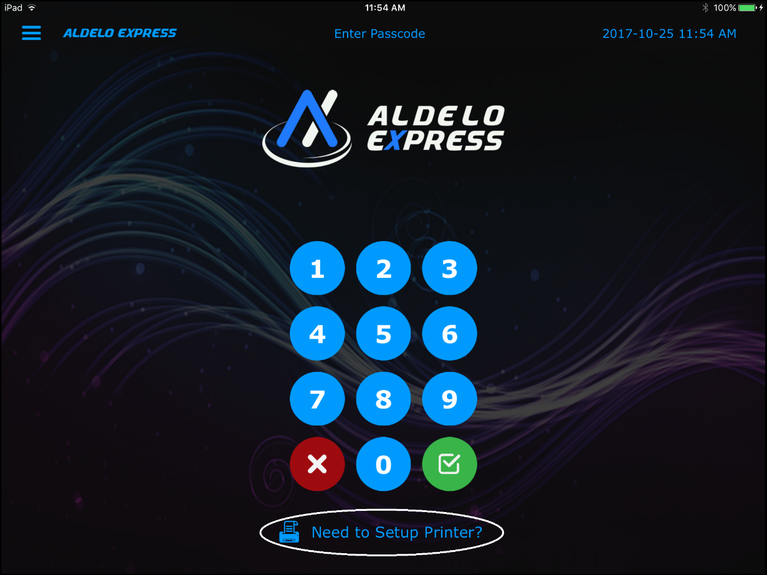
Figure 6-1

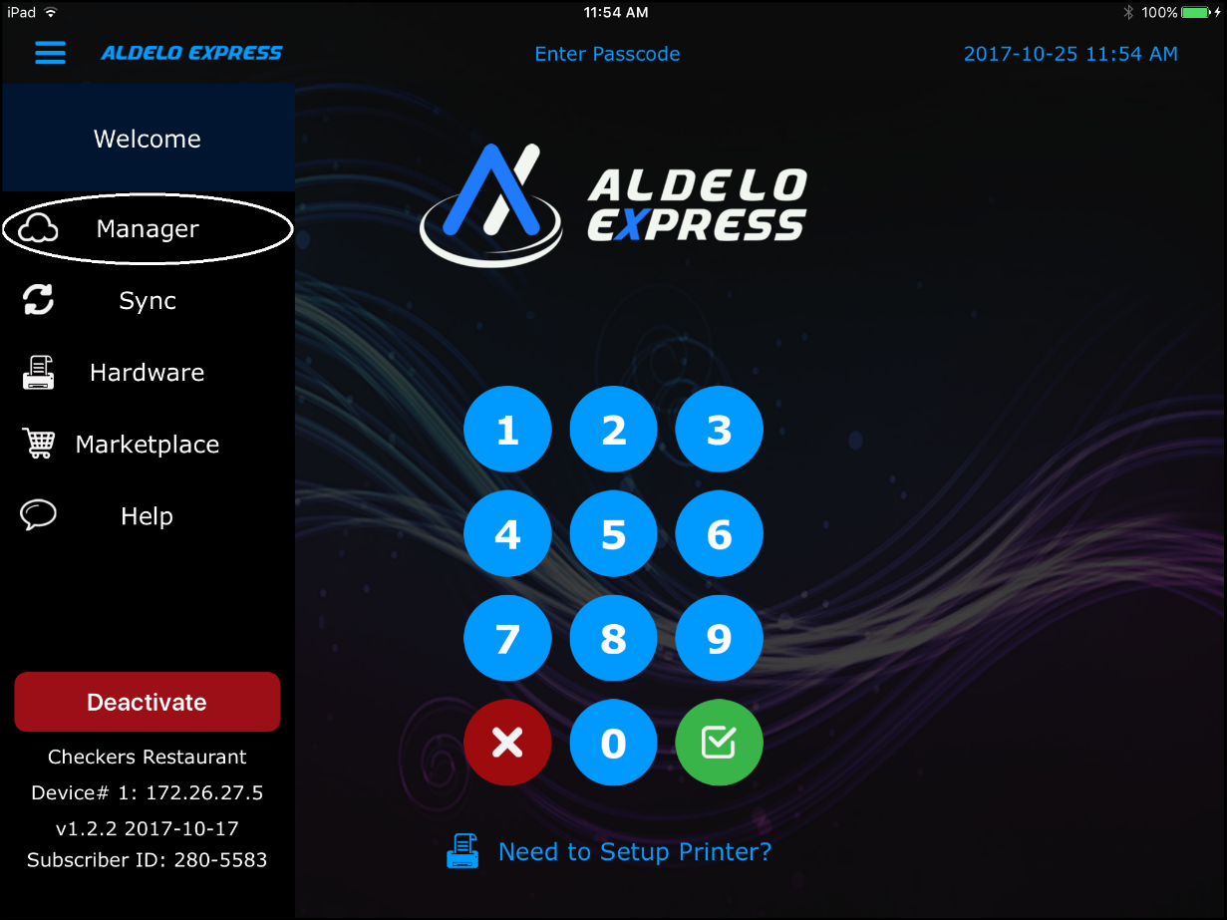
Figure 6-2

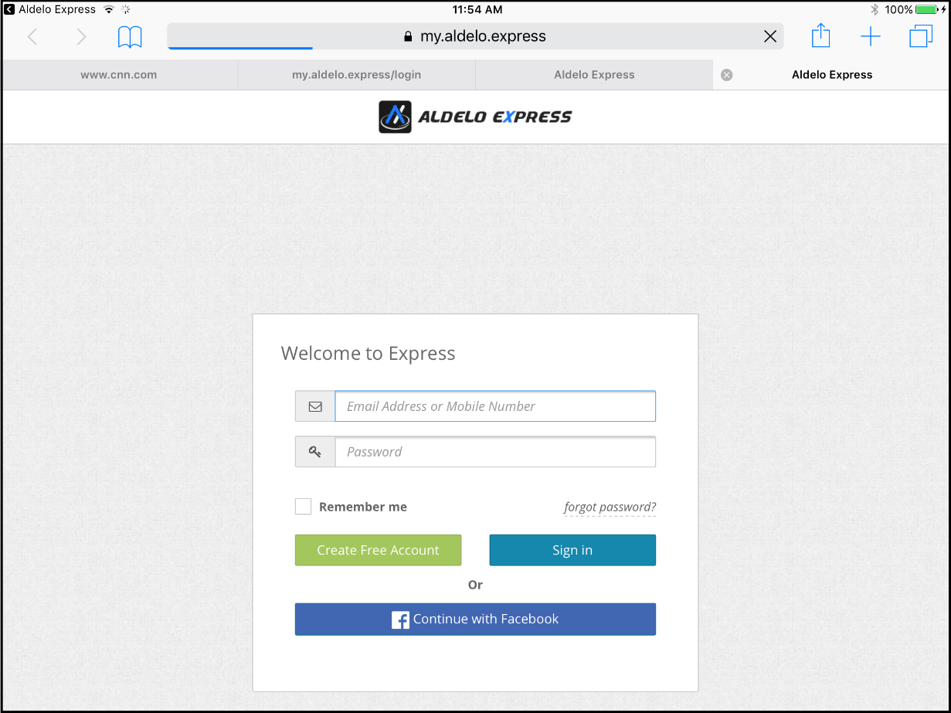
Figure 6-3

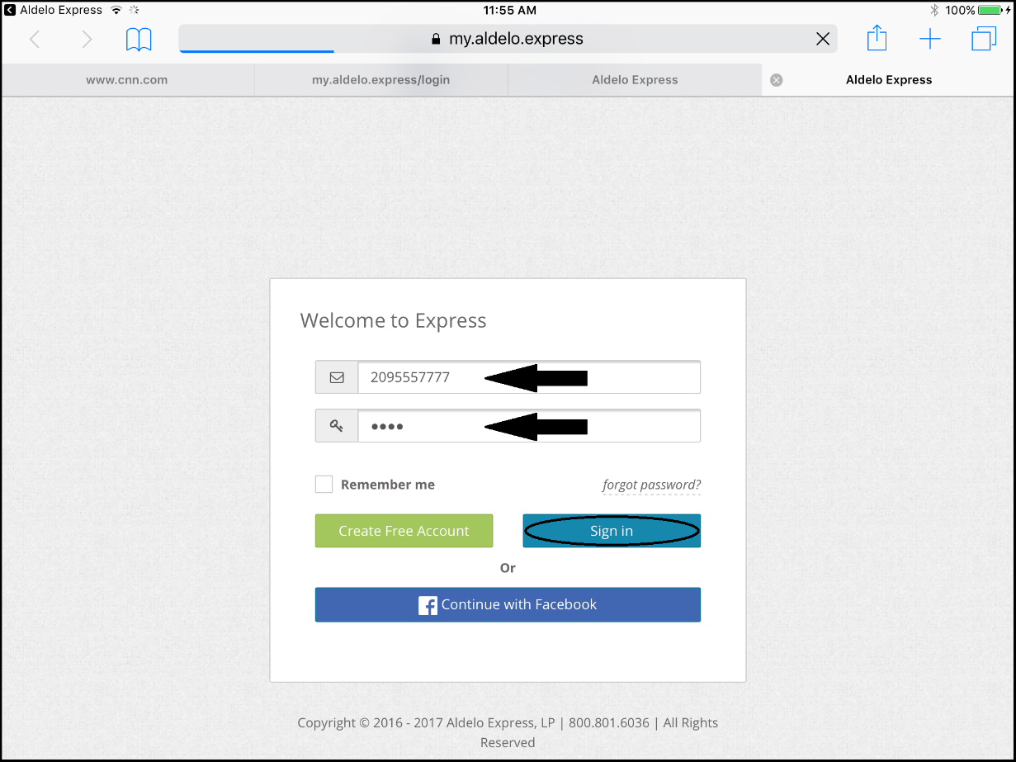
Figure 6-4

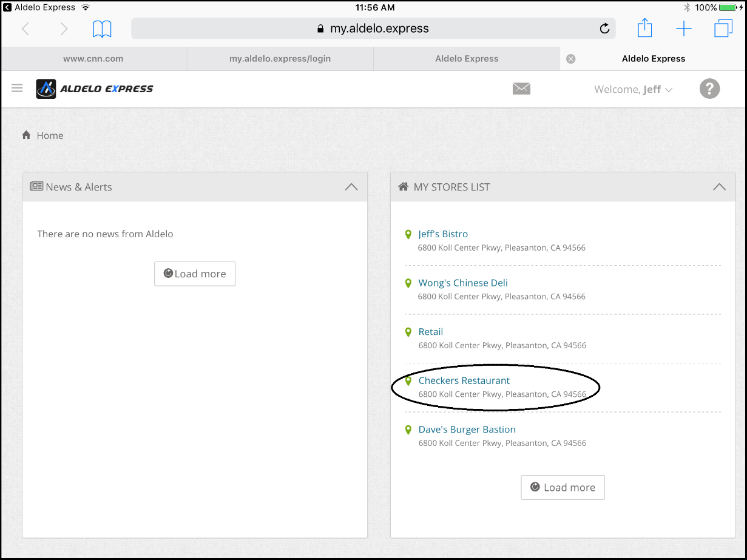
Figure 6-5

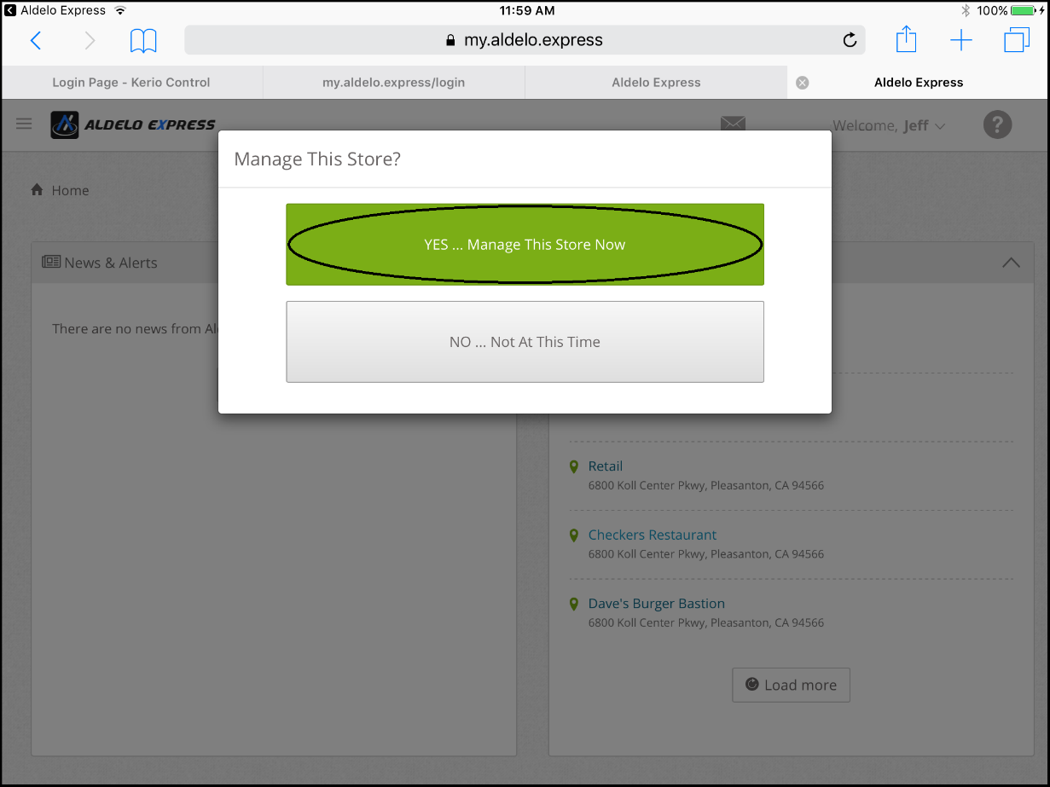
Figure 6-6

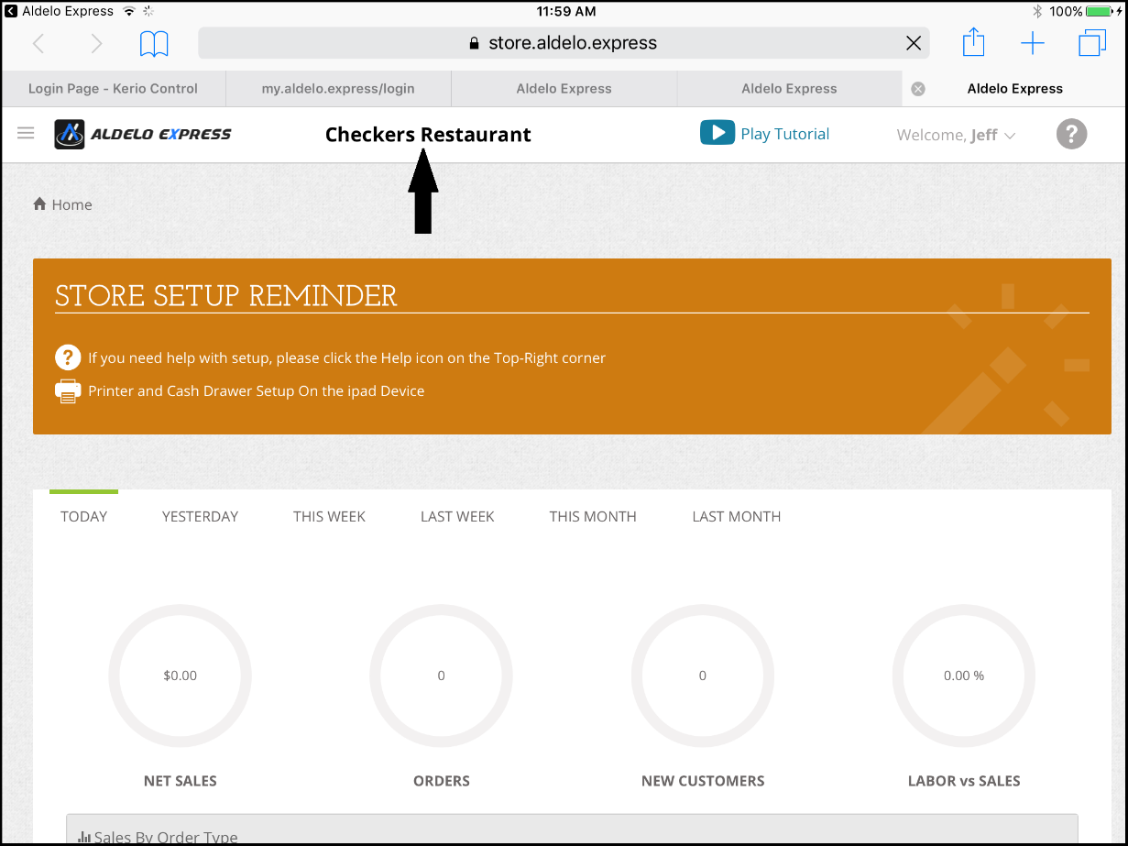
Figure 6-7

Notes

